Welcome to the assembly guide for the Rostock Max 3D printer.

Version 1.14, March 24th, 2013

Copyright 2012 by Gene Buckle

Licensed as Creative Commons Attribution-ShareAlike 3.0

Questions or corrections should be emailed to [geneb@deltasoft.com](mailto:geneb@deltasoft.com)

Many thanks to LulzBot for the use of their images in the Troubleshooting Section!

Table of Contents

Recommended Tools and Additional Materials 3

1 – Assembling the Machine Base 6

2 – Installation of the Heated Bed 16

3 – Install Belt Pulleys on Stepper Motors 17

4 – Install the Connectors on the Stepper Motors 18

5 – Installing the Stepper Motors to the Motor Mounts 20

6 – Installation of the Power Supply 21

7 – Installation of the RAMBo Controller 22

8 – Installing the T-Slot Hardware in the Base 24

9 – Assembling and Installing the Idler Mounts 26

10 – Installing the Top Support Plate 28

11 – Tighten the Rails at the Base 29

12 – Adjusting the Top Support Plate 30

13 – Assembling the Filament Spool and Extruder Bracket 31

14 – Assembling the Extruder 36

15 – Building the Carriage 37

16 – Assembling the Cheapskate Bearings 44

17 – Idler Assembly 52

18 – Installing the Belts! 54

19 – Installing the Limit Switches and Adjustment Screws 58

20 –Wiring the Heated Bed 64

21 – Assembling, Wiring and Mounting the Hot End Assembly 67

22 – Wiring the Power Switch & RAMBo Power 74

23 – Final Assembly! 76

Software Installation and Configuration 81

Calibrating Your Rostock MAX 86

Your First Print with the Rostock MAX 92

Fail Happens. (to *everyone!*) 115

Maintenance & Troubleshooting 120

Change Log 125

# Recommended Tools and Additional Materials

Before you begin, please make sure you’ve got the following tools and materials:

* P1 & P2 Sized Phillips Screwdrivers
* Standard Flat Head Screwdriver
* 3/32” Allen (hex) Wrench (T-handle with a ball end would be a good pick for both of these tools.)
* 5/32” Allen (hex) Wrench
* Needle nose pliers
* Forceps – these are VERY handy and will make your life easier in a number of the assembly steps. They look like this:

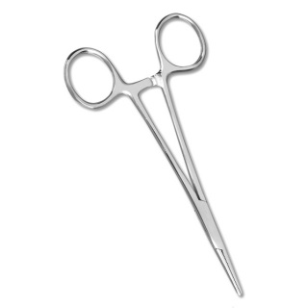

You can purchase these online from Amazon for as little as $3.50 for a set of two.

I would recommend getting the ones with a slight curve to the jaws.

* Wire Strippers
* Wire Cutters
* Metric Tape Measure or Meter Stick
* A Small File – you may wish to get both a fine and coarse file. This is needed for adjusting the spacing on some plastic parts later on in the build.
* 100-150 Grit Sand Paper
* 5/16” Wrench (used on the Cheapskate Bearings)
* X-Acto Knife or other hand-held razor blade
* PermaTex Ultra Copper High Temp RTV (used on the Hot End & Heated Bed)
* Kapton Tape
* Aluminum Foil
* Crimp-On Wire Nuts (used on the heating resistors, crimp barrel should be about 3/16” in diameter)
* Split Flex Tubing (for the Hot End wires)
* 1 T 1-3/4 LED (Power on indicator for the Heated Bed – see note in Section 20)
* 1 1k 1/4 Watt resistor (for the LED above)
* A Digital Caliper. These can be had from places like Harbor Freight tools for as little as $10.

There will be a parts inventory included in the shipping box. Before you begin assembling your Rostock Max, please check the parts included against this inventory. This will make sure you’ve got everything you need to complete the assembly of your 3D printer. In the unlikely event that a part is missing, contact SeeMeCNC immediately. Their technical support is excellent and you’ll have the missing components on their way to you in no time.

The laser cut components in the Rostock Max kit are held in place with masking tape to ensure that they’re not damaged in transit. The simplest way to remove these parts from the scrap material is to use a razor blade to cut the tape around the perimeter of the part.

Each laser cut part also has a protective film on it that must be removed. This film prevents “flash-over” from the laser cutting process from leaving scorch marks and combustion byproducts on the parts. The film is removed easily – however, the film in the lettering can be difficult to remove. I recommend using the edge of a credit card or stiff plastic scraper to remove the remaining film from these areas.

Finally, take a dry washcloth or shop towel and wipe down the edges of each part. This will remove most of the “soot” left over from the laser cutting process. If you’ve got an Acrylic kit, you can of course skip this step.

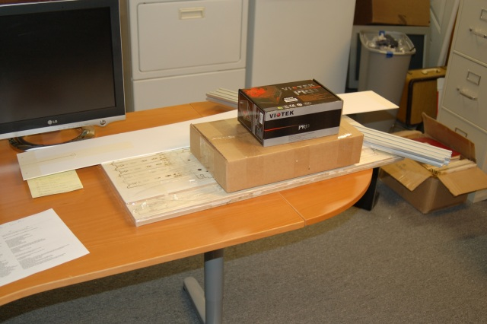

Figure – The parts for the Rostock MAX printer.

# 1 – Assembling the Machine Base

* 1. – Pop out the counter sink rings from the bottom plate (P/N: 68355)

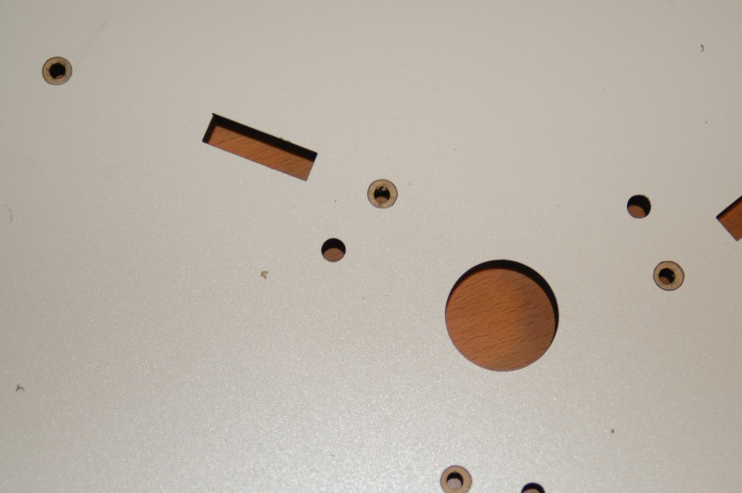

Figure – Countersink rings.

1.2 - The counter-sink rings are simply circles have been engraved through the Melamine surface. Popping them out is easy using the point of a razor knife. It exposes the softer inner material of the Melamine and allows flat head screws to create their own counter-sink by the pressure they apply as they’re tightened down.

* 1. – Install the six feet to the bottom face of the base plate (P/N: 69355).

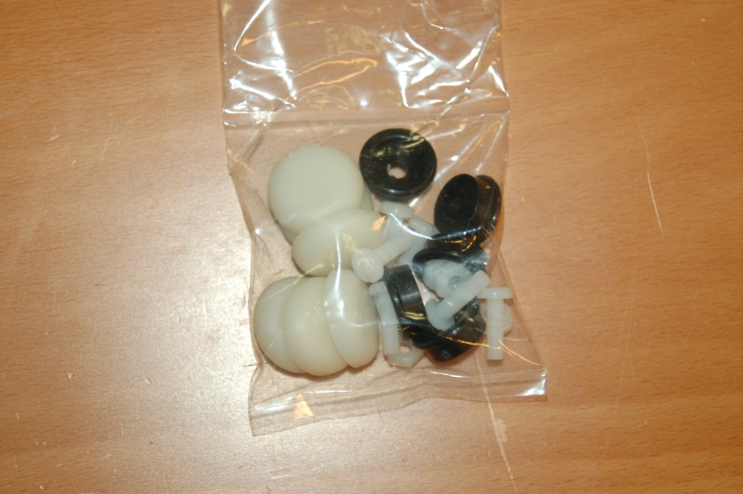

Figure – Plastic parts that make up the feet for the machine.

1.4 - In the photo below I’ve got the first two feet installed – note that I initially inserted the nylon fasteners incorrectly. The nuts should be on the _other_ side. Installing them as shown in the photo will prevent the soft rubber caps from fitting properly.

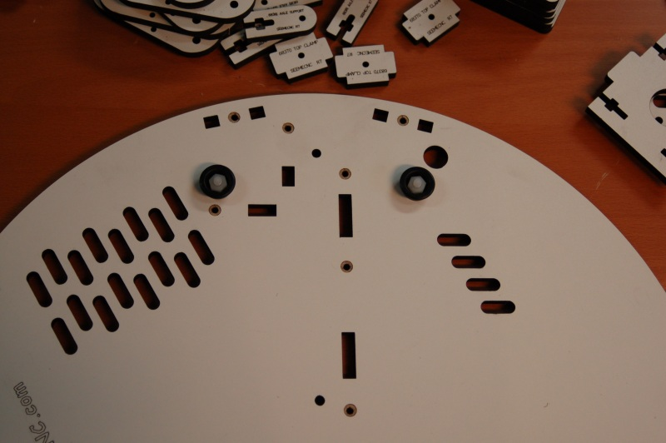

Figure – First two feet mounted.

1.5 - This is what the six feet should look like when installed in their proper location:

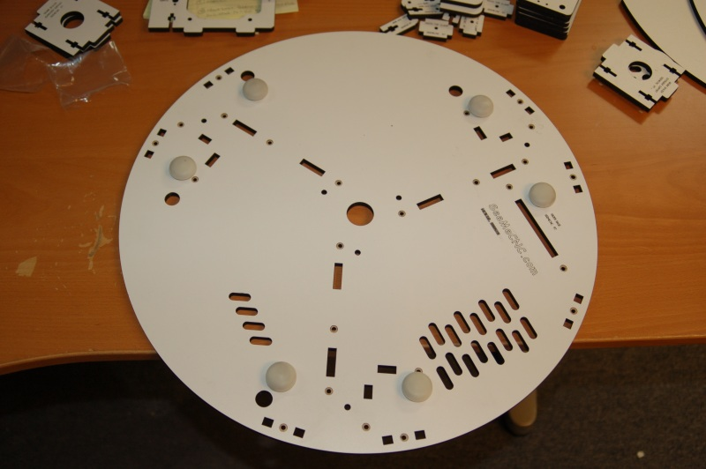

Figure – All six mounted, with rubber caps installed.

* 1. - The white caps just fit over the black plastic feet. Makes for a great non-slip assembly.

1.7 – Install the Tri-Supports (P/N: 68352), T-Slot Supports (P/N: 68377), and Motor Mount (P/N: 68364)

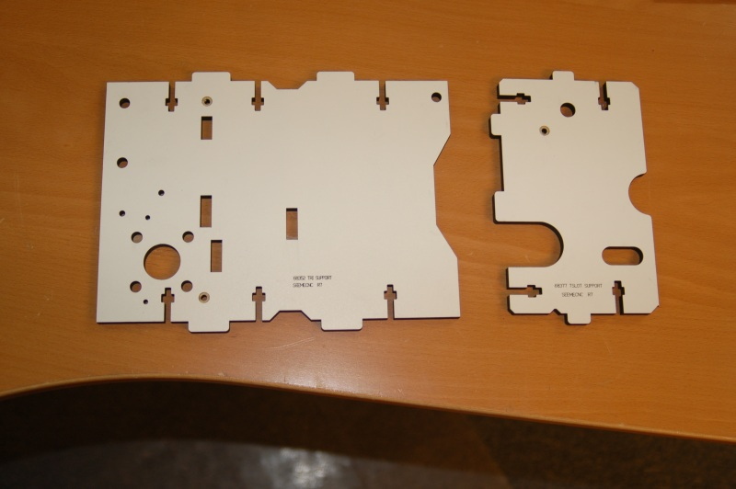

Figure - Tri Support and T-Slot Support

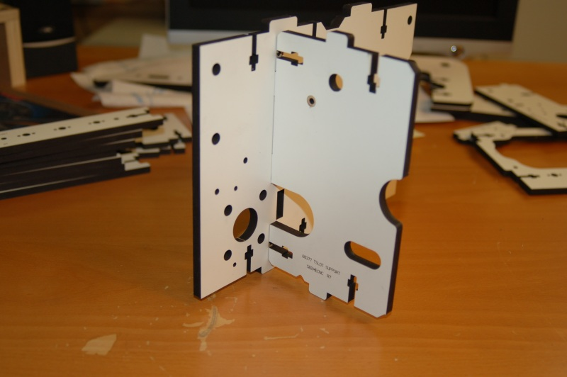

Figure - Dry fitting the T-Slot and Tri-Support together.

***Note that that Fig. 7 above and Fig. 8 below show the T-Slot panel mated to the wrong side of the Tri-Support. Figures 9 and on are correct!***

1.8 - Dry fit the parts as shown in Fig 7 in order to get an idea how they go together. You’ll do this for many steps in the assembly guide. Next, pop out the counter-sink rings on the Tri-Support and install a pair of #6-32 Nylon lock nuts into the notches in the T-Slot Support as shown below.

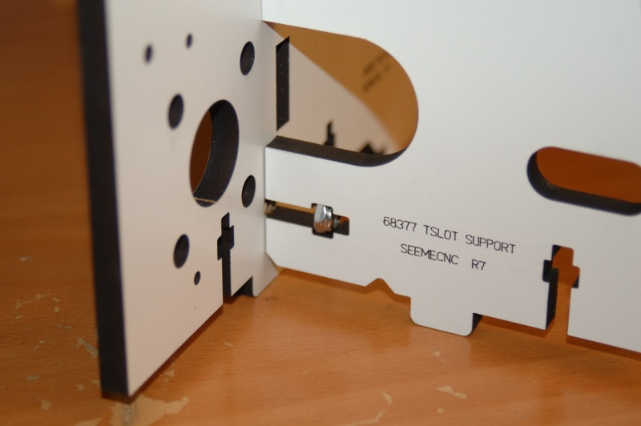

Figure - Lock nut installed in the T-Slot Support.

1.9 - Take two #6-32, 1” long flat head machine screws and attach the T-Slot Support to the Tri Support as shown. Make sure that the counter-sink rings are facing out when you assemble the parts.

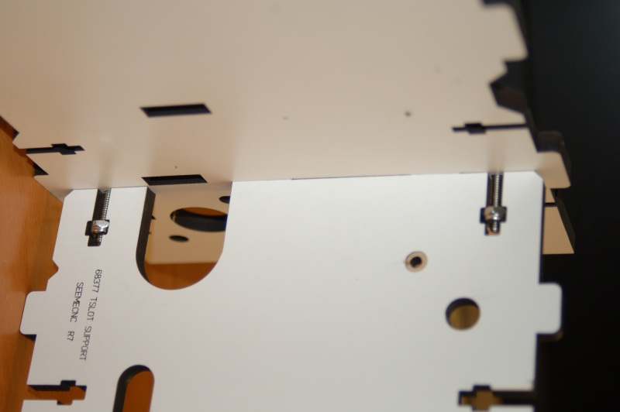

Figure - Tri Support assembled.

1.10 - Install the Motor Mount on the T-Slot Support. You’ll want to insert two #6-32 Nylon lock nuts as shown. Use a #6-32, 1” flat head machine screw to attach the Motor Mount to the T-Slot Support. Do not tighten it down! Drive the screw in only a bit so it engages the Nylon. This will be tightened down when the assembly is installed in the base plate.

1.11 - You may wish to install the stepper motors (Steps #4 & #5 below) and their connectors at this point. It's easier to install the stepper motors on the X & Y axes without the doors in place. (The connectors for the X and Y axis motors can be connected directly to the wires on the stepper motors, but the Z axis requires a short extension to reach the electronics bay.)

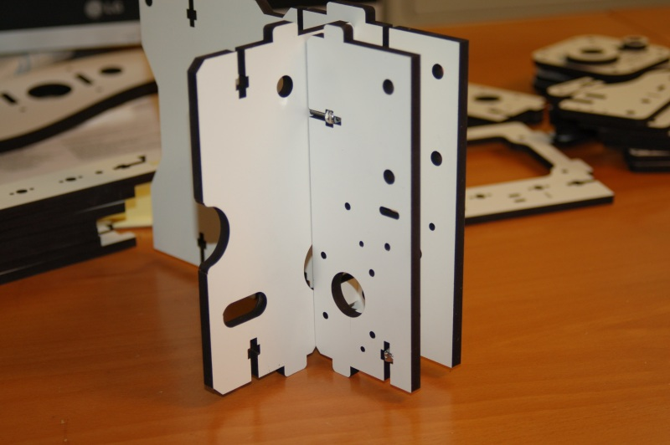

Figure - Motor Mount attached.

1.12 – Install Tri Support assemblies into the base plate. Before mounting in the base, install the #6-32 nylon locknuts - doing them at this stage is much simpler than when the assembly is set in the alignment notches in the base. Also note that the locknuts may not be the same dimension as the notches they go into. They may be slightly over or under-sized depending on how they're measured. The nuts will try to rotate and it makes the fit difficult. If the nut doesn't fit easily, turn it to a new set of faces until it fits properly.

1.13 - Leave the screws a bit loose until all three assemblies are installed. Install first two as shown:

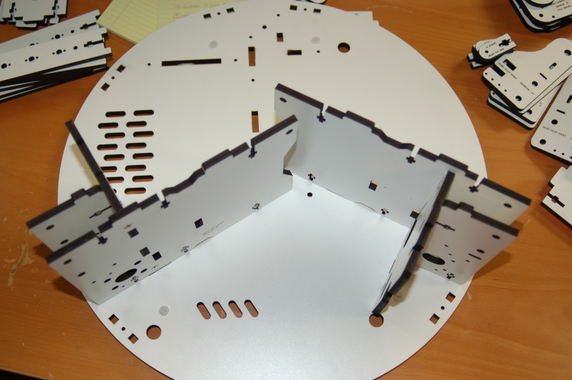

Figure - Two Supports installed.

1.14 - Install Power supply mount in third support – note that it’s a simple friction fit at this point. It gets attached to the base when the whole assembly is installed.

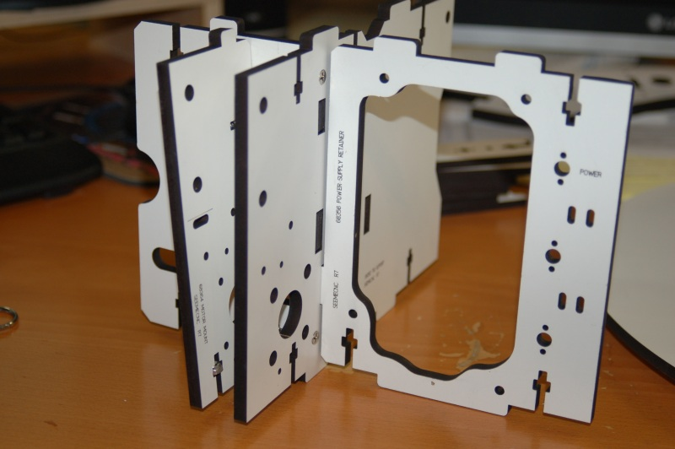

Figure - Power Supply Bracket in place.

1.15 - Place third assembly as shown

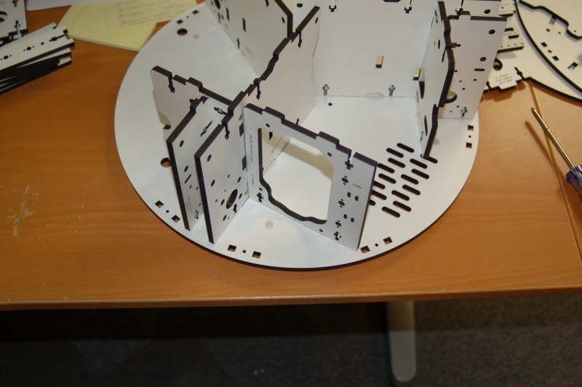

Figure - Final Tri-Support installed in the base.

1.16 - Finally, tighten screws but leave them a little bit loose. Having the components slightly free to move will help when you’re attaching the top to the base.

1.17 - Install Cover Brackets (P/N: 68361). The brackets that are installed to either side of the power supply need to have threads cut in them.

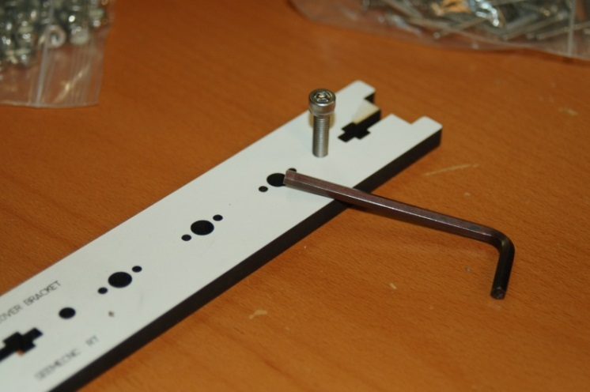

Figure - Cutting threads in the bracket.

1.18 - To cut the threads in the bracket, take a #10-32 socket head cap screw and carefully thread them into the holes at the top & bottom of two brackets. This is where the Nylon thumb screws will be installed in order to hold the plastic wrap-around cover.

1.19 - Using #6-32 Nylon lock nuts and #6-32, 1” flat head machine screws, install the cover brackets in the base.

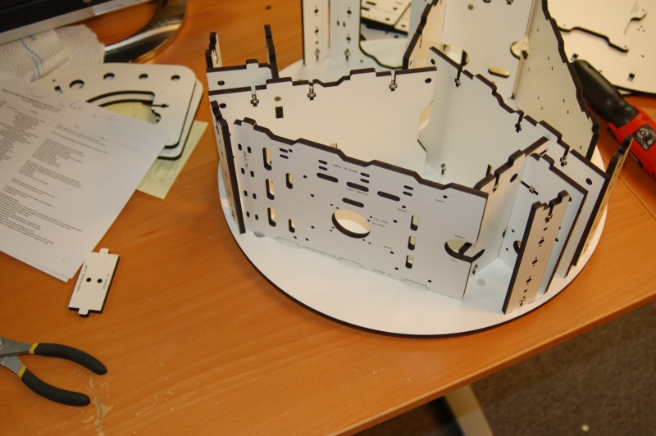

Figure - Cover Brackets and Electronics Door installed.

1.20 – Install Electronics Mount (P/N: 68358) and Support Panel (P/N: 68357). Refer to Fig. 15 above for the location of the Electronics Panel. The door “pin” fits into the hole located next to the X axis T-Slot mount. If you’ve got the version of the door that has the LCD mount in it, you’ll want to swap the doors – install the LCD door where I show the electronics door and the electronics door where I show the Support Panel going. The reason for this is that if, in the future you want to use dual extruders, the second extruder can block your access to the LCD panel if you’ve installed it where the Support Panel would normally be installed. Thanks to cjdavis618 in the SeeMeCNC forums for pointing this out!

1.21 - Install the Support Panel as shown – the door “pin” fits into the hole next to the Y axis T-Slot mount.

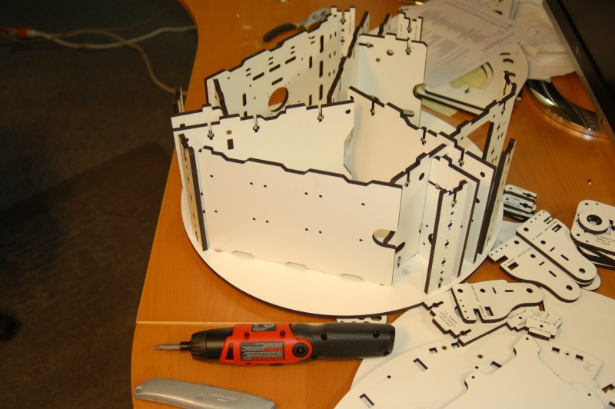

Figure - Support Door installation.

1.22 – Install the Base Top (P/N: 68351). With a razor knife, pop out all the counter-sink rings in the Base Top. Ensure that you’ve got #6-32 Nylon lock nuts installed in the notches in the various vertically oriented components. It’s difficult to install them all when the top is in place. Orient the top so that the Z axis is straight across from the Electronics Panel. **Note, it is recommended that you jump to Section 17 and install the bottom Idler Bearings at this time! Installing them later can be difficult.**

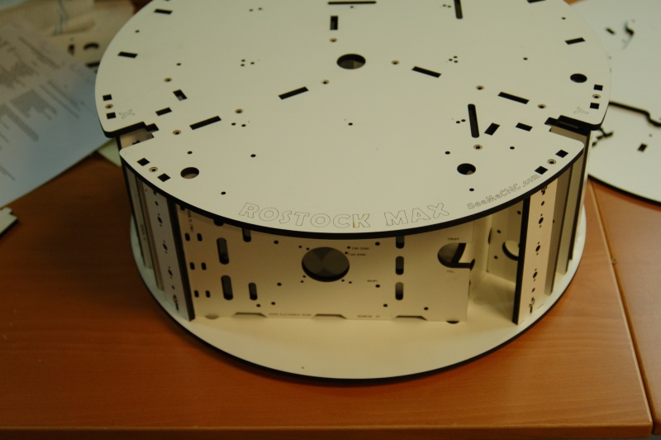

Figure - Base Top Orientation

1.23 - It can be difficult to get all the tabs aligned with the slots in the top of the machine. I recommend that you choose a point, get a few tabs inserted in the base slots and then loosely install a few of the #6-32, 1” flat head screws around that location. This will allow you to work your way around the top getting tabs locked in place without having them pop off areas you’ve already got set in place.

# 2 – Installation of the Heated Bed

2.1 - Identify the nine holes in the top marked with a laser engraved “1”. These holes are where you’ll install nine #4-40 T-Nuts from below. The simplest way to seat the t-nuts is to use one of the heated bed mounting screws and a washer to pull the t-nut into place. Place a t-nut into one of the correct holes and thread in a #4-40 ¾” socket head cap screw with a washer on it. Tighten it down until the tiny prongs have penetrated fully into the Melamine. If you’re building an Acrylic version, the prongs should fit in to the pre-cut notches in the Acrylic. Note that your kit may have been supplied with Philips head screws instead of the cap head screws.

2.2 – Attach the heated bed to Mount Bed Insulator (P/N: 68335) using eight #4-4 ¾” socket head screws. Set a small plastic spacer over each of the mounting holes that you installed a #4-40 t-nut into. Set the heated bed & Bed Insulator in place. Make sure that the solder pads for the heated bed are oriented towards the slot near the Z axis as shown in the below.

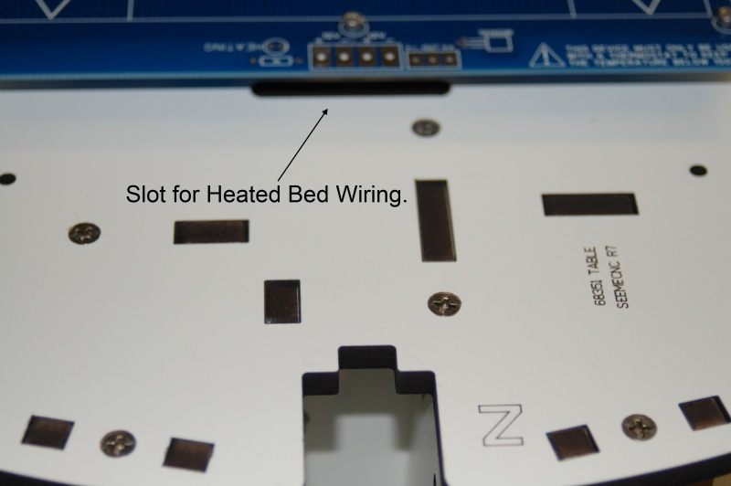

Figure - Heated Bed Position

Note that you’ll need to remove the bed in order to install the wiring for it later on – you may want to just leave the bed off for now, or skip ahead to Section 20 where I cover the wiring of the heated bed.

# 3 – Install Belt Pulleys on Stepper Motors

3.1 – When installing the pulley, make sure you do NOT over-tighten the screws. The belt pulley is made from aluminum and can be stripped out easily. Tighten both screws equally.

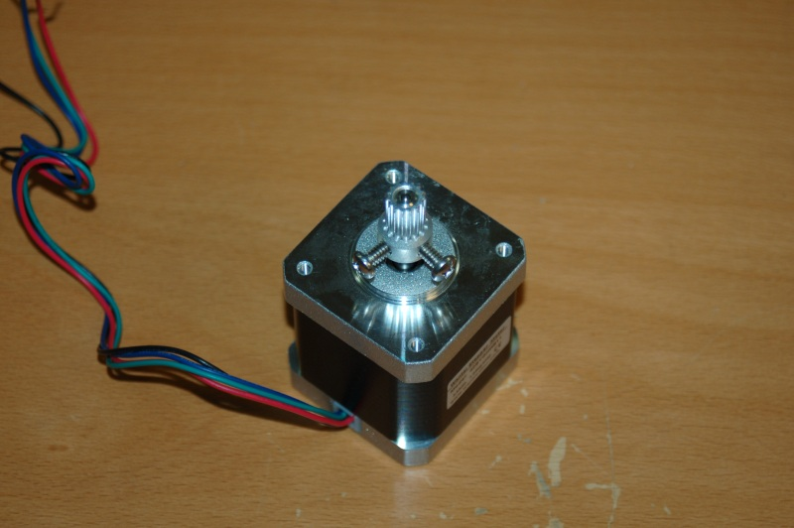

Figure - Belt Pulley Installed

3.2 - Note that if the set screws in your kit are as large as those shown in Fig. 19, you’ll need to install the pulley after you’ve installed the stepper motor in the motor mount. The set screws won’t clear the opening in the motor mount.

# 4 – Install the Connectors on the Stepper Motors

4.1 – If you’re installing the RAMBo or other controller board on the inside face of the electronics mounting plate/door, you only need to add extension wires to the stepper motor for the Z axis. If you’ll be installing the LCD controller, the drive electronics *must* be installed on the inside of the electronics mounting plate. If the electronics are installed on the outside face of the electronics mounting plate, you’ll need to test fit each stepper motor in order to determine which ones will require an extension cable.

4.2 – Using the included wire, the extension wiring pattern goes like this:

Stepper Wire Extension Wire

Red----- ---------------------Red

Black------------------------Black

Green----------------------Green

Blue------------------------White

4.3 - The crimp on connector is wired in this order:

Pin 1 – Red

Pin 2 – Blue (White if using the extension)

Pin 3 – Green

Pin 4 – Black

4.4 - Pin 1 on the connector is indicated by a small triangle pointer that points to the end of the connector. Fig. 20 below shows a 2 pin connector with this pin 1 arrow. The four pin stepper connectors have the same style indicator.

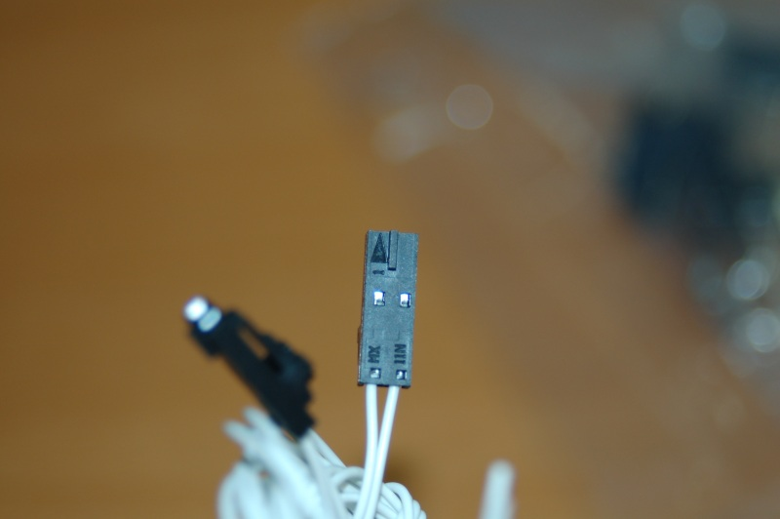

Figure - Pin #1 Indicating Arrow

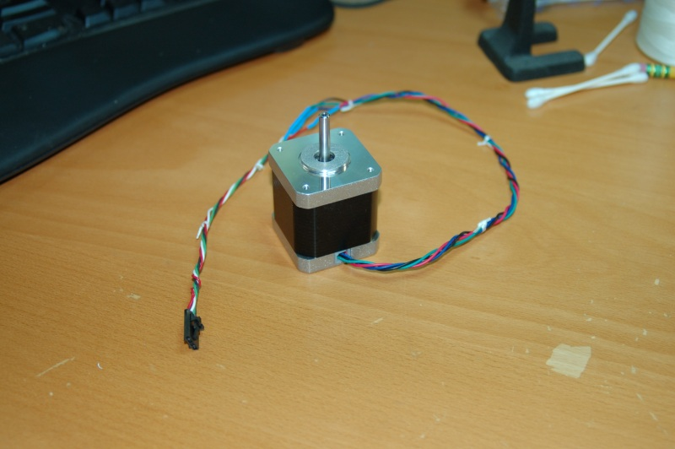

Figure - Stepper motor with connector installed

# 5 – Installing the Stepper Motors to the Motor Mounts

5.1 – The stepper motors are installed using four M3, 10mm pan head screws. I would recommend using #4 star lock washers for extra peace of mind, but these are not included in the kit.

5.2 - Be very careful not to over-tighten the screws as you can easily strip out the holes on the stepper motors.

5.3 - There are access holes directly across from each of the four stepper motor mounting holes – they are there to allow you to install the screws on each motor. A longer than normal screwdriver may help here.

5.4 - At this point you’ll want to install the belt pulley on each motor if you haven’t done so already. Make sure that when you install the pulley, it’s positioned with the teeth aligned in the center of the space as show in Fig. 22.

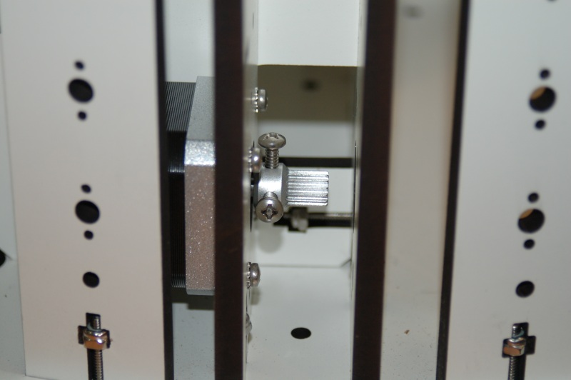

Figure - Pulley correctly installed

# 6 – Installation of the Power Supply

6.1 – Install the power supply as shown in Fig. 23. The power supply is attached to the power supply mount using four #6-32 ½” Nylon pan head screws. You’ll need your flat tip screwdriver for this.

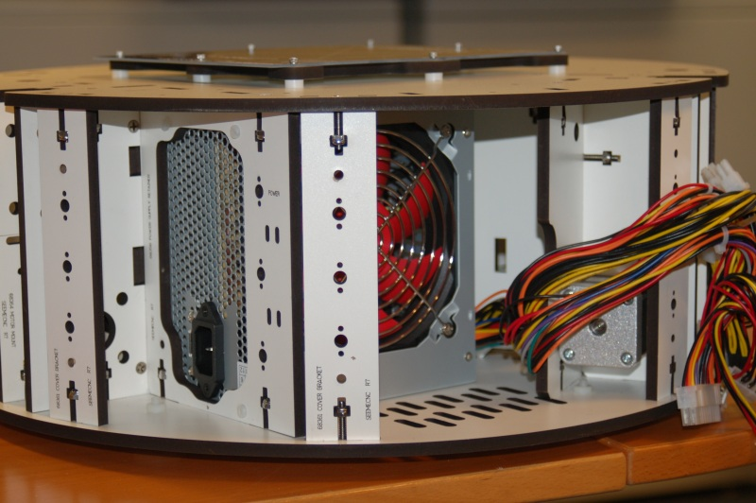

Figure - Power Supply Installation

6.2 - Insert the power supply with the wiring end pointing toward the center of the machine and rotate to the left to set it into position.

6.3 - Do not tighten all four screws until you have them all started, otherwise you’ll only be able to place three of the four. I recommend starting the two screws closest to the Tri Support that the power supply mount mates to.

# 7 – Installation of the RAMBo Controller

7.1 – If you’re planning on installing the LCD control panel, you’ll want to install the RAMBo on the *inside* of the electronics mounting plate.

7.2 - The installation uses four #4-40 x ¾” socket head cap screws, four #4-40 t-nuts, four #4 flat washers and eight of the small plastic spacers.

7.3 - If you're building the Melamine version, don't fold back the prongs on the T-nuts. Instead, take one of the mounting screws and a #4 washer and use that to set the T-nut into the mounting panel as shown below:

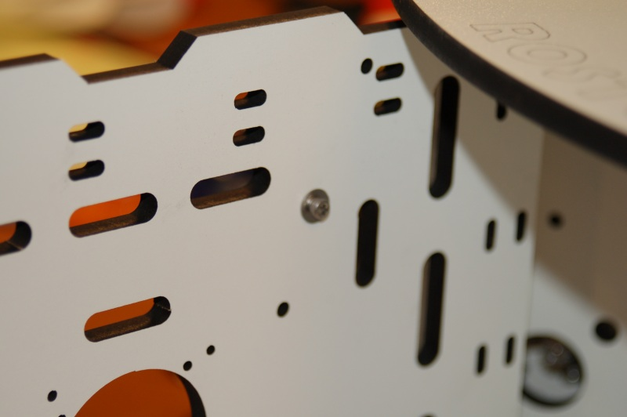

Figure - Installing the T-Nuts, front side

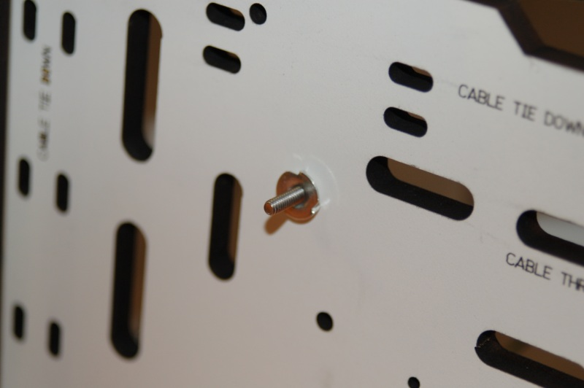

Figure - Installing the T-nuts, back side

7.4 – If you’re installing on the inside of the mounting plate, orient the RAMBo such that the stepper motor connectors are towards the bottom of the mounting plate. This allows the USB cable to exit through the finger notch on the door.

7.5 - If you’re mounting to the outside, orient the board such that the stepper motor connectors are close to the top of the mounting plate.

7.6 - The SeeMeCNC assembly video shows using one plastic spacer on either side of the board. I chose to install the board with both spacers stacked behind the circuit board. Take care not to over-tighten the screws or you could crack the circuit board.

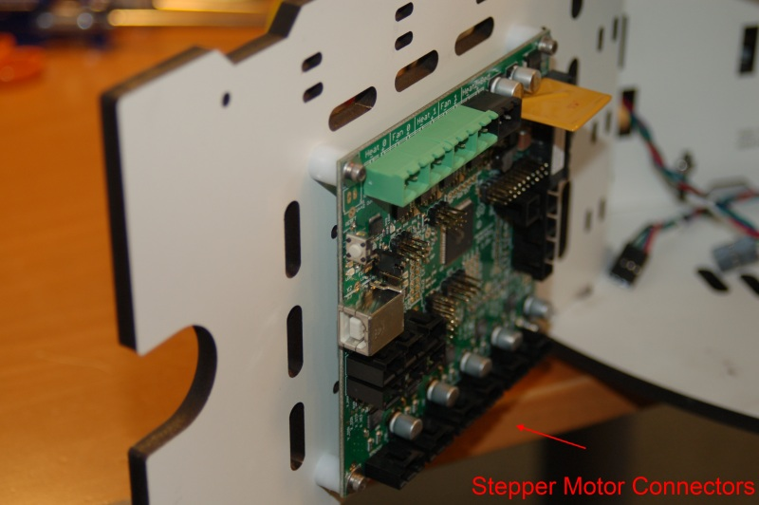

Figure - Mounting the RAMBo

# 8 – Installing the T-Slot Hardware in the Base

8.1 - Installing the three T-Slot rails uses 12 each of the 1/4-20 x 1/2" button head cap screws and 12 each of the 1/4-20 t-slot nuts.

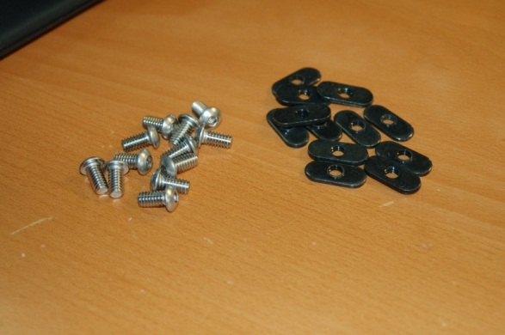

Figure - T-Slot Hardware

8.2 - When installing the fasteners, orient the t-slot nut with the "boss" or protruding thread area facing the inside of the T-Slot rail as shown below:

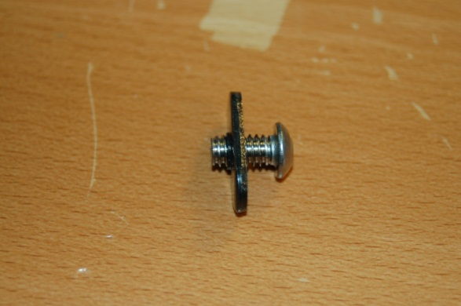

Figure - Orientation of T-Nut Boss

8.3 - Install four screw/nut pairs in each rail location as shown below

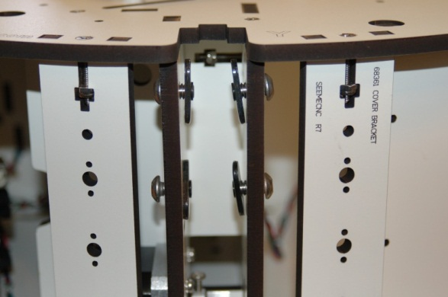

Figure - T-Slot Nuts Installed

8.4 - The nut should only be installed about one turn. There needs to be room for the rail to slide easily for installation in the next step.

8.5 - Carefully slide the three rails over the t-slot nuts - the fit may be a bit tight if you don't have the t-nuts loose enough.

Slide rail down to meet the scribe line marked on the panel.

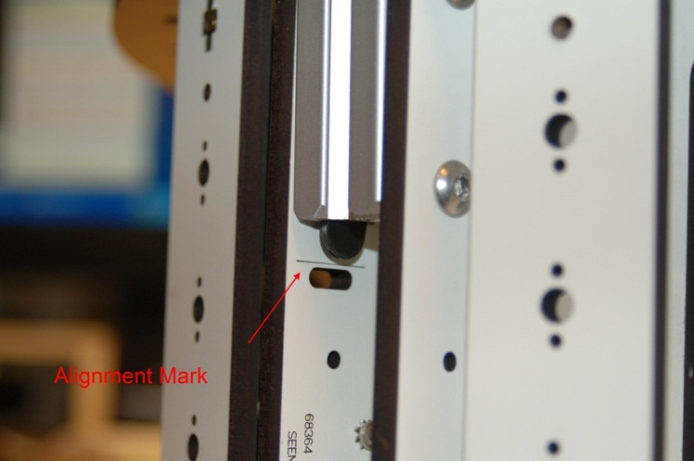

Figure - Rail Installed to Alignment Line

8.6 - Tighten screws only enough to hold the rail in place - this will be adjusted and tightened up later in the build process.

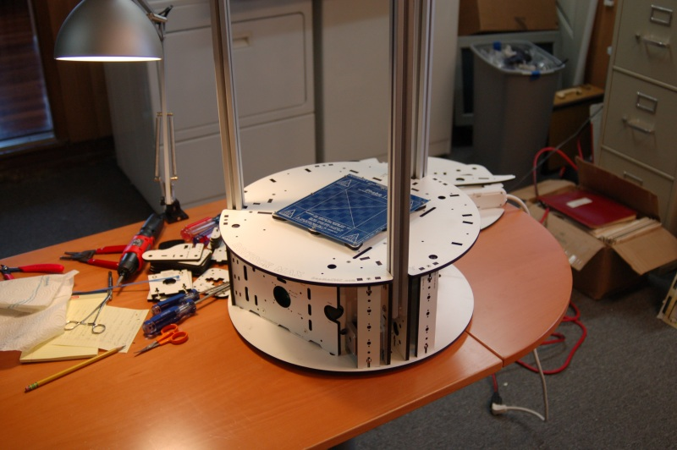

Figure - All Three Rails Installed

# 9 – Assembling and Installing the Idler Mounts

9.1 - Assemble the three Idler Brackets from the six Idler Mount parts (P/N: 68369) and the three Top Clamps (P/N: 68370)

9.2 - Insert the remaining 1/4-20 button head screws as shown in the photo below.

9.3 - Note that you may want to keep the writing facing "in" in order to make sure the horizontal alignment mark is visible.

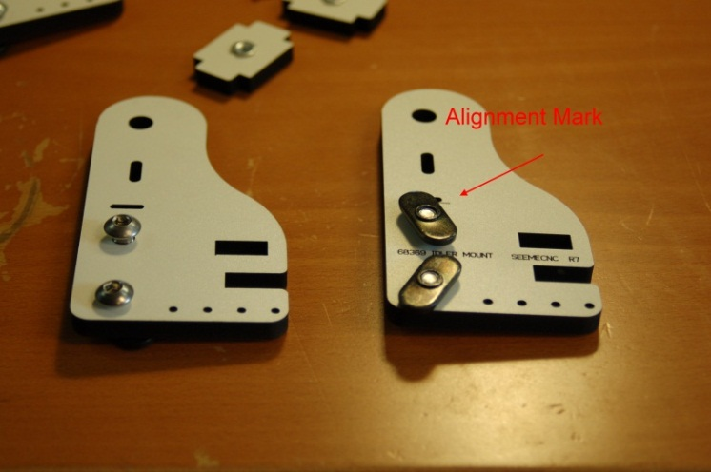

Figure - Button Head Screws Installed

9.4 - Assemble each Idler Mount as shown below and then attach them to the top plate as shown in Fig. 34.

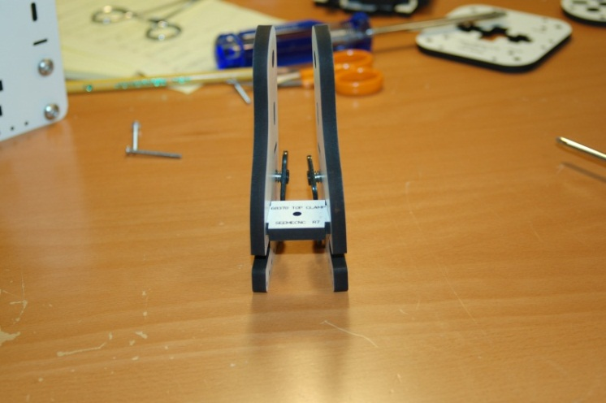

Figure - Idler Mount Assembled

9.5 – Install each Idler Mount to the Top Support Plate (P/N: 68368) as shown below:

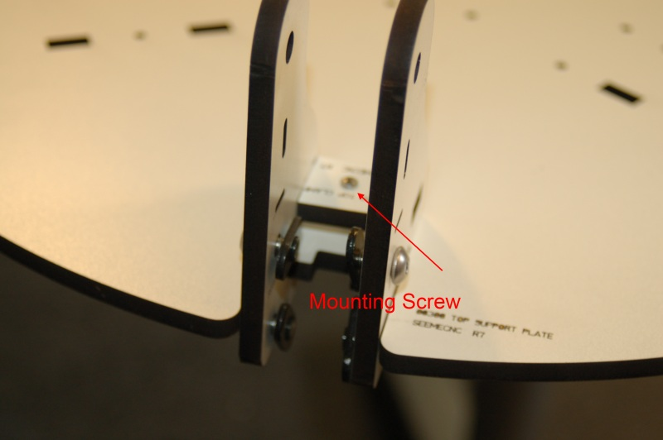

Figure - Idler Mount Installed

9.6 - Note that the mounting screw shown in Fig. 34 is a #4-40 1-1/4” machine screw that is threaded into a #4-40 T-Nut that’s installed on the underside face of the Top Support Plate.

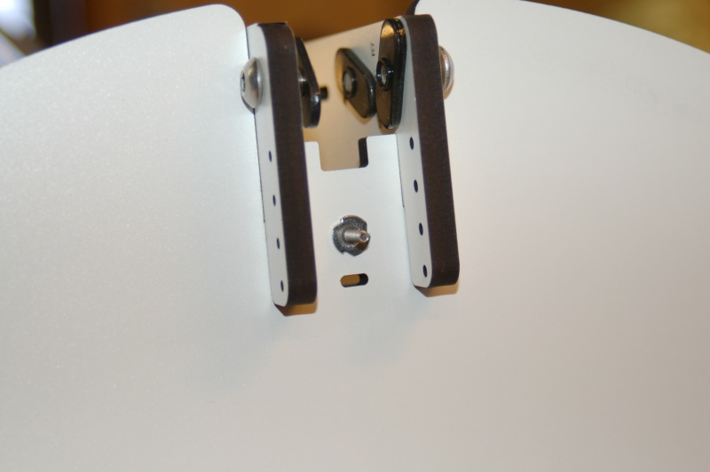

Figure - Mounting Screw and T-Nut

# 10 – Installing the Top Support Plate

10.1 – Attach the Top Support Plate to the mounting rails. Finger tighten the button head screws after you’ve got the Top Support Plate installed. The Idler Brackets get a final adjustment and tightening later.

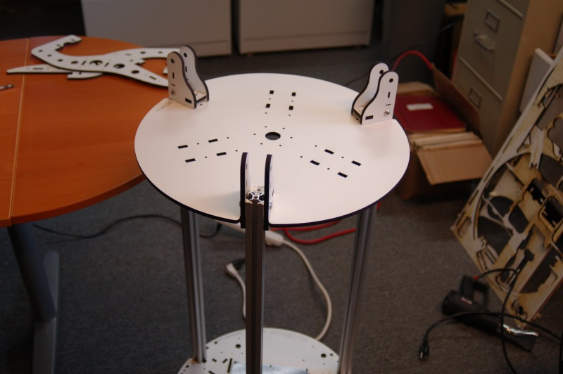

Figure - Top Support Plate Installed

# 11 – Tighten the Rails at the Base

11.1 - Make sure the bottom of the rail aligns with the laser engraving marks and then tighten the T-Slot bolts for the base. A hex wrench with a “T” handle will be handy for this step. A builder suggested that a ball-end hex tool would well here due to the odd entry angle when trying to reach the screws through the side door gap.

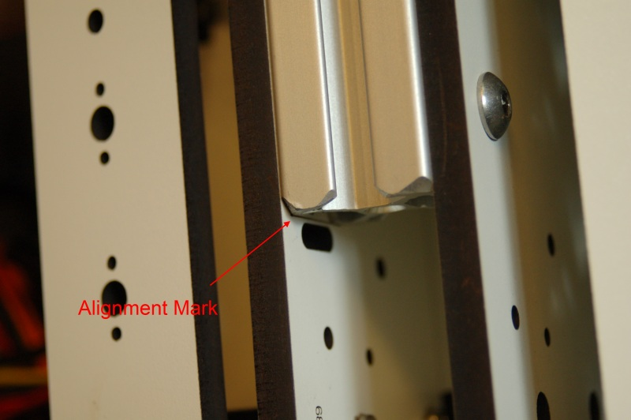

Figure - Rail Bottom Aligned with Mark

# 12 – Adjusting the Top Support Plate

12.1 - Pick a tower and align the Idler Mount's engraved reference line to the top of the rail and tighten all four bolts - make sure that ***BOTH*** reference lines are aligned with the top of the rail. I chose the Z axis to begin this step.

**MAKE SURE THAT THE IDLER BRACKETS ARE FLAT AGAINST THE INSIDE SURFACE OF THE T-SLOT RAIL MATERIAL!**

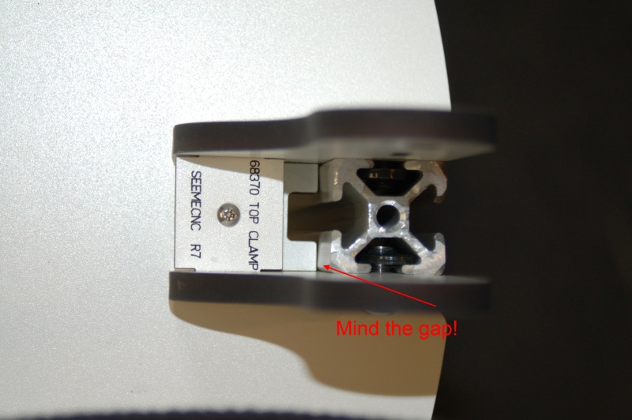

Figure - No gap between the rail and top!

12.2 - If any gap is present here, the machine will be misaligned and cause you no end of problems. If you cannot get the gap closed on a tower, loosen the base of the rail a little bit. This will often allow the gap to be closed at the top. Just don’t forget to re-tighten the base and make sure it hasn’t moved off the alignment line!

12.3 - Using your tape measure or meter stick, measure from the bottom of the top base plate (the part that the heated bed is attached to) to the top of the top plate. Record this measurement. The measurement on mine came out to 715.5mm

12.4 - Using the measurement you obtained in the prior step, adjust the other two towers to match that distance and tighten down the four bolts on each Idler Mount as you go.

Make sure you measure on both sides of the Idler Mount. Each side will float a bit until the Top Clamp screw is tightened.

12.5 – Tighten the screws in the top of each Idler Bracket to lock the Top Plate in place.

# 13 – Assembling the Filament Spool and Extruder Bracket

13.1 - The filament spool mounting bracket is made from two arms (Filament Spool Bracket P/N: 68392) attached to the Extruder Brackets (P/N: 68387). The three Extruder Support Spacers are also used (P/N: 68388). Using your box cutter, pop out the countersink rings at the ends of the extruder brackets and the filament spool brackets.

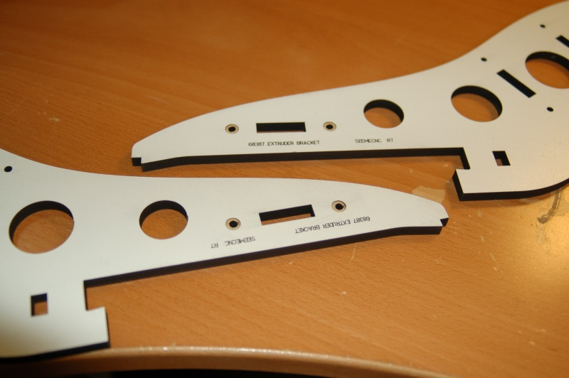

Figure - Countersink Rings in the Extruder Brackets

13.2 - Attach the filament bracket and the Extruder Support Spacers as shown in Fig. 40.

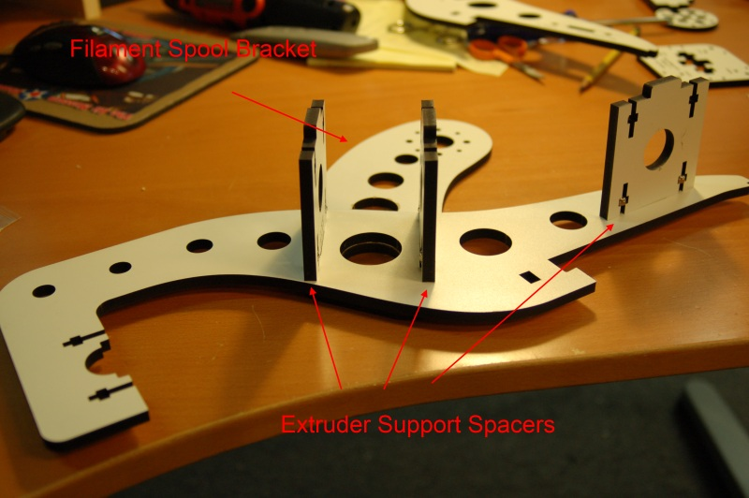

Figure - Filament Spool Bracket and Extruder Support Spacers

13.3 - Install Extruder Clamp (P/N: 68389) and then install the other half of the Extruder Support Bracket & Filament Spool Bracket.

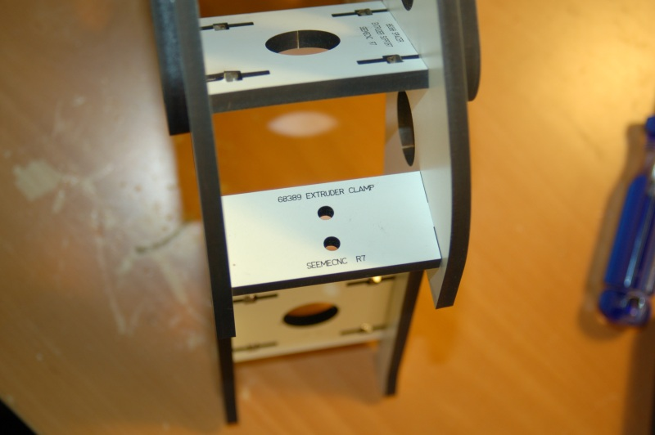

Figure - Extruder Clamp & Extruder Support Bracket

13.4 - After assembly you can hang the extruder on the machine like so:

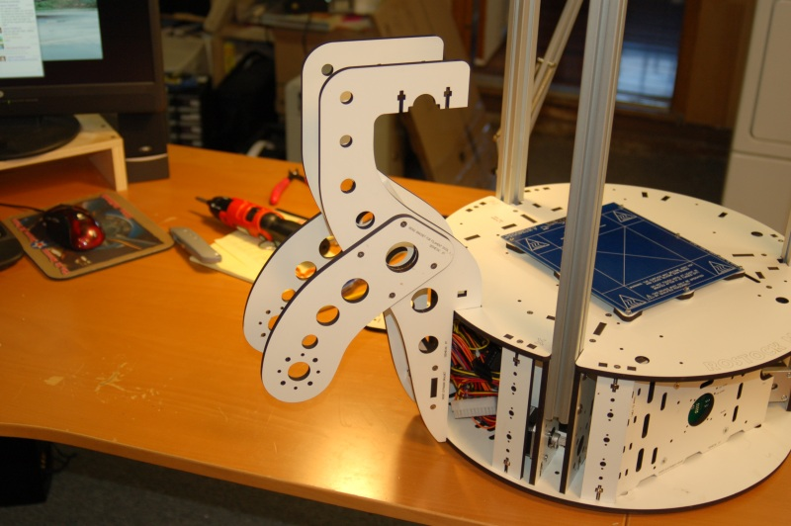

Figure - Filament Spool & Extruder Support in the operating position.

13.5 – Install the Extruder Mounting Plate (P/N: 71534). The Extruder Mounting Plate attaches to the Filament Spool & Extruder Bracket using four #6-32, 1” long flat head screws and four #6-32 nylon lock nuts.

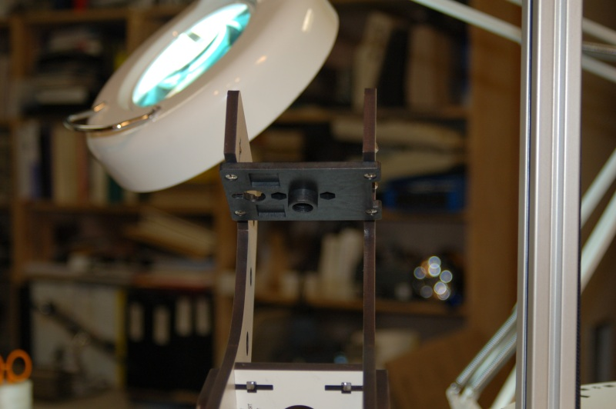

Figure - Extruder Mount Installed

13.6 – Install the Bowden fitting to the Bowden Drive PTC adapter:

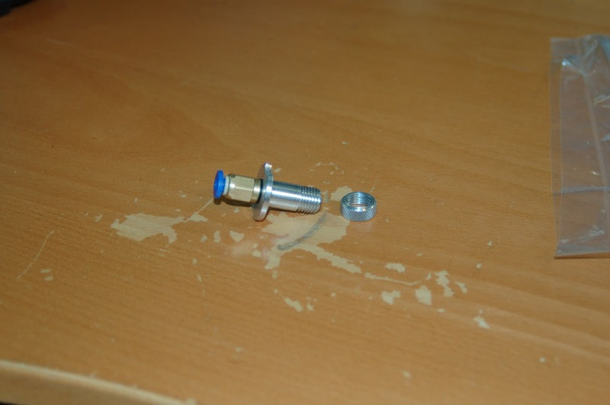

Figure - Bowden fitting on Bowden Drive PTC Adapter

13.7 - Take care not to over-tighten the adapter – you want a good seal with the O-ring and that’s it.

13.8 – Install Bowden Drive PTC Adapter on Extruder Mount Plate.

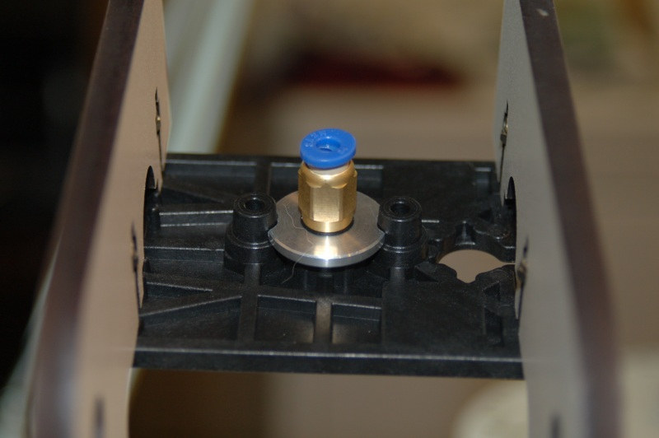

Figure - Bowden Drive PTC Adapter Installed

Set this assembly aside for now – it won’t be needed for a while.

# 14 – Assembling the Extruder

14.1 – I’m going to cheat on this one and point you to the assembly video that PartDaddy (Steve) published on YouTube - <https://www.youtube.com/watch?v=mua3i_wP32I>. He does an excellent job in describing how the extruder is constructed. He designed it after all!

14.2 - I assembled mine using a vice with soft jaw covers to install the bearings in the gears as well as install the drive gear on to the stepper motor. Please take care when installing that gear – you need to ensure that you’re applying force straight down with no angular component or you’ll break the gear or bend the stepper motor output shaft.

14.3 - I created a short video that describes some of the less clear elements of assembling the extruder here: <http://youtu.be/rAVlvRuHuE8>.

# 15 – Building the Carriage

15.1 - Get three of the six short steel rods, the two platform halves (P/N: 68304) and six of the CNC cut U-Joints (P/N: 68309).

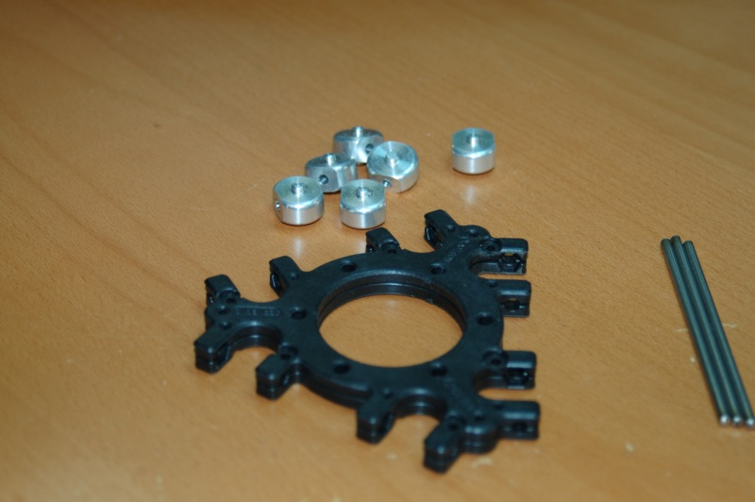

Figure - Platform Halves, U-Joints and U-Join Axles

15.2 - The first step is to assemble the platform halves and then start test fitting each of the U-Joints.

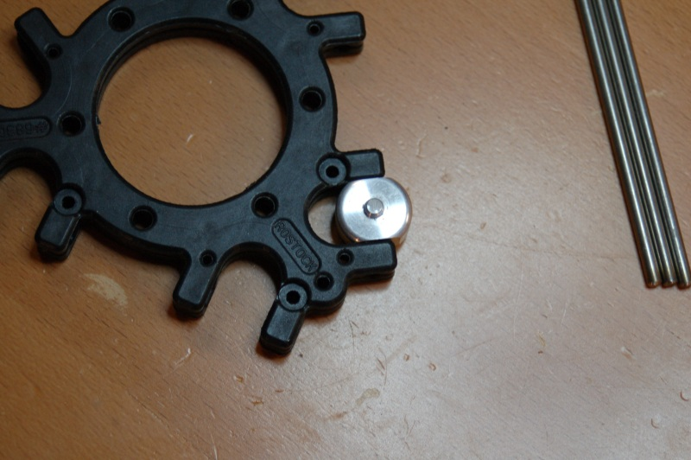

Figure - Test fitting the U-Joint

15.3 - The U-Joints will be tight. Take your file or sandpaper and clean up the sides where the U-Joint makes contact. You want to remove enough material to loosen up the friction, but not introduce any side-to-side play in the part. Do this for all six U-Joint locations.

You may want to insert one of the U-Joint axle rods to help get a feel on how much force is needed to turn the U-Joint. Just remember, you don't want any side-to-side play in how the U-Joint fits.

15.4 - Install U-Joints and the U-Joint axles (the steel rods)

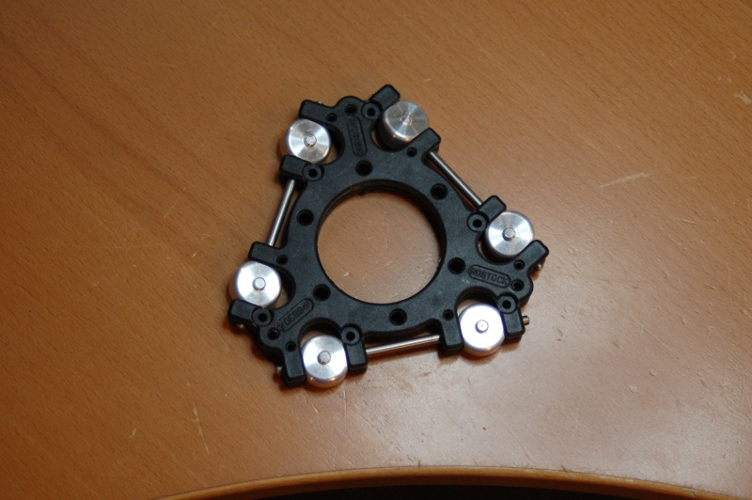

Figure - U-Joints and U-Joint Axles Installed.

15.5 - You can install these parts by either setting the U-Joints in place and then sliding the axles in from the end, or put the U-Joint on the axle, set them into one half of the platform and then fit the other platform half in place when you're done.

15.6 - Join the two platform halves using 12 #4 x 1/4" sheet metal screws.

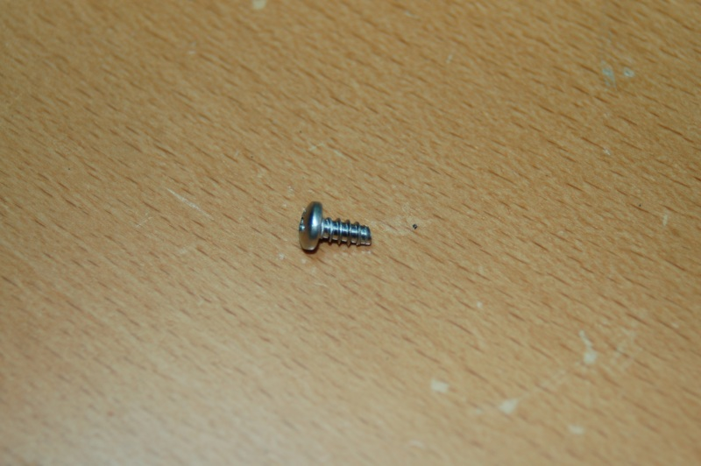

Figure - #4 x 1/4" Sheet Metal Screw

15.7 - Six screws are used on the top, six on the bottom. Use a P1 Philips screwdriver for this. Take care not to over-tighten the screw or you could damage the screw holes - the plastic is pretty soft. After you've got the screws in, work each U-Joint for a bit to make sure that it moves freely.

15.8 - If you have one that's very tight, loosen the screws on that side, withdraw the axle, remove the U-Joint and file it down a bit more, carefully checking it before putting it back together.

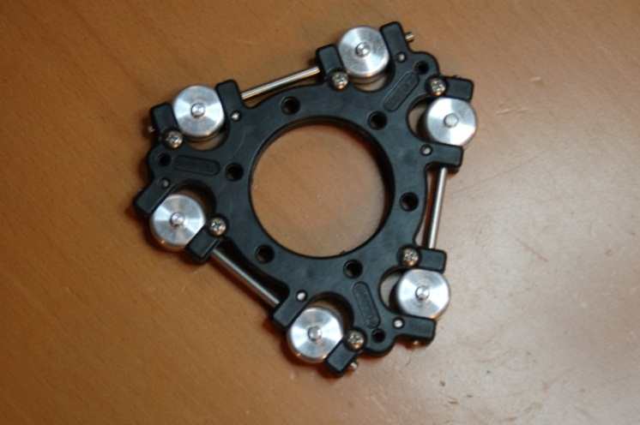

Figure - Screws Installed.

15.9 - Now you need to grab the six Parallel Delta Arms (P/N: 68303) and "adjust" them.

15.10 - The arms have square corners, but they should have a radius to them. To do this, grab a sheet of 100 grit sandpaper or a good file and sand the corners so they look like the photo below. (Sanded arm on the left, un-sanded on the right)

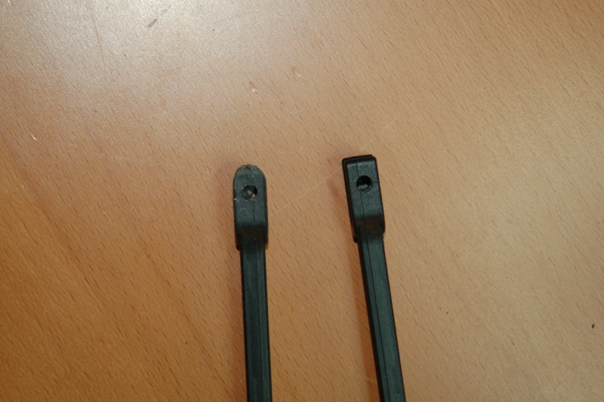

Figure - Radius Sanded in Arm End.

15.11 - After sanding the radius, you'll want to remove the flashing on the ends of the arms so that they'll grip the U-Joints about the same as you did on the platform. The idea is to just reduce the friction, not make them loose in the joint.

15.12 - Now fit the delta arms to the U-Joints. Snap them on to the U-Joints that are attached to the platform. Use a twisting motion to get them on there. They're tight, but they will fit.

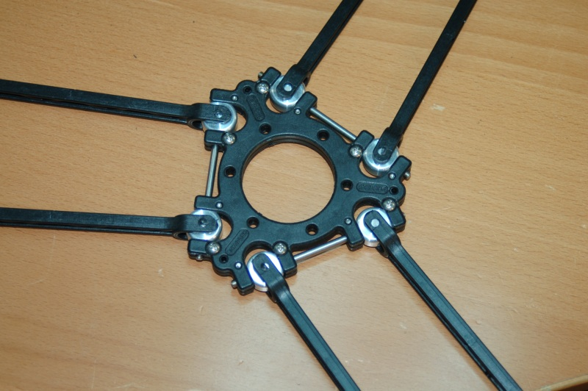

Figure - Arms Installed on the U-Joints

15.13 - Next, grab the Carriage U-Joint mounts, six CNC U-Joints, the package of #4 x 3/8" sheet metal screws and the last three axle rods.

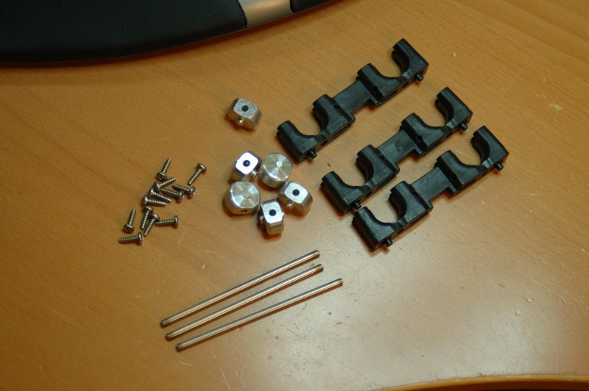

Figure - Carriage U-Joint Mount Parts.

15.14 - You'll want to use the same sanding procedure as on the platform to ensure that the U-Joints fit well in the mounts. However, you'll want to slide the U-Joint you're working with on to an axle and use that to ensure proper alignment in the mount.

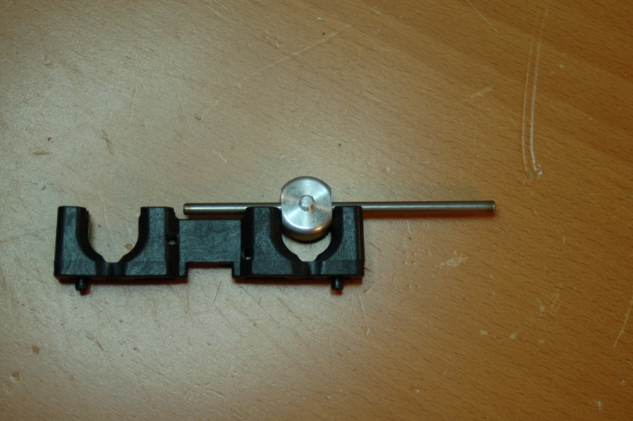

Figure - Test Fitting the U-Joint

15.15 - You might want to complete step #16 and THEN sand the components - apparently mounting the parts deforms the plastic a bit and may require further sanding after installation.

15.16 - Now it's time to mount the Carriage U-Joint mounts to the Arm Plates (P/N: 68344)

This requires six #6-32 Nylon lock nuts and six #6-32 x 5/8" Cap head screws.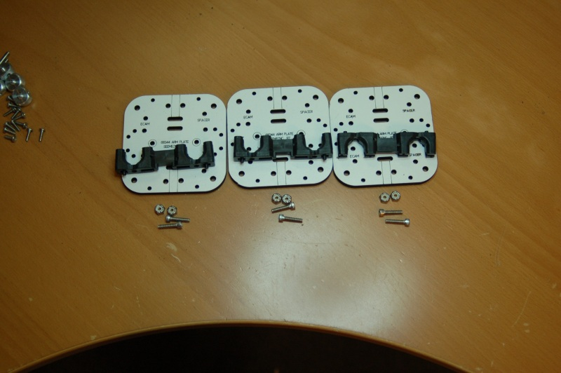

Figure - Carriage U-Joint Mounts and Arm Plates.

15.17 - Assemble each unit as shown in the picture, paying attention to how the Arm Plate is oriented.

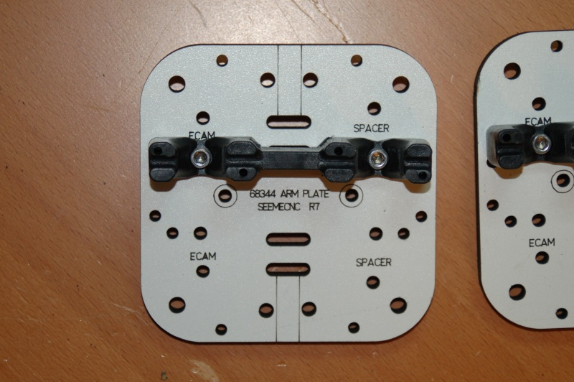

Figure - Assembled Arm Plate

15.18 - Fit the U-Joint and their axles in the mounting plate. Note that the mount may be gripping the U-Joint more tightly. File until it fits the same as before.

15.19 - Now lock the axles in place using the #4 sheet metal screws. Take care to examine how the axle sits in the carriage grooves - you may need to file the sides a bit to get the axle to fully seat.

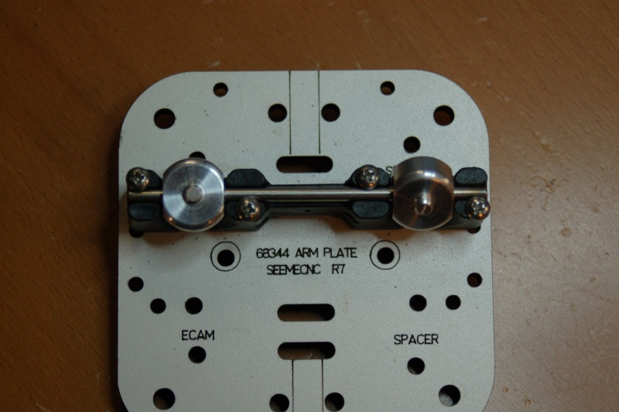

Figure - Arm Plate with U-Joint Mount in Place.

# 16 – Assembling the Cheapskate Bearings

16.1 - For this step, you'll need the three Carriage Plates (P/N: 68343), the remaining CNC machined aluminum hardware that was in the same bag with the U-Joints, the 608 bearings, and the machined plastic bearing sleeves.

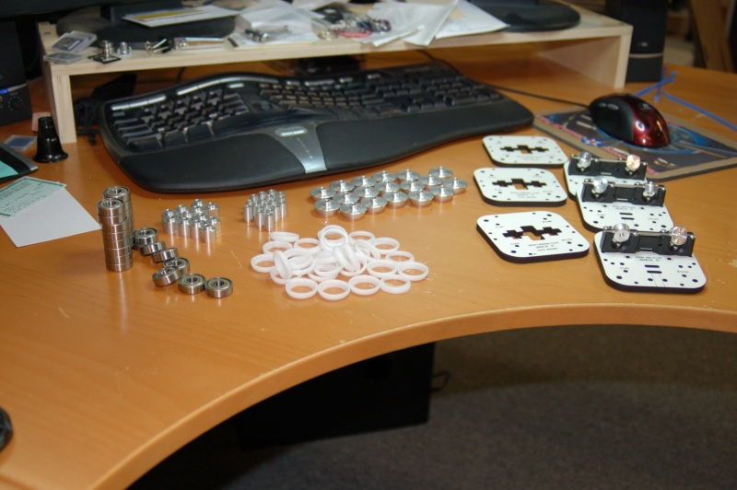

Figure - Cheapskate Bearing Components

16.2 - Install the bearing sleeves on to the 608 bearings. Make sure to carefully de-burr the plastic sleeves and remove any flashing from the rim of each one. Take care to not damage the outside surface of the sleeves.

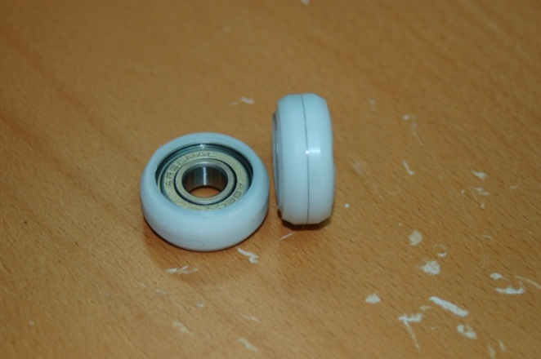

Figure - Bearings with Acetal Sleeve Installed.

16.3 - Next we'll get the 3 Cheapskate bearings built. For this step you'll need the package of #6-32, 2" machine screws, the #6 washers, the #6-32 x 1.75" cap head screws, the bag of #6-32 Nylon lock-nuts, #4-40 x 1/2" socket head cap screws, #4 washers and #4 T-Nuts. Make sure when assembling the Cheapskate that the text on the faces of the Melamine or Acrylic parts face the same direction. Note that it may be easier to install the #4-40 T-Nuts for the next step at this stage. If you're using Acrylic, you'll want to flatten the prongs on the T-Nuts. Insert two #6-32 machine screws with #6 washers in the holes marked "SPACER" and install spacers on the other side.

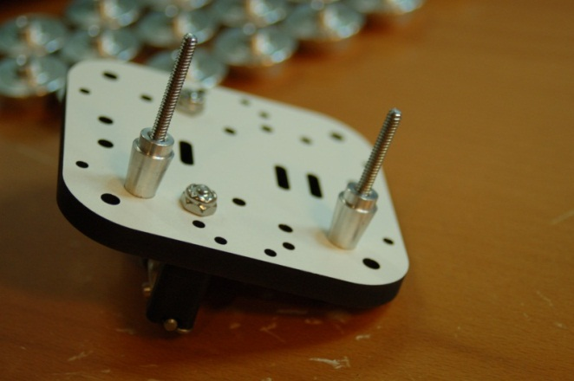

Figure - Bearing Spacers Installed.

16.4 - Install two bearings on to the spacers

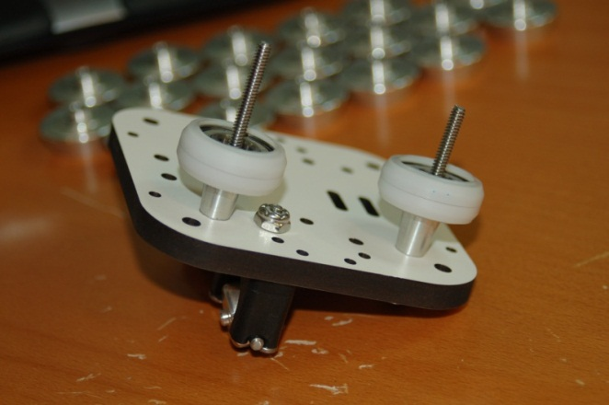

Figure - Bearings Installed.

16.5 - Now install two more spacers on the bearings.

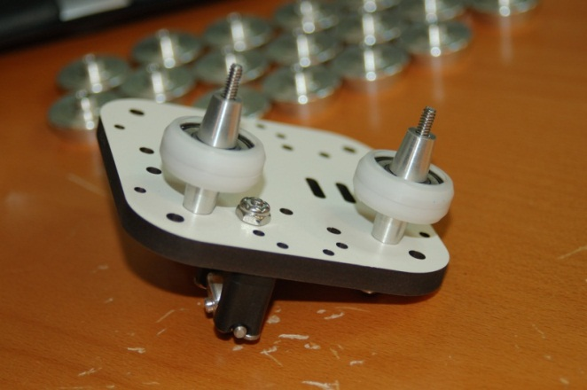

Figure - Last Spacers Installed

16.6 - Place the Carriage Plate on to the machine screws in the holes marked "SPACER"

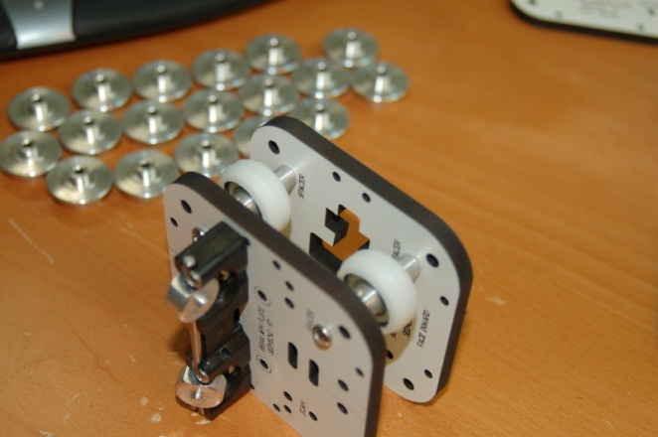

Figure - Carriage Plate Installed

16.7 - Install #6 washers and #6-32 nylon lock-nuts, finger tight

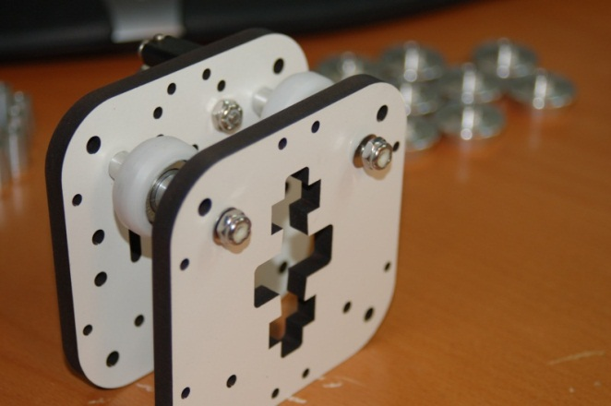

Figure - Lock Nuts on Finger Tight.

16.8 - Attach belt clamp to the carriage. Install two #4-40 T-Nuts as shown

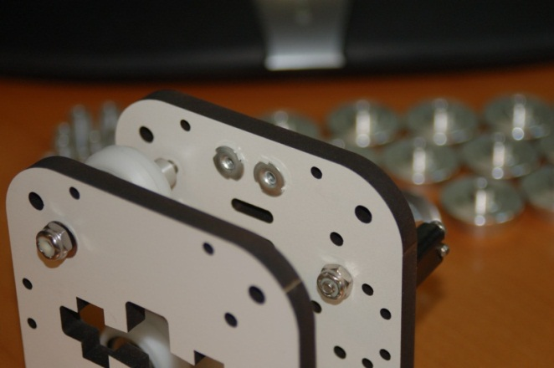

Figure - T-Nuts Installed

16.9 - Next, fold the belt clamp in half as pictured.

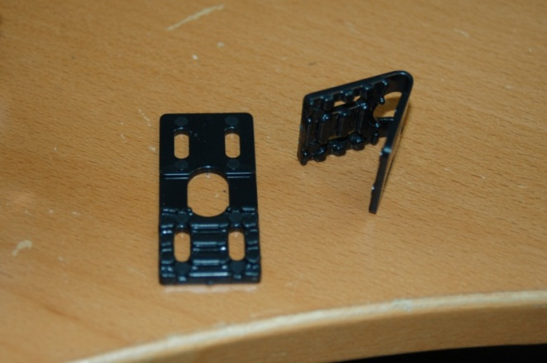

Figure - Folded Belt Clamp

16.20 -Install the belt clamp with two #4-40 cap head screws with the "open" end of the clamp oriented as shown in the photo below.

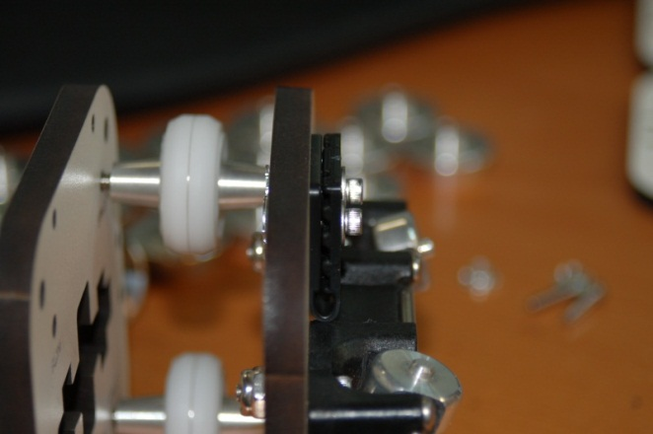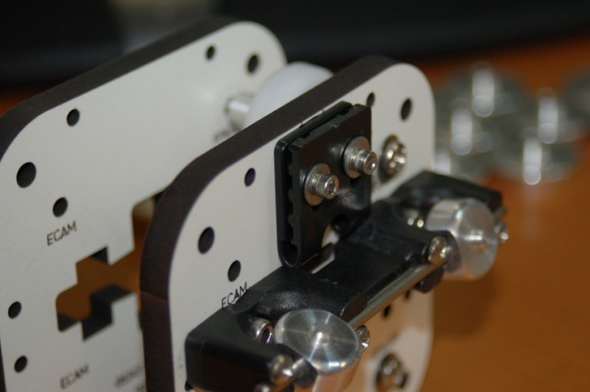

Figure A & Figure 67B – Upper Belt Clamp Installed

16.21 - Install the other belt clamp as shown:

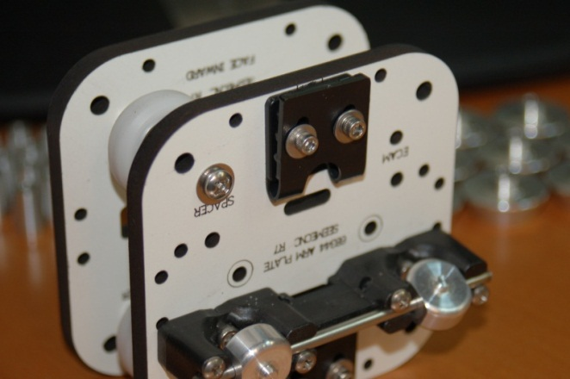

Figure - Lower Belt Clamp Installed

16.22 - Prepare the Axle Supports (P/N: 68381) for installation. Insert a #6-32, 2" machine screw and washer into the end of the axle support.

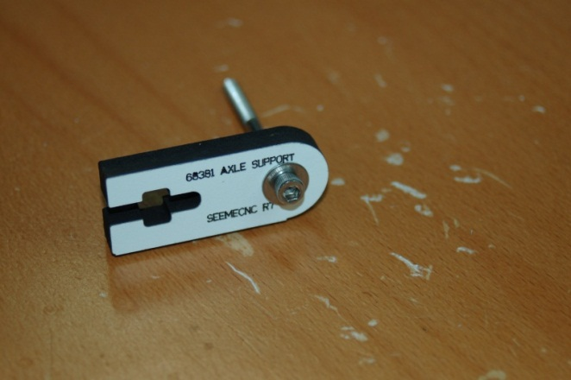

Figure - Axle Support and bearing screw

16.23 - Next, install two spacers, a bearing and the opposite half of the axle support as shown - finally install a #6 washer and #6-32 nylon lock nut (finger tight).

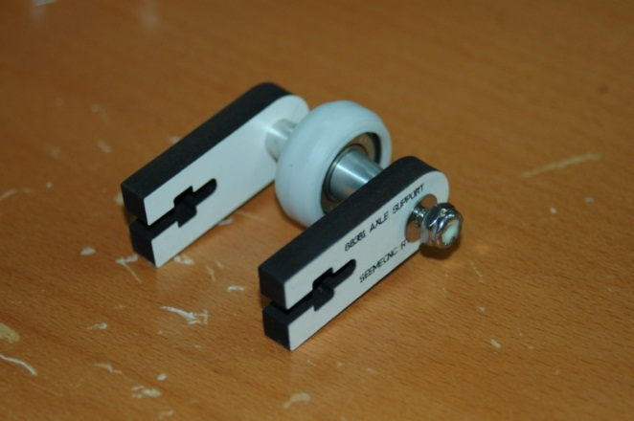

Figure - Assembled Axle Support

16.25 - Insert a #6-32 nylon lock-nut into the base of each support as shown.

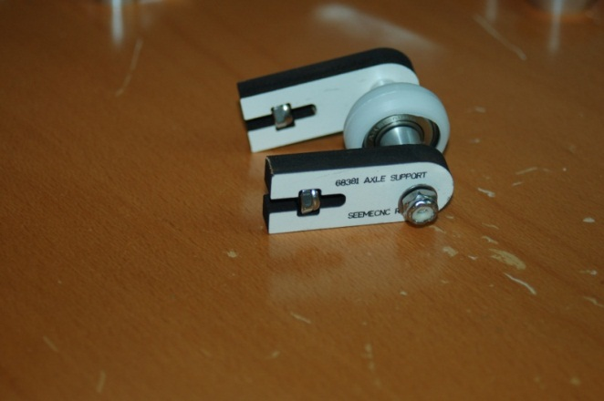

Figure - Axle Support with Lock Nuts Installed

16.26 - Construct the other two Axle Supports the same as this unit.

16.27 - Install Cheapskate bearings on the rails. Orient the bearing as shown below:

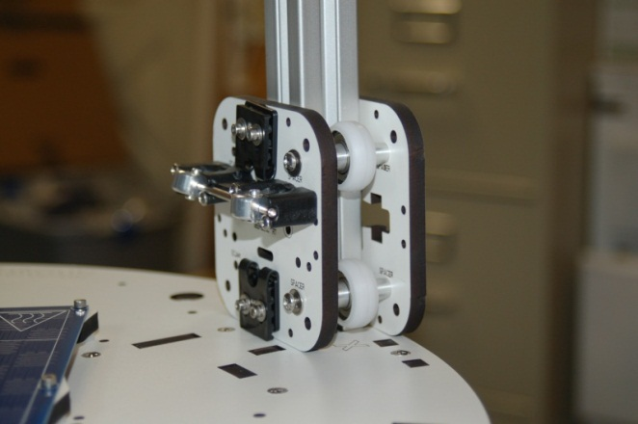

Figure - Cheapskate on Rail

16.28 - Take two eccentric cams and one bearing, assemble as shown:

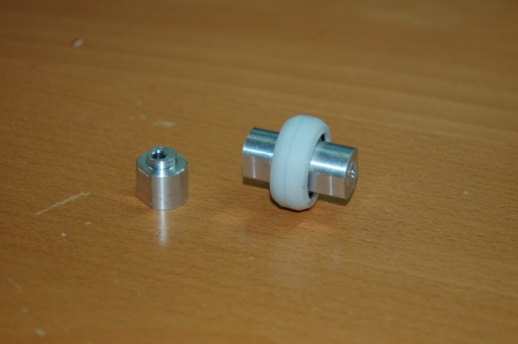

Figure - Bearing and Eccentric Spacers

16.29 - Install the bearings using a 2" #6-32 screw, 2 #6 washers and a #6-32 nylon lock nut as pictured below. The screws go into the holes marked "ECAM". To make the installation easier, make sure you've got the center holes in the eccentric cams lined up or the screw won't go in easily.

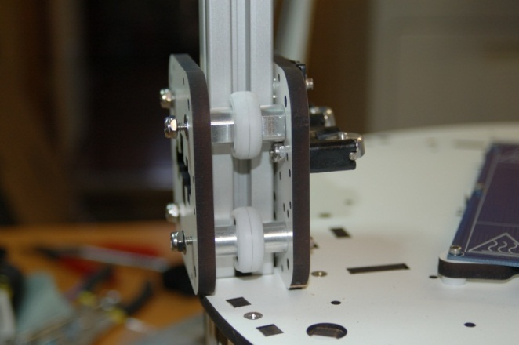

Figure - Eccentric cams & Bearings

16.30 - Do this for all three Cheapskate assemblies.

16.31 - Install Axle Supports. Installing the Axle supports requires 2 #6-32 1" flat head screws each. You may need to lightly sand the Axle Supports in order to get them to fit. Do NOT force them - you'll break the bearing assembly if you use too much force.

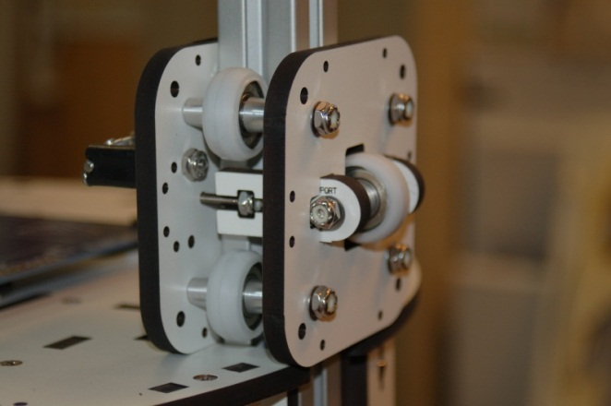

Figure - Cheapskate with Axle Support Installed.

16.32 - Tighten it down! Tighten down the "fixed" bearing sets first - the ones *without* the eccentric spacers. Now tighten down the eccentric bearing side, but not as tight as you did the fixed side. You want it loose enough to move the eccentric spacers. While adjusting the eccentric spacers, make sure you adjust on either side of the bearing equally.

16.33 - Adjust the top eccentric spacers "UP” (Facing the Cheapskate, rotate the eccentric in a counter-clockwise fashion) until the bearing has a good grip on the T-Slot extrusion.

16.34 - Adjust the bottom eccentric spacers "DOWN" (Facing the Cheapskate, rotate the eccentric in a clockwise fashion) until the bearing has a good grip on the T-Slot extrusion.

16.35 - You don't want the bearings gripping the rail too tightly - the Acetal bearing covers will develop a flat spot overnight if you do. You want to adjust the side eccentrics to remove a lot of the side-to-side "Wiggle". When you've got it where you want it, you can adjust the Axle Support assembly to remove any remaining backlash and tighten down the screw holding the eccentric side in place. Please make sure when adjusting the Axle Support screws that you tighten each one evenly so that the bearing remains square to the rail.

16.36 -When you've got it adjusted, make sure you run the bearing up and down the rail a few times, putting roughly 15-20lbs of pressure against it to wear in the Acetal a bit - you'll need to tweak your adjustments after this process. (The video explains it pretty well about at the 1:38 mark)

Repeat this procedure for the other two Cheapskate bearings.

16.37 - Install the delta arms! Just like you did when mounting the arms on the platform U-Joints, give the arms a little twist and they should snap right on. Make sure the U-Joints on the Cheapskates still move freely before you install the arms. Fair warning, installing the arms is a bit like wrestling an octopus. :)

# 17 – Idler Assembly

17.1 - Using the 9 remaining bearings, assemble the idler bearings using two idler spacers and a 608 bearing for each. See photo below:

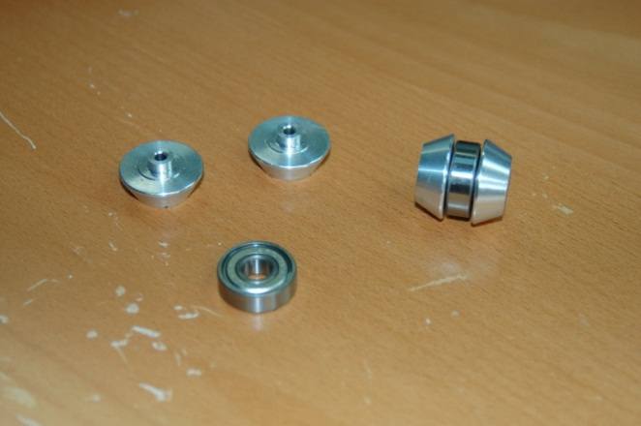

Figure - Idler Bearing

17.2 - Install two idler bearings at the bottom of each tower. Prepare six #6-32 1.75" socket head cap screws with #6 washers. Install each idler pulley as shown in the photos below. Note that your kit may include the same size Philips head screw instead of the cap head screw.

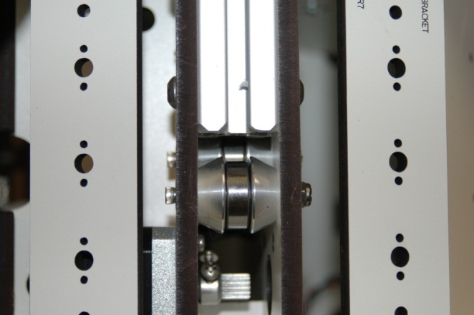

Figure - Lower Idler Bearings Installed

17.3 - It may be easier to install the parts if you lay the Rostock Max down on its side. Note that the "inner" idler bearing must be installed first or you won't be able to reach its location past the "outer" idler bearing.

17.4 - Install one idler bearing at the top of each tower. The bearings are mounted in the slot in the idler bracket as shown in the photo below.

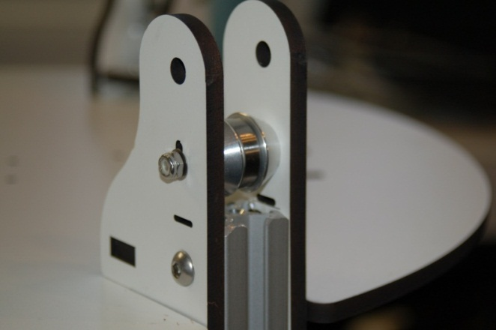

Figure - Upper Idler Bearing Installed

17.5 -Do not tighten down this idler yet - it's used later to correctly tension the drive belts.

# 18 – Installing the Belts!

18.1 - To begin, route the Z axis belt (or whatever axis you choose to begin with) from the top of the base plate, down below the bottom idler pulleys. Draw most of the belt through.

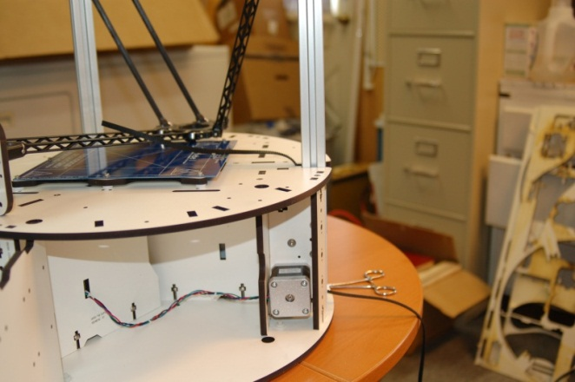

Figure - Initial Belt Routing

18.2 - Special care must be taken with this stage of the belt routing. You need to ensure that the belt passes ***between*** the two lower idler pulleys. If the belt passes to the outside of the “inner” pulley, the belt will rub against the belt notch in the top plate of the base. (I know it will because I screwed it up the first time and didn’t realize it until I was finished with the mechanical assembly of the whole machine!)

18.3 - Figure 79 above will show you what it should look like from the outside when you're done with this step. Note that the belt teeth must be facing "in" towards the rail. Make sure while pulling the belt that it doesn’t engage the drive pulley that’s installed on the stepper motor – you don’t want to spin the motor by hand.

18.4 - Attach the short end of the belt to the Cheapskate. Start by removing the lower belt clamp - you'll need it out of the way as you'll need to fish the belt end through the small slot that's right above the clamp. I'd really suggest laying the machine down in order to do this as it makes it a bit easier. In order to fish the belt through that tiny slot, you'll need to find a large paper clip.

18.5 - Straighten it out and then bend a small "L" on one end. You'll use that to snare the belt tip to drag it through that tiny, tiny little slot. :) Note that I don't actually know how well I would have fished the belt with the paper clip. I cheated and used a tiny set of forceps to do the job. :) Take care to not twist the belt!

18.6 - An alternate (and probably much easier method) is to insert the belt into the slot and drag it down and around the idler pulleys. No matter what though, you're going to have to fish that sucker at least three times when you attach the other end of the belt to the top.

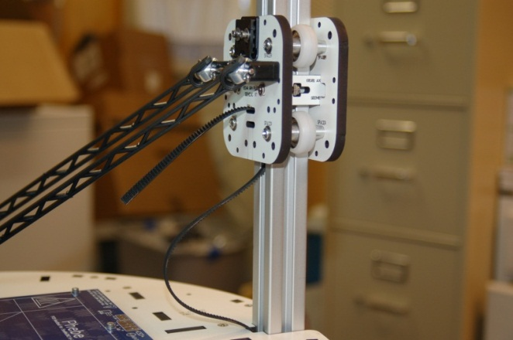

Figure - Belt inserted into Cheapskate

18.7 - Re-install the belt clamp with about 1/8" to 1/4" of belt extending below the clamp. Be careful not to tighten the belt clamp too much or you'll split the clamp.

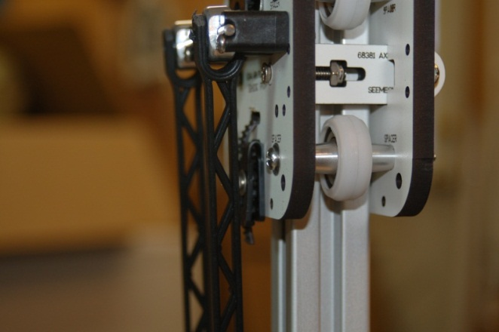

Figure - Belt Clamp Installed

18.8 - Attach the long end of the belt to the Cheapskate. Remove the upper belt clamp and route the belt up to the top idler, passing to the inside of the Cheapskate and fish that poor belt through that tiny, tiny slot. Note that Fig. 82 shows the belt teeth facing away from the rail, this is an error! The belt teeth should be facing **IN** towards the rail.

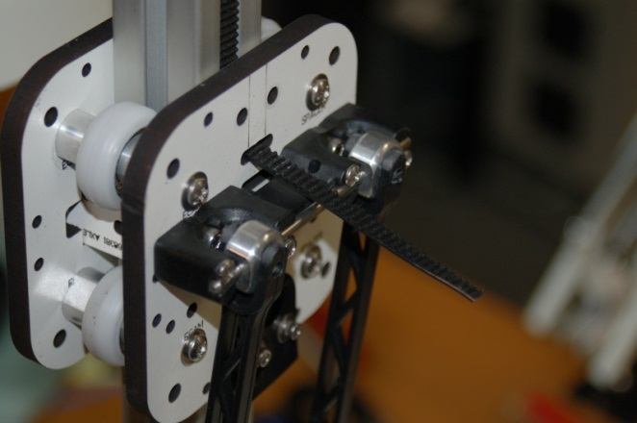

Figure - Belt inserted in top of Cheapskate

18.9 - Once you've got the belt through the slot (make sure you don't twist it!) make sure that the belt is actually on the toothed pulley at the bottom before you begin to install the belt clamp.

18.10 - Install the belt clamp - make sure that the top idler has fallen to the lowest position before you tighten up the belt clamp - adjusting that idler is how we set the tension in the belt.

18.11 - I cannot emphasize enough how easy the forceps make this task! Before the next step, you want to make sure that the toothed pulley on the stepper motors is properly aligned. See below for an example of a properly aligned pulley.

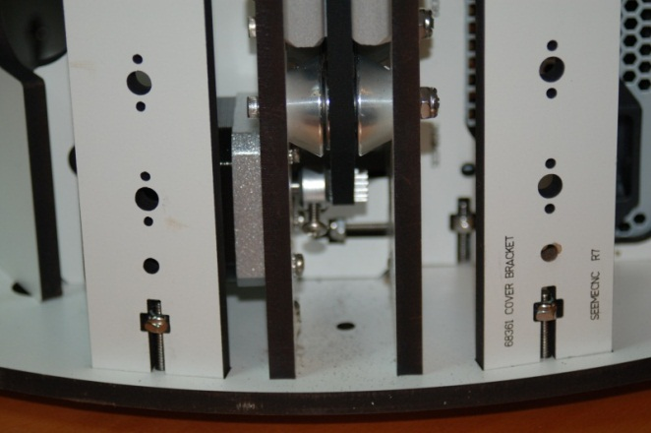

Figure - Properly Aligned Pulley with Belt Installed.

18.12 - Tighten Idler Bearings. Using a screwdriver as shown, raise the Idler bearing up until the belt is tight and then tighten down the screw holding the idler bearing.

18.13 - Place the tip of the screwdriver on the other side of the rail and pry up gently. This should raise the idler bearing up evenly. When the belt is tight, tighten the screw.

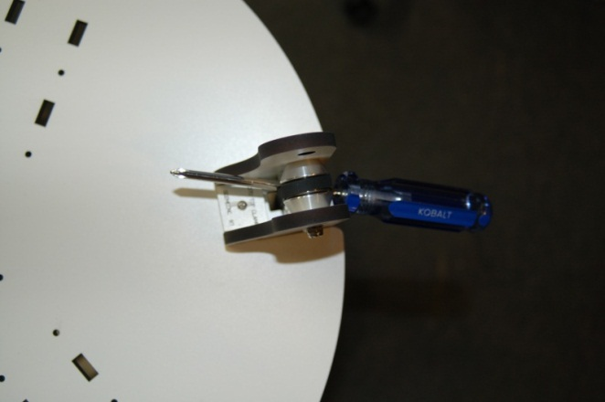

Figure - Tensioning the Idler Pulley

# 19 – Installing the Limit Switches and Adjustment Screws

19.1 - First, install three adjustment screws, #6-32, 2" as shown on each of the three U-Joint carriers. Thread the screw about 3/8" deep.

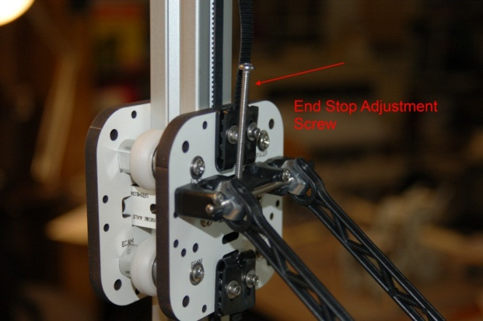

Figure - End Stop Adjustment Screw

19.2 - Next, the three wiring harnesses (2 wires) for the limit switches need to be routed. Gently twist the wires together at the end with the little brass crimp on connectors. Please note that one set of wires is longer than the other two by about 12”. Make sure to install this pair into the Z tower, across from the RAMBo mounting plate.

19.3 - Get some fishing line or dental floss. You'll use this to pull the wiring down the inside of the rail. The reason for this is that due to the angle of entry, the wire isn't stiff enough for you to be able to push it down the channel. You'll save yourself a lot of grief by pulling with fishing line. (You'll eventually go mad and throw the machine through your living room window. Then much Scotch ensues. It's not pretty.) If you don’t want to mess with fishing line and you’ve got a speed-controllable drill, you can use the following method that was contributed by a forum member: “I used a drill to twist the wires together (about 2 turns per inch) so they're stiff enough to easily push through the rails on their own with no need for fishing line. I wrapped the wire ends (with connectors attached) in a piece of paper towel and tightened the drill chuck just enough to keep the wires from slipping out. Don't tighten more than needed, to avoid damaging the connectors.” This is a very slick idea.

19.4 -Before you thread the wire down the rail, route it through the wire slot that's right in front of the Idler Bracket as shown on the next page.

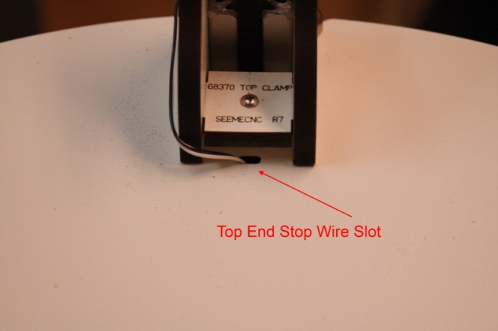

Figure - Top End Stop Wire Slot

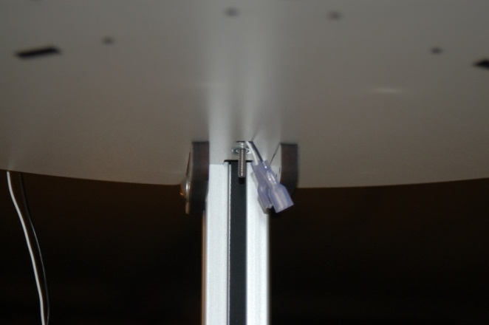

Figure - Top End Stop wiring shown from the bottom.

19.5 - Next, you want to thread the wire around the side to the wire slot that’s in the Idler Bracket as shown below.

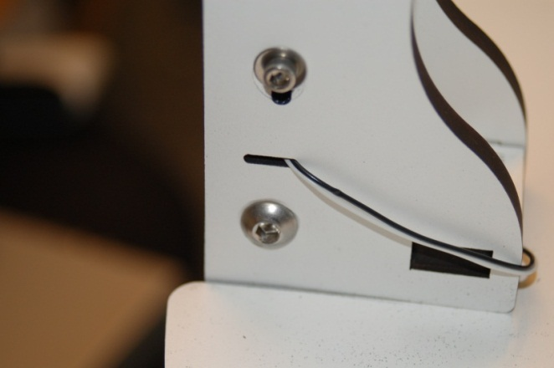

Figure - Wire slot in the Idler Bracket.

19.6 - Thread the wires down the central shaft of the extrusion using the fishing line - simply tie a looped knot (a granny knot) around both wires just ahead of the crimp on connectors - make sure you've twisted the wires together a bit as it makes pulling them both a bit easier. Thread the fishing line down the tower and pull the extra out to the left side - that is the side that the wire exit slot is on. When you're done, the top should look like this:

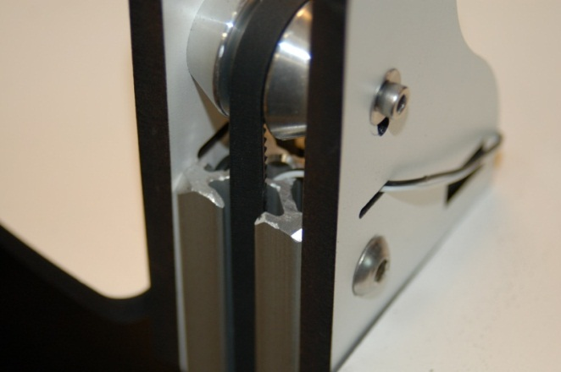

Figure - Properly routed End Stop wiring.

19.7 - At the bottom of the tower, the wire should exit the rail as shown in Fig. 90.

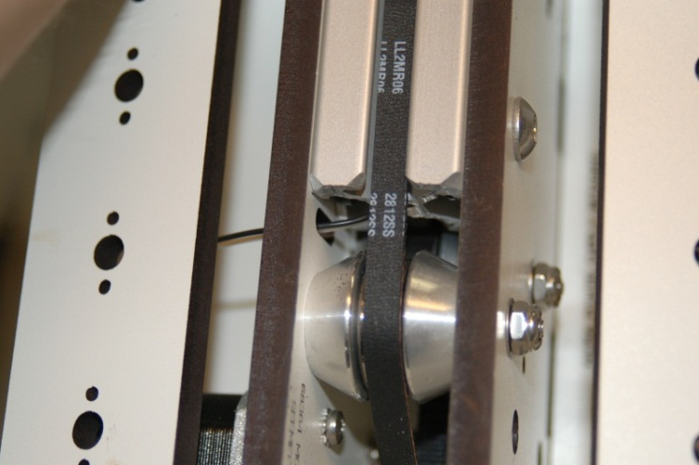

Figure - Wire exiting the tower rail.

19.8 - Make sure that the wires pass through the wiring slot to the left as shown above. Pull wire on all three towers. We'll be coming back to them later, so don't attach the plastic connector shells to them yet.

19.9 - There are three limit switches, one each for the three towers. Each switch is installed using two #2-56 5/8" machine screws and two #2-56 nuts. The switches are wired as Normally Closed. The end-stop wires should be attached to the "C" and "NC" terminals. In the photo below, these terminals are on the left (C) and right (NC) of the switch.

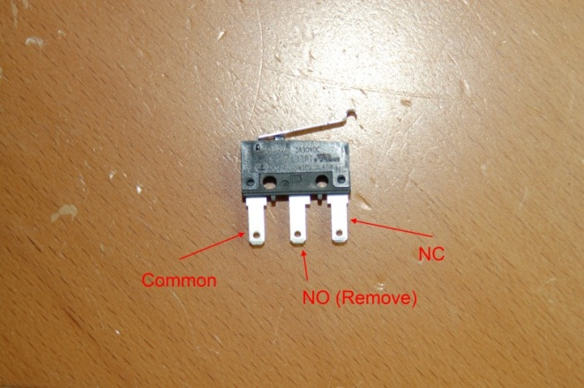

Figure - End Stop switch with connector lugs identified.

19.10 - Clip off the center terminal of the switch (marked "NO") and then bend the leads out as shown in the photo.

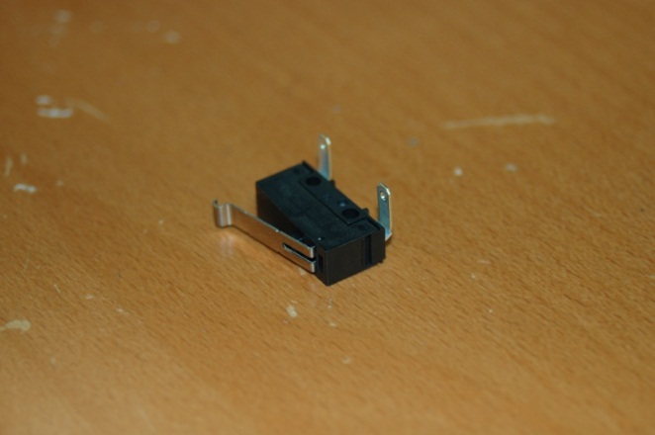

Figure - End Stop Switch with leads bent to clear the top.

19.11 -Bending the leads ensures that you'll be able to push on the spade lug connectors later on. Please make sure that before you bend the leads on the switch that you’re bending them in the correct direction! Do this by holding the switch so the Common leg is on the end closest to the center of the machine. Raise the axis you’re going to install the switch on and bend the leads such that when the switch is installed on one of the INSIDE faces of the Idler Bracket, the End Stop Adjustment Screw will engage the end of the switch lever when it travels to the top.

19.12 - Install the switch wiring and using the #2-56 screws and nuts, install the switch as shown in Fig. 93.

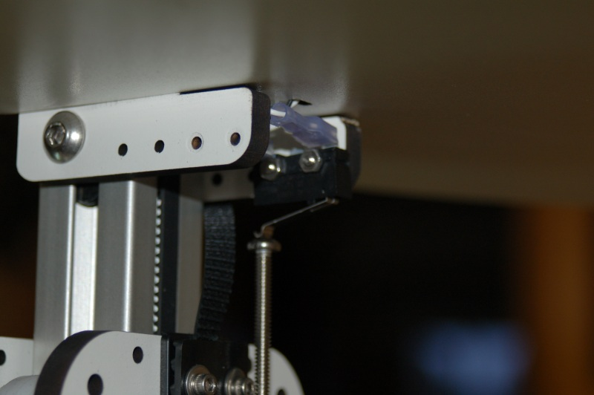

Figure - End Stop Switch installed.

19.13 - Note that the position of my setup may differ from yours. Make sure the adjusting screw will come in contact with the switch lever when the Cheapskate is at the top of its travel.

19.14 – Now you need to wire up the other end that connects to the RAMBo. Locate the three pin locking connectors in the RAMBo wiring bag and six crimp-on connectors. You’re going to wire them up such that pin #1 is the white wire and pin #2 is the black wire.

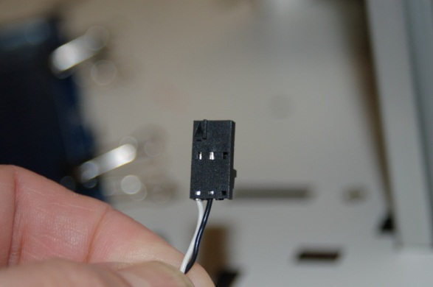

Figure 93-1 End Stop connector.

19.15 – The three end stop connectors belong in the “Max” row of the End stops on the RAMBo. Please refer to the connector illustration that came with the RAMBo for their location. **DO NOT CONNECT ANY WIRE TO THE “+” LEAD ON THE CONNECTOR. PERMANENT DAMAGE TO THE RAMBO MAY OCCUR!**

Congrats! The mechanical portion of the Rostock MAX Assembly Guide is complete. Next up is all heaty-burny stuff and electronics. ☺

# 20 –Wiring the Heated Bed

20.1 – For this task, you’ll need to remove the Heated Bed from the base and install the LED and 1k resistor as shown below. Make sure to orient the “flat spot” on the LED to the right. The flat area marks the Cathode or “-“side of the LED. The 1k resistor limits the voltage in order to prevent the 12v Heated Bed power from blowing the top off the LED.

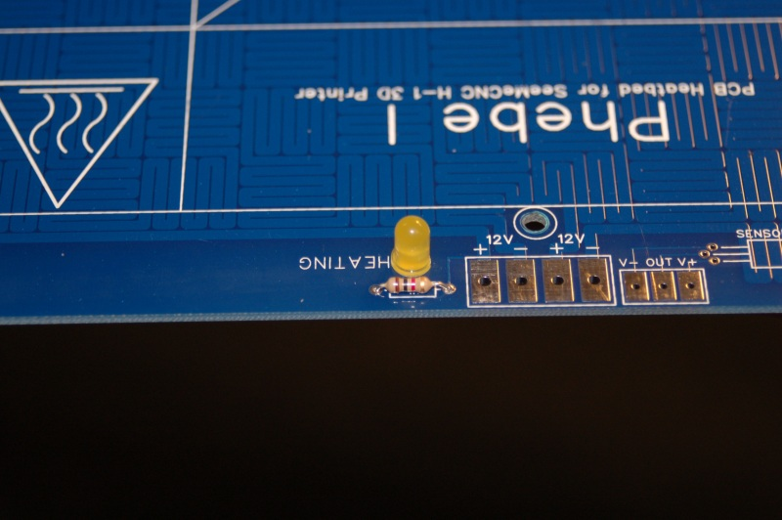

Figure - Power LED installed.

Note – if you’re unable to locate a T 1-3/4 LED, you can use any LED that has the same lead spacing as a T 1-3/4. If you buy a LED that has the voltage drop resistor already installed (LEDs “rated” at 12v will have this resistor built into them) you can just install a short piece of wire where the 1k resistor would go.

20.2 – Mount the thermistor to the heated bed. Thread the thermistor leads through the holes shown below and place a small amount of tape over the leads where they enter the Heated Bed. This will help pin the leads in place so they can’t be bumped by something and short together. Apply a small amount of RTV over the thermistor. This will affix it to the board and protect it. Flip the board over and solder the leads in.

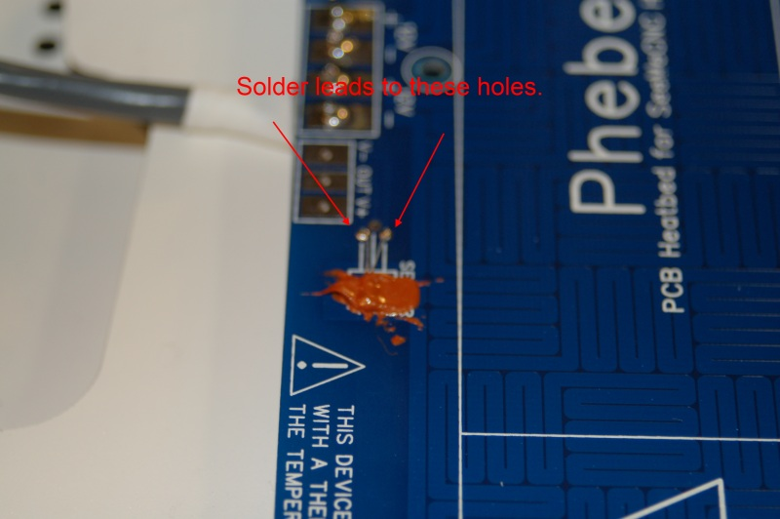

Figure - Thermistor soldered & affixed in place.

20.2 – Now solder the two conductor white wires to the under –side of the heated bed where it’s marked “V+” and “V-“. Before soldering the wires in, you may wish to intertwine them in order to make the wires easier to manage.

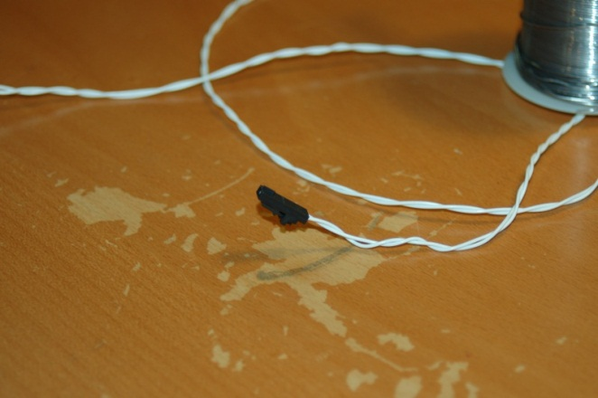

Figure - Thermistor wires intertwined for easy management.

20.3 – Now you’ll want to take the four conductor 18ga cable included in the kit and solder it to the Heated Bed. Each pair of 12v terminals provides power to half the heating element on the board. This is why four wires are required. Trim the wires back only about ¼” inch and insert them from under the board. The colors I used were red/black for +/- on one pair, white/green for +/- on the second pair.

20.4 – Re-install the heated bed, routing the four conductor cable & thermistor cable though the slot cut in the base as shown below. You may want to add a small piece of heat shrink tubing to neaten the appearance of the wiring.

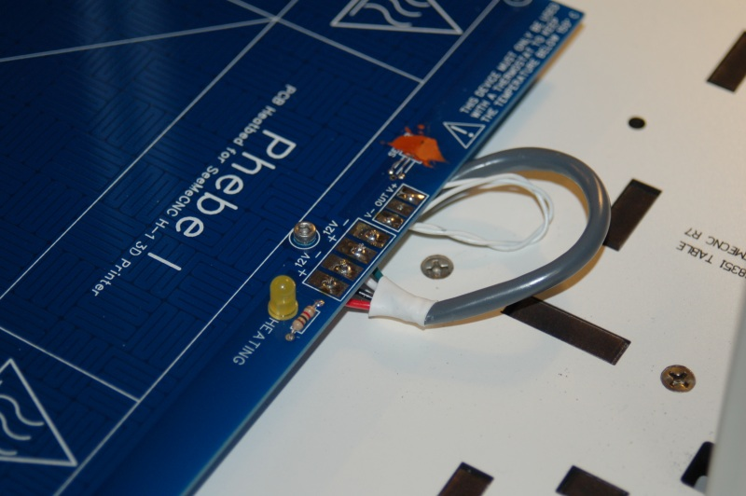

Figure - Wires routed through the top

20.5 – Pull the four conductor cable through the bottom of the machine so it ends up in the section where the RAMBo is located. Cut the cable long enough that you’ll be able to have the electronics door completely open with the heated bed connector still plugged in. Install the connector like shown in Fig. 98. Please make sure you wire it as shown if you followed my color guide above – if you mix the polarities of the wires, you’ll either blow the fuse on the RAMBo or destroy it.

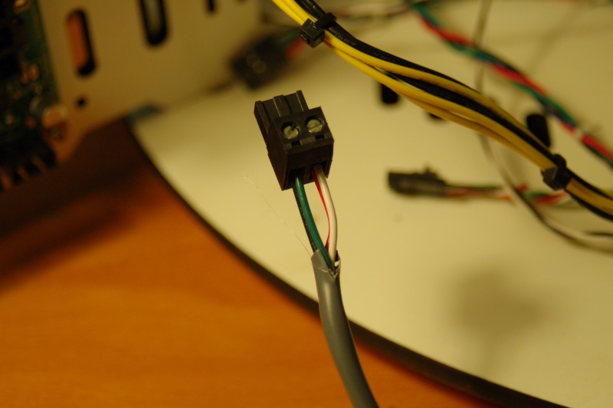

Figure – Heated Bed power connector.

# 21 – Assembling, Wiring and Mounting the Hot End Assembly

21.1 – For this step, you’ll need all the components for the hot end. This includes the Hot End Spacer (P/N: 68324), Hot End Adapter Plate (P/N: 68328), Bowden Hot End PTC Adapter (P/N: 68316), Feed Tube Insulator, Heater Clamp, Nozzle (P/N: 71541), the Bowden Tube fitting, a thermistor, 2 power resistors and finally, the Teflon Liner.

21.2 – The Hot End will come pre-assembled for the most part, but we’ll have to disassemble it a bit to complete the assembly. First, remove the knurled nut on the Bowden Hot End PTC Adapter and then slide the Hot End Adapter Plate & Hot End Spacer over the PTC Adapter. Replace the knurled nut, just a bit more (and I mean a *little* bit more) than finger tight.

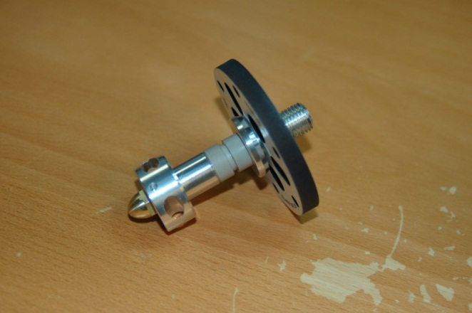

Figure - Hot End Adapter Plate in position.

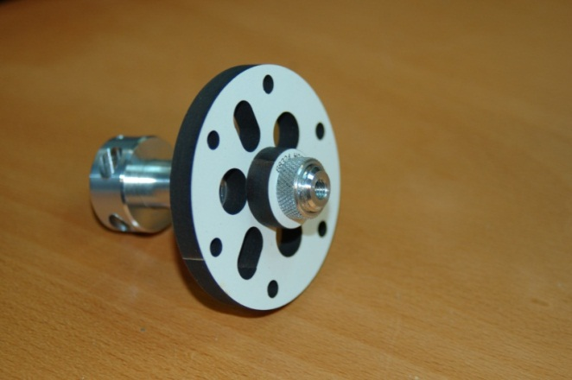

Figure - Hot End Spacer and knurled nut in place.

21.3 – Next you’ll install the Bowden Fitting on the Bowden Hot End PTC Adapter by threading it into the hole in the top. Tighten this down so it compresses the O-Ring seal, but not so much that it starts to squish it out from under the brass fitting.

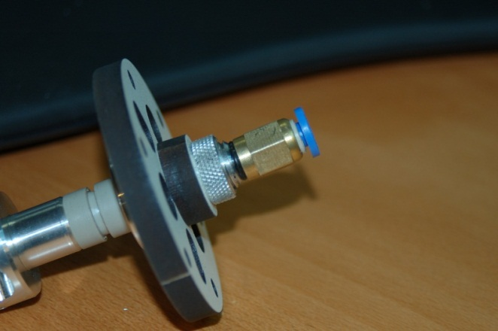

Figure - Bowden Fitting installed on the Bowden Hot End PTC Adapter.

21.4 – Now remove the Nozzle from the Hot End and install the Teflon Liner. When replacing the brass nozzle, you want to finger tighten it and then tighten it just a tiny bit more. You don’t want to deform the liner inside the Hot End.

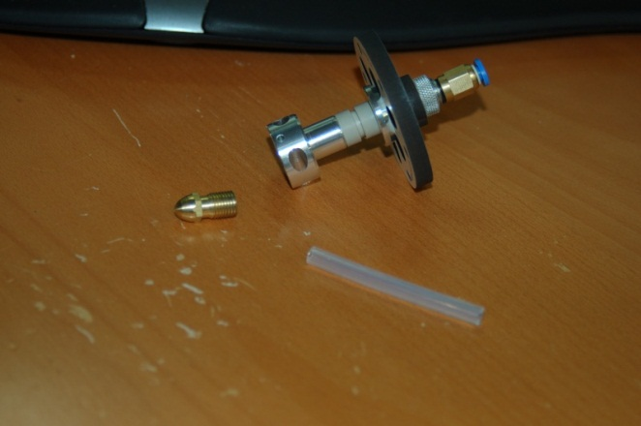

Figure – The Teflon Liner ready for installation.

21.5 – In order for the RAMBo controller to determine what temperature the Hot End is at, it uses a thermistor. The thermistor is shipped with bare leads, so the first thing we need to do is take steps to prevent the leads from shorting out against one another.

21.6 – If you’ve got Kapton tape, you can create a “thermistor sandwich” that consists of a layer of tape, the thermistor and another layer of tape. However, I didn’t have any Kapton so I’ll be illustrating how I worked around the lack.

21.7 – I purchased some high-temperature silicone tape from the local auto parts store and made a thermistor sandwich using that tape as well as a “mayo” layer of RTV.

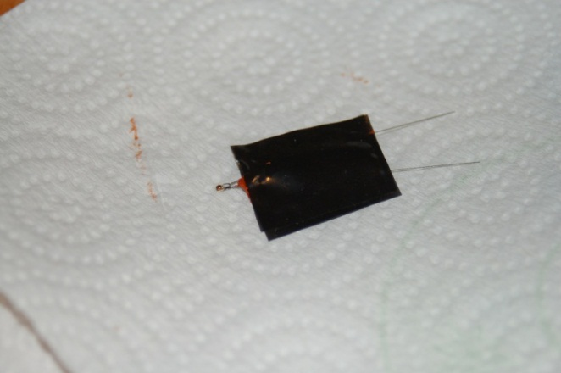

Figure - Thermistor sandwich with RTV sauce!

21.8 – The RTV takes about an hour to set up, so while the “thermistorwich” is cooking, let’s get the power resistors prepared and installed in to the Hot End. You’ll want to cut a few strips of aluminum foil just a little bit narrower than the resistor body is wide. You’ll need to wrap the resistor in foil in order to get it to fight tightly in the milled holes that are in the Hot End. Please take special care to make sure that any of the aluminum foil does not come into contact with the leads coming out of the resistor. This can cause a short circuit and then we could bounce into a star and that would cut your trip pretty short. Wouldn’t it, kid?

21.9 – Once you’ve got the resistors pressed into place, coat each end with RTV in order to seal them to the Hot End.

21.10 – The thermistor is installed in one of the two small holes drilled parallel to the resistor chambers on the Hot End. Fill one with RTV and press the thermistor in to place as shown below. Make sure you’ve let the RTV cure at least one hour before moving on to the next step.

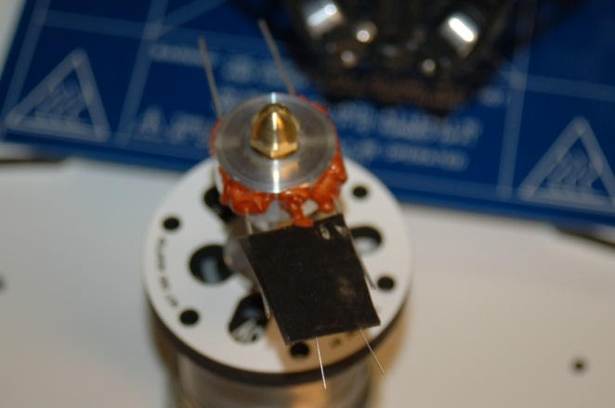

Figure - Resistors & Thermistor sealed in with RTV.

21.11 – Now we’re going to get the resistors ready to wire up – wrap each resistor lead pair together as shown:

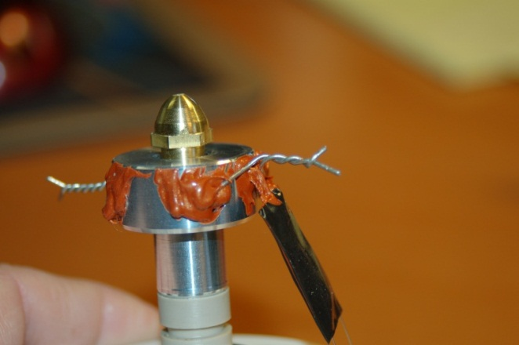

Figure - Resistor wires wrapped together.

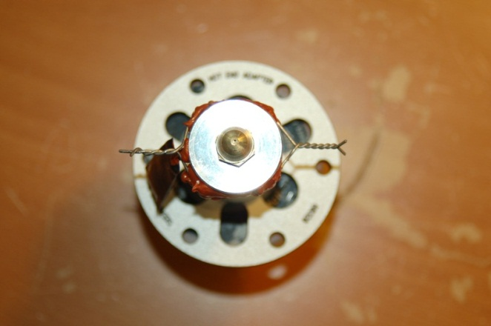

Figure - Resistor wires wrapped together.

21.12 – Take the remaining 4 conductor 18ga wire and strip off about 3” worth of the outer insulation and fold back the white & green wires as shown. You will only use two of the four at this time, but having two spare available is handy if you want to install a fan or some lights without having to run a new run of wire.

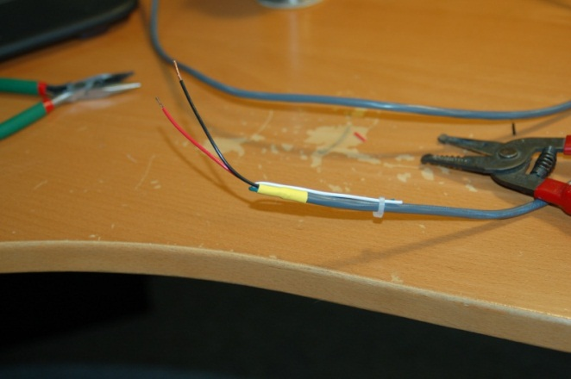

Figure - Hot End wires ready to go!

21.13 – Trim off the “skirt” from two crimp-on wire nuts – this will help them clear in the limited space available once the Hot End is mounted on the delta platform.

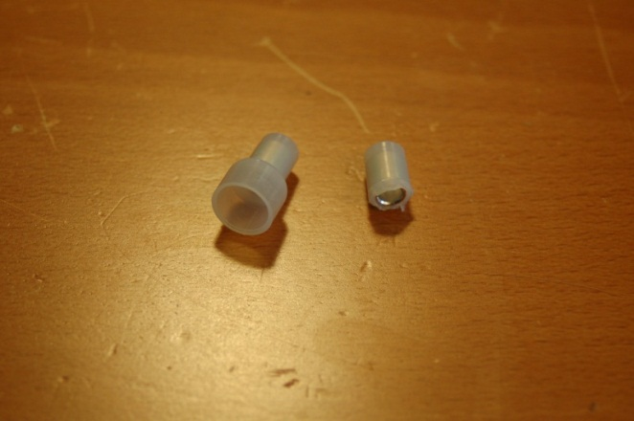

Figure - Skirt trimmed from the crimp-on wire nut.

21.14 – Route the power wires through the Hot End Adapter Plate and crimp each one to a resistor wire pair. Note that if you so choose, you can route the wires on the outside if you’ve trimmed enough of the grey insulation back. This would give you a bit more room to work with when mounting the Hot End.

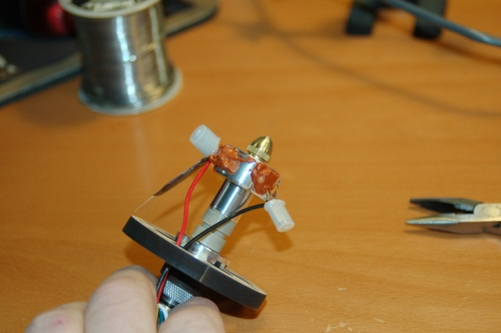

Figure - Power wires connected to the resistors.

21.15 – Next up, you’ll get the wires for the thermistor routed and soldered up. For my installation I used some more of that Silicone Tape to protect the solder joints – they’re delicate. If you’ve got Kapton tape, use it here.

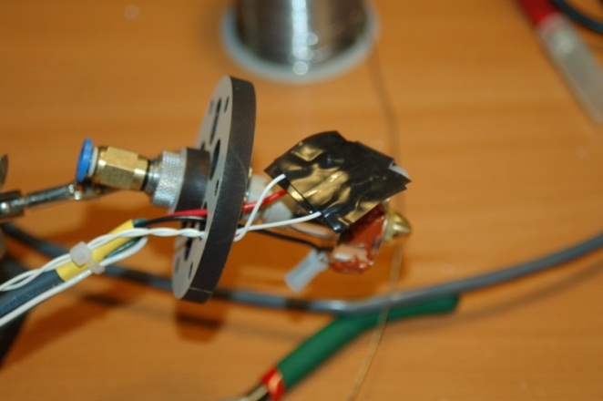

Figure - Wires soldered to the Hot End thermistor.

21.16 – Ok, now it’s time to mount the Hot End Assembly to the delta platform. For this step, you’ll need three 2” #6-32 machine screws, three #6 washers, three #6-32 Nylon lock nuts and three #6 aluminum spacers.

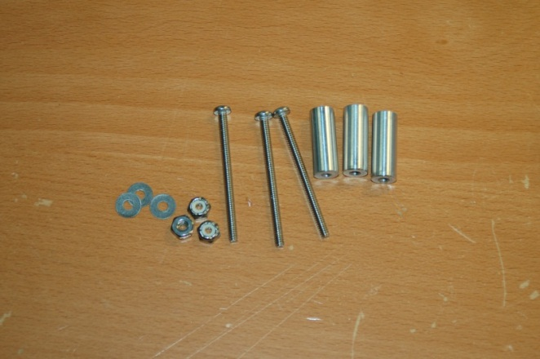

Figure - Parts needed to mount the Hot End Assembly.

21.17 – Mounting the hot end is very simple, but take care not to damage the thermistor installation. When you’ve got the Hot End Assembly mounted, inspect the wires coming out of the resistors VERY carefully! You want to make sure that there’s no chance of the resistor leads coming in contact with the Hot End itself. If you create a short circuit here, VERY VERY bad things will happen, up to and including a fire, much running in circles, screaming and cursing.

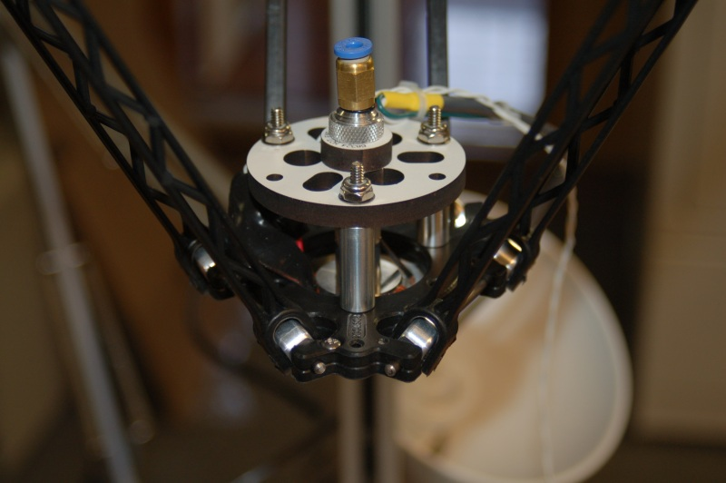

Figure - Hot End mounted in position.

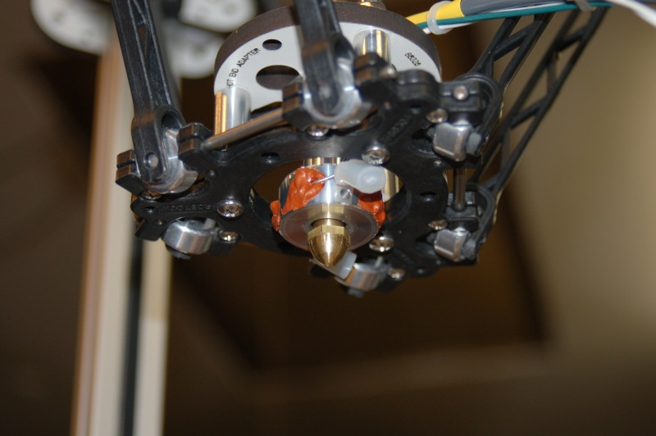

Figure - Hot End installed.

21.18 – Coil the wires up on the bed for the time being, we’ll be getting back to them soon.

# 22 – Wiring the Power Switch & RAMBo Power

22.1 – Take the included power switch and remove all the mounting hardware from it. The mounting point is ¼” thick and there won’t be any room except the outside nut when it’s time to install it.

22.2 – Cut one black wire and the green wire from the large 22 pin plug on the power supply. Solder the black wire to the center lug on the switch and the green wire to one of the outside lugs – make sure that the lugs you’re soldering to are in line. If you solder to one of the end lugs that are not in line with the center lug, the circuit will not be completed when the switch is closed. I recommend using heat shrink tubing to protect the exposed joints from shorting out against anything.

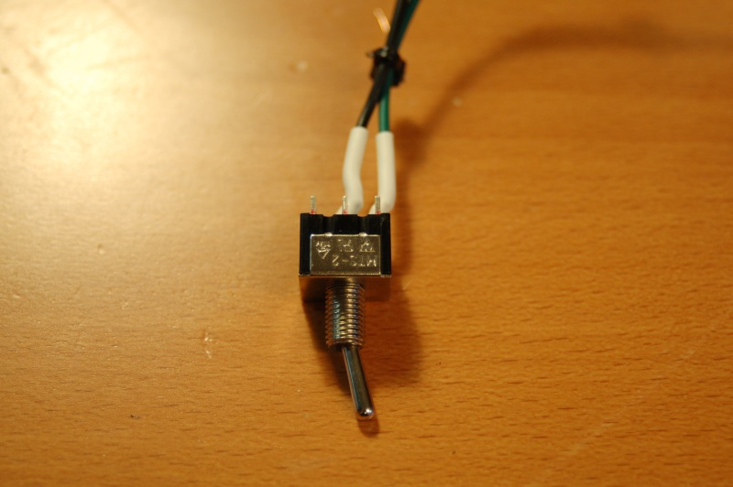

Figure - Power Switch wired.

22.3 – Install the switch in the hole marked “Power” as shown. To orient the switch correctly, rotate it so that the toggle is pointing down towards the green wire. If you draw an imaginary line along the center of the toggle, it will “point” to the lug it’s in contact with. When in the “on” position, you want it pointing to the green wire. Simple!

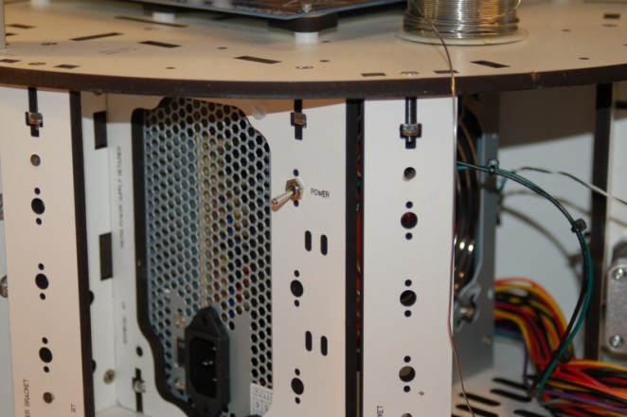

Figure - Power switch installed.

22.4 – Now find the six pin connector that has three yellow and three black wires attached. Cut the wires right off at the connector and route the wires into the electronics bay. Take the black six pin terminal connector and attach the wires as shown. You only need to trim off about ¼” or so of insulation. Note that the picture only shows one black and one yellow wire in the “Heater Bed” positions. To get the most out of your power supply, it’s recommended that you put three yellow and three black in the “Heater Bed” (the two terminals on the right) positions to get more power to the heated bed. I recommend twisting three together and then soldering them to ensure good contact. (**DO NOT SOLDER THE BLACK AND THE YELLOW TOGETHER. MUCH SCREAMING AND FIRE MAY ENSUE.)**

The reason for the additional wires is that you can only draw so much power through a wire of a given gauge. Think of it like a small water hose. No matter how much you try to draw water through that little hose, you’re only going to get as much as it has room for. However, if you use three small hoses, you effectively get the same volume as if you had one hose with the same volume capacity as the three smaller ones combined. The Phebe I bed doesn’t require all that much power, but the Onyx bed does, simply because it’s nearly twice the area (and heating filament!) as the Phebe I.

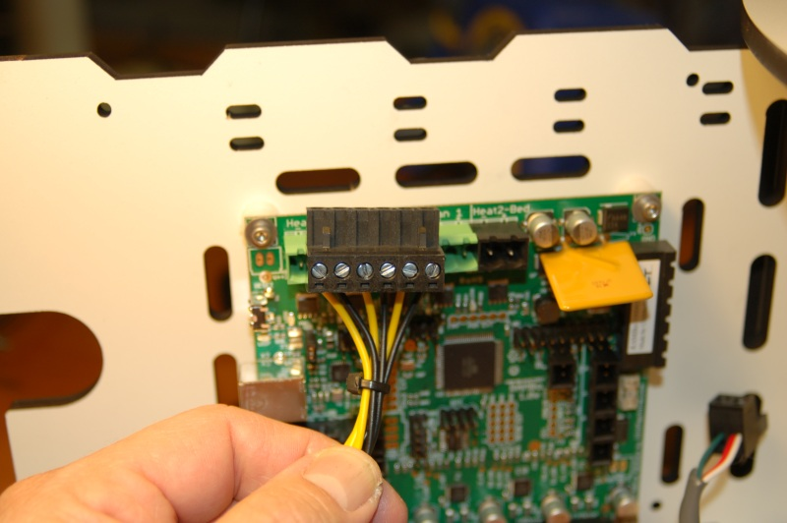

Figure - Power Block connector wired up.

22.5 – That’s all there is to it! When we get to the final connection step, this will plug into the board on the connector shown in the photo above – it’s to the right of the large yellow component.

22.6 – Take some time now to bundle up the unused wiring coming out of the power supply with some wire ties to keep it out of the way.

# 23 – Final Assembly!

23.1 – It’s final assembly time! The first thing up is getting the extruder installed on to the extruder mount. As shipped, the extruder is designed to feed both 1.75mm and 3.0mm filament. This set up is going to focus on the 1.75mm settings.

23.2 – Orient the extruder as shown in Fig. 117. You want to make sure the 1.75mm groove is aligned with the Bowden fitting on the extruder mount.

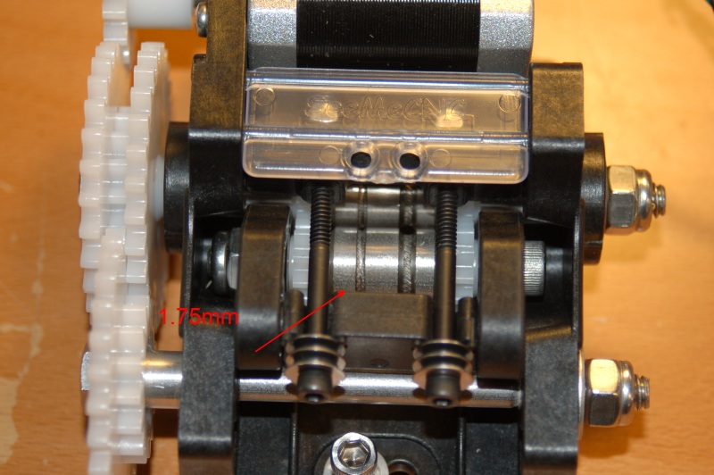

Figure - Extruder with 1.75mm drive highlighted.

23.3 – You want to install the extruder so that it aligns the 1.75mm drive groove with the Bowden fitting on the mount. See below:

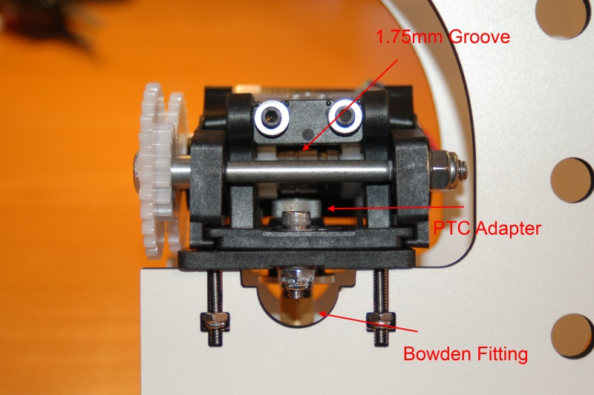

Figure - Extruder correctly installed.

23.4 – Once you’ve got the extruder installed, go ahead and mount the Extruder Bracket assembly as shown. If you haven’t already extended the leads for the drive stepper motor, now would be a good time to do that. Please review the instructions in Section 4 for wiring details. The stepper motor wiring can be routed as shown, or you can go around the outside of the door, through the finger pull.

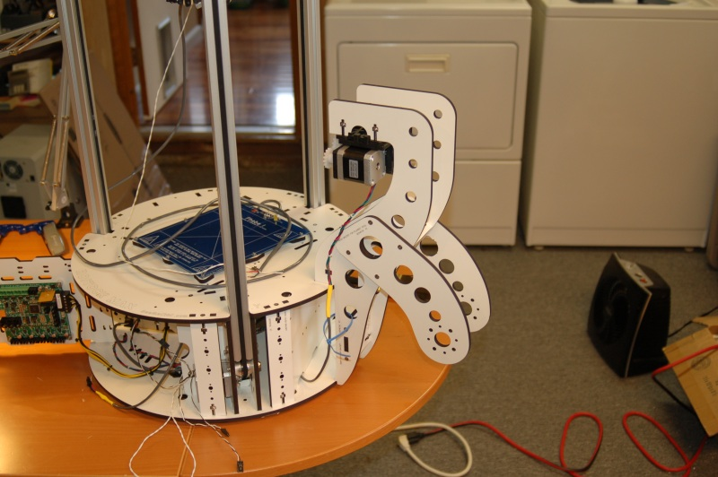

Figure - Extruder mounted on the machine base.

23.5 – Install the Bowden Tube! This is a 4mm Teflon tube that goes between the Bowden fitting on the Hot End and the Bowden fitting on the extruder mount. It just presses into place, but make sure it’s fully seated.

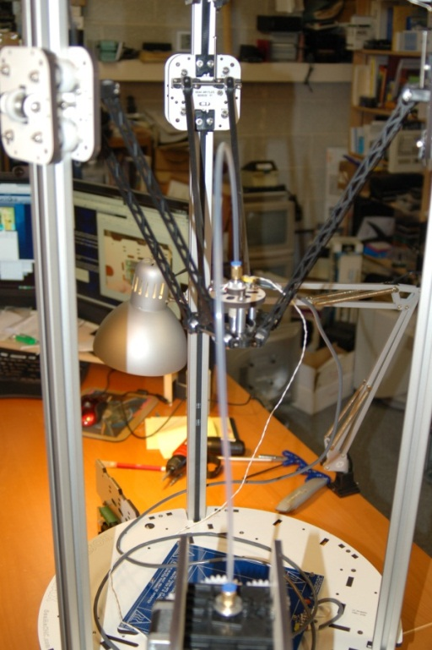

Figure - Bowden Tube installed.

23.6 – Tie the thermistor wire to the Hot End heater cable as shown below. I used waxed lacing cord here because it won’t catch on the split tubing I’ll use to protect the wires with.

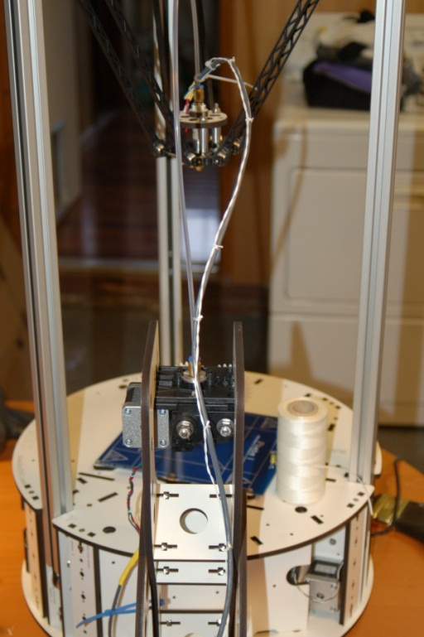

Figure - Hot End heater and thermistor wires tied together.

23.7 – The wires supplied for the thermistors are not long enough to reach the RAMBo from the Hot End. You’ll need to extend them at this time to make sure they’ll reach. Once you’ve done this, route the thermistor and Hot End power wires into the electronics bay. Add a green, two position terminal block to the Hot End wiring as shown:

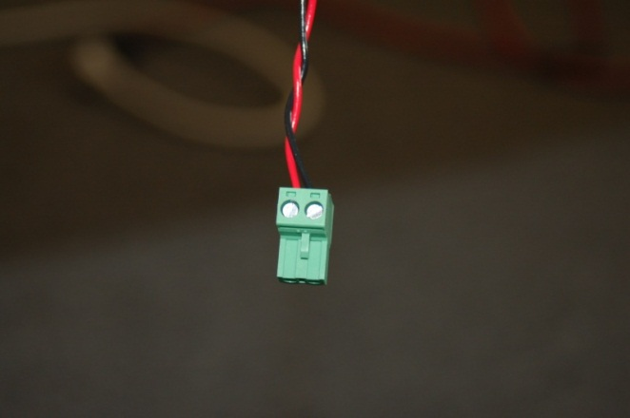

Figure - Hot End power connector.

23.8 – Install the split flex tubing on the wires leading to the Hot End and lightly bind it to the Bowden tube using wire ties. Don’t over-tighten the wire ties as you’ll crush the split flex tubing.

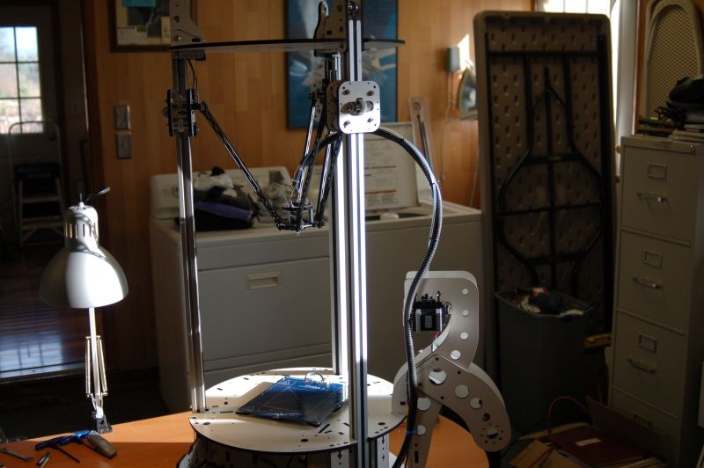

Figure - Split Flex Tubing installed on Hot End wiring.

23.9 – Now it’s time to hook it all up!

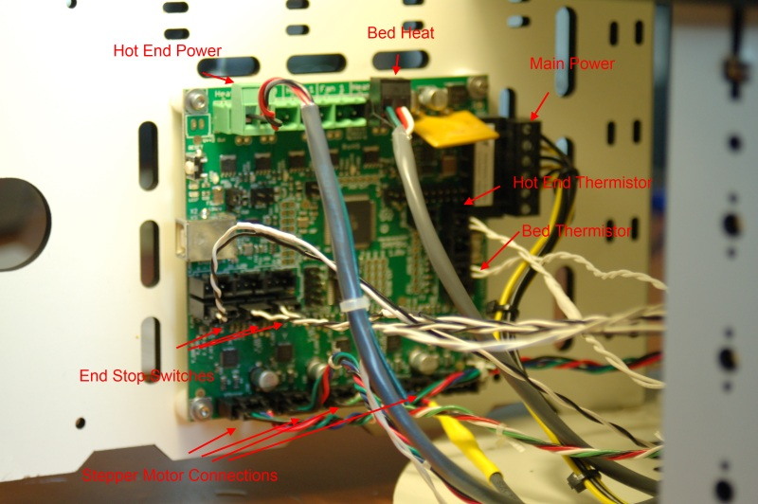

Figure - RAMBo wiring illustration.

Use the RAMBo documentation as well as Fig. 124 to get all your connections made.

CONGRATULATIONS! You’ve got yourself a fully assembled Rostock MAX 3D Printer!

Kick back, relax and have your beverage of choice. After you’ve had a chance to recover from your ordeal, we’ll get the necessary software installed and get the machine checked out in preparation for your first print!

# Software Installation and Configuration

Ok, you’ve managed to get this far, so it’s time to get this old beastie printing little green squirrels (or whatever other “legitimate” use you have for this fancy thing).

The instructions provided in this guide are centered on the Windows operating system – that’s because it is what I have. Details for Linux & MacOS should be on the Rostock MAX Wiki page.

In order to communicate with the RAMBo, you’ll need to download the driver for the board. This driver is essentially just an INF file that Windows needs to figure out what’s going on with the new peripheral you’ve just hooked up.

Download the USB Driver zip file from this location: <http://www.reprap.org/wiki/File:RAMBo_USBdriver.zip>

Unzip the file to a temp directory or other place that you know the location of. For Windows users (and likely XP, Windows 8 and Vista users as well), plug in the RAMBo and let Windows “fail” to find the correct driver for the board. Open up the device manager by right-clicking on “Computer” or “My Computer” and select “Properties” followed by “Device Manager”. Scroll down to the “Unknown Devices” entry and right-click on the RAMBo entry. Choose “Update Driver” and then “Browse my computer for driver software” (or something similar to this). Choose “Let me pick from a list of device drivers on my computer”, then click the button for “Have Disk”. Browse to where you unzipped the file you downloaded and then click “OK”. It may complain (depending on OS) that the driver isn’t signed – allow it to install it anyway. That’s all there is to it. The RAMBo will now appear on your computer as a standard serial port. On my computer it appeared as COM6 – it will most likely be different on yours.

If you need to make any changes to the firmware, you should head over to <http://www.arduino.cc> and download the Arduino IDE.

The firmware for the Rostock MAX can be downloaded from this location: <https://github.com/johnoly99/Marlin-for-rostockmax-rambo>. If you click on the “Zip” button on that page, it will create a zip file of the current code and you can download it all in one go instead of picking each file. I would recommend you download the firmware and unzip it so you can tweak it if need be.

For the initial check out of the printer, we’re going to use Repetier-Host which is commonly used with the Rostock MAX. The software can be downloaded from <http://repetier.com>.

Run Repetier-Host and click on Config->Printer Settings. You’ll want to make sure that the Connection tab looks like what is shown in Fig. 125. The Port: value for your computer will likely be different.

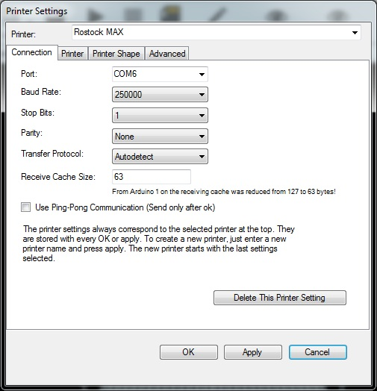

Figure - Connection configuration tab.

Where it says “Printer:” at the top of the window, enter in “Rostock MAX” or another name of your choice and click the Apply button.

Next, click on the Printer Shape tab and change the settings there to those shown in Fig. 126.

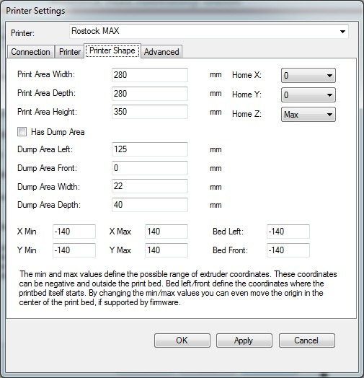

Figure - Printer Shape settings

After making the changes above, click “Apply” and then “OK”.

Now on to testing this sucker out – we first need to check and make sure that a) we can talk to the RAMBo and that the end-stop switches are operating properly.

Click the Connect button on Repetier-Host – it is right under the “File” menu item at the top.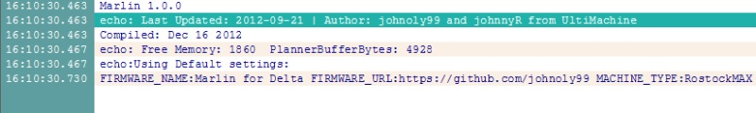

Figure - Connection Successful!

If you’ve selected the correct Port, you should see something along the lines of Fig. 127. If you don’t and you’ve got a green light lit on the RAMBo, pick a different Port (Don’t forget to hit Apply!) through the configuration screen and try it again.

Now that you’re connected, I want you to click on the “Manual Control” tab on the right side of the Repetier-Host program. In the input field marked “G-Code:” I want you to type “M119” and press the enter key.

In the log window you should see the text “x_max:L y_max:L z_max:L” This would indicate that all three end-stop switches have not been pressed. If you see anything different, please check your wiring! Now I want you to hold down the switch lever for the X axis and re-run the M119 command. You should see the **X_MAX** value change to “H”. Do this for the Y and Z axes. This will ensure the end-stop switches are function – this is very important for the next step.

If you haven’t powered on the Rostock MAX yet, please do so now. Ok, now you can climb out from under the table. See, I told you it wouldn’t explode.

We’re now going to check the wiring of the stepper motors. You’re going to issue a “G28” command which tells the machine to home all three axes against the end-stop switches. BEFORE you issue the G28 command, please have your hand on the power switch. If the axes begin to travel downward when you send G28, turn off the power immediately. Note that you should never try to manually move the axes if the power is turned on – you could damage the machine. While moving an axis with the machine powered off, do so slowly. A stepper motor can generate voltage when moved too quickly and you run the risk of blowing a driver chip on the RAMBo. Take it slow!

If the axes all traveled up, great! If not, there are two ways to correct the problem (providing of course the axes at least moved, even if in the wrong direction). The easy way (software!) and the hard way (hardware!)

If you chose the hard way, rewire the misbehaving stepper motors to switch the positions of the red and blue wires. Re-run the G28 homing test to make sure you’ve got it correct.

If you want to change the software, it’s pretty straightforward, but detailed step-by-step instructions are a bit out of scope here. You essentially want to look for this block of code in Configuration.h:

#define INVERT_X_DIR true // for Mendel set to false, for Orca set to true

#define INVERT_Y_DIR true // for Mendel set to true, for Orca set to false

#define INVERT_Z_DIR true // for Mendel set to false, for Orca set to true

For the axis that is going the wrong direction, change it to the opposite of whatever it currently is shown in the file, recompile and upload the new firmware to the RAMBo. Note that you’ll have to make sure you’re disconnected from the RAMBo in Repetier-Host or the Arduino IDE will not be able to connect to the RAMBo for the update operation. Note that you should NEVER try to move the carriage while the power is turned on! You don’t want to damage the motors or drive electronics. If you want to move the platform around by hand, just turn off the power switch. You can leave the RAMBo plugged in to the computer as it doesn’t power the stepper motors through the computer.

# Calibrating Your Rostock MAX

Now that you’ve spent the last five minutes randomly positioning the axes, sending G28 and then giggling like a school girl, why don’t we calibrate the Z axis? One thing I cannot stress enough, in order for the calibration settings to be accurate, YOU MUST DO THEM WITH THE HOT END AND THE BED AT OPERATING TEMPERATURE! For ABS this would be about 230C for the hot end and 70-100C for the heated bed. PLA would be about 190C for the hot end and about 50-70C for the heated bed.

For this step you WILL need to have downloaded the Arduino IDE and the Rostock MAX firmware source code.

If you haven’t done so already, install the included build plate on the heated bed using the included binder clips. The plate only fits one way so it’s pretty easy to get it right. For the Phebe I heated bed, you’ll use the 7” x 6.5” build plate. For the Onyx heated bed, you’ll use the included 280mm circular build plate.

Using the manual Z axis control in Repetier-Host, you are going to move the Z axis down until it’s nearly touching the bed. Each time you click the tip of the down arrow, the Z axis should move 10mm. In order to get it close to the bed, enter “G28” in the G-Code window to home the machine and then enter “G1 Z50 F1200”. This should get you approximately 50mm from the build platform.

Once you’ve got the Z axis about a half-inch from the plate, place a sheet of notebook paper on the build platform and start clicking the middle of the down arrow – this will move the platform down at 1mm per click. When you’re REALLY close to the paper, start moving it .1mm at a time (click the other end of the down arrow for this). **DO NOT ALLOW THE NOZZLE TO “CRASH” INTO THE BED**!

Slide the paper back and forth a bit while moving down and stop as soon as the nozzle begins to touch the paper and interfere with you sliding it back and forth.

If the Z axis reaches zero and still hasn’t touched the paper yet, increase the Z_HOME_POS by 10. The default for the Rostock MAX is 345.0. You can fine tune the Z axis by adjusting the end-stop screws on each axis. Turning the screw “out” will decrease the height from the table, turning them “in” will increase it. Think “Lefty, Lower”, “Righty, Raise”

Now that you’ve got the Z height set correctly, it’s time to make sure that each arm is moving parallel to the table. Get a notepad and something to write with – this step needs notes. The calibration locations I’ll be giving you will work with both the small Phebe I heated bed as well as the Onyx heated bed.

Home the machine using G28 and then jog down to about 5mm using **G1 Z5 F1200**.

Using a caliper or other precise measuring tool (aka **NOT** your finger), measure the height from the top of the platform to the print bed. This is your center measurement and this is the number you want to get the next three measurements to match. Remember that every time you take a measurement, you need to take it from the same spot on the carriage each time. If you don’t have a caliper or don’t want to hassle with using this method, skip to the end of this section for a neat trick I learned recently.

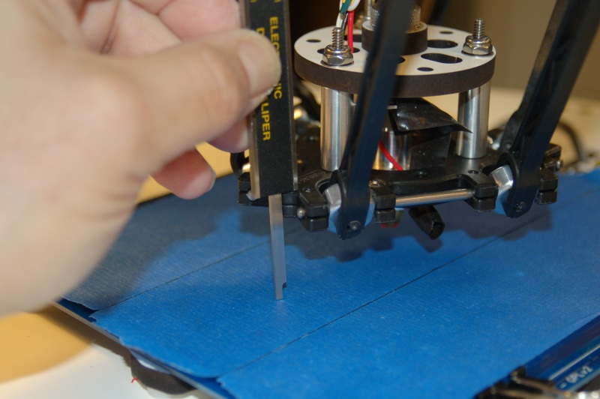

Figure - Using the caliper depth probe to take the center measurement.

Now jog the platform towards the Z column by entering the G-Code “**G1 Z5 Y110 F1200**”. You want to position the arm so it’s nearly parallel with the Z tower. Don’t be surprised if you find yourself turning the screwdriver in such tiny amounts you can hardly notice the screw move.

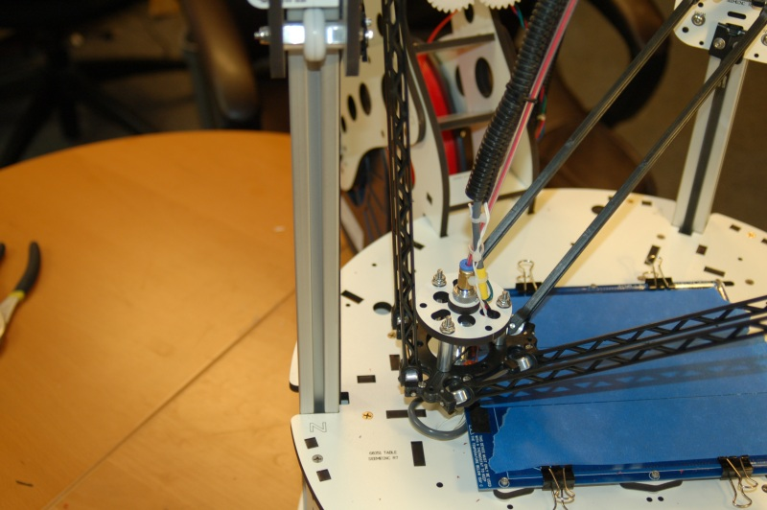

Figure - Carriage positioned close to the Z axis tower.

If the measurement you get at that point is higher than at the center, you’ll want to turn the adjustment screw UP (out) a quarter turn or so and then in the G-Code command field, “**G1 Z5 Y110 F1200**”. This will position the platform in the exact same spot as it was in for your first measurement. Repeat this process until the Z tower measurement matches the center measurement as closely as you can get it. The closer you are to that center measurement, the better and more consistent your print results will be.

On to the Y tower!

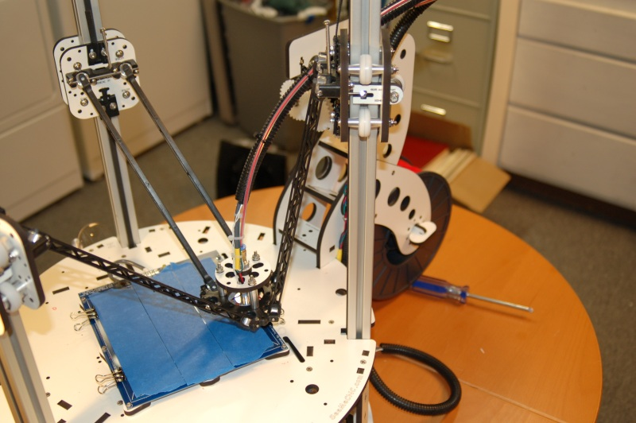

Figure - Carriage positioned next to the Y axis tower.

The first thing you’ll notice about the photo above is that the arms aren’t nearly as close to the tower as we got for the Z axis. This is because we need to be able to still touch the build platform and it’s as close as it can get and still have room for the depth probe on the caliper to still hit the bed from our measuring point.

To position the carriage next to the Y tower, enter the G-Code “**G1 Z5 X70 Y-30 F1200**”. Repeat the steps taken to align the Z tower for the Y tower.

Finally, let’s do the X tower.

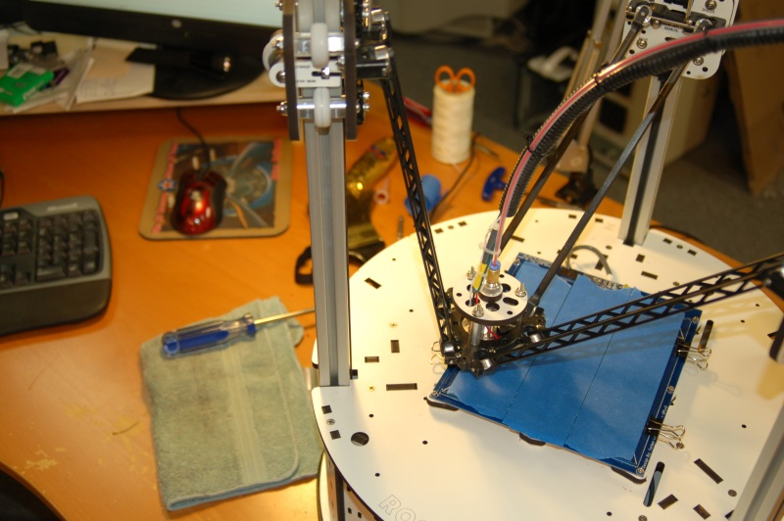

Figure - Carriage positioned next to the X axis tower.

The process is the same as for the other two towers. Enter the G-Code “**G1 Z5 X-70 Y-30 F1200**” to send the carriage to the measurement point for the X tower. Don’t forget, each time you adjust the end stop screw, you MUST enter the G-Code “**G28**” in order to re-home the machine so that your next measurement will reflect the change you made to the adjustment screw!

You should now have your Rostock MAX calibrated! The great thing about the Rostock MAX and delta designs in general is that once you’ve got it calibrated, you never need to touch it again unless you change the thickness of the build plate! None of this “leveling the bed” crap that those poor Cartesian printer users have to deal with. Set it and forget it!

Now that you’ve run the axes around for a while, I want you to re-check each Cheapskate bearing to make sure it’s still got a good grip on the rail it’s attached to. You’ll want to do this periodically as time goes on in order to compensate for the gradual wear that will happen over time as you use your Rostock MAX printer.

If you don’t have a caliper or didn’t want to mess with my method of doing the calibration, you’re in luck! I recently learned about a very slick method of easily calibrating your machine.

You’ll do very much the same as above, but your tower points are now:

|  |
| --- |
| Z Tower – X0 Y90 |
| Y Tower – X63 Y-30 |
| X Tower – X-78 Y-48 |

Go to the base if each tower with a Z0 height – keep a sheet of paper between the head and the bed. You’ll adjust each tower so that the paper just begins to grab the tip of the nozzle. When you’ve done this for all three axes, you should be perfectly calibrated! Many thanks to the person that wrote up this procedure at http://minow.blogspot.com.au/!

Another important ongoing maintenance task is to ensure that the knurled nut holding the Hot End together remains tight. Before you heat up the Hot End for the first time each day, please take the time to ensure that the nut is tight. Heating and cooling cycles can loosen it over time.

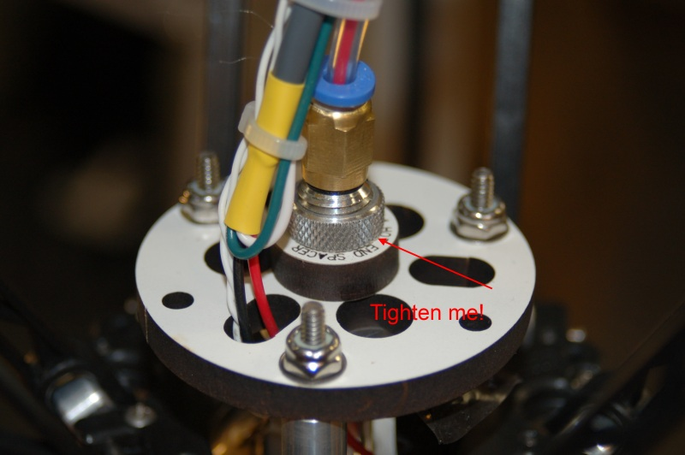

Figure - Tighten me!

Not keeping an eye on that nut can ruin prints and if left un-noticed long enough could even damage the wiring on the Hot End. I’ll give you a perfect example. When running my second part, the nut began to loosen. The hot end rotated a bit and the resistor wires came in contact with the hot end. This blew the 5A micro fuse for the MOSFET outputs on the RAMBo. Because of how the board is oriented in my installation, I didn’t notice there was a second fuse. The MOSFET fuse is right below the large yellow component, right next to the primary power connector. 12 hours later, after much poking prodding, hair pulling and yelling, that fuse was found and tested. If you don’t have a replacement, a quick & dirty field repair can be made by carefully soldering two 28ga wires to the top of the burned out fuse. Solder those wires to a small, blade-type 5A automotive fuse. You’ll be back in business long enough for the proper replacement to arrive. Don’t throw your fix away either, it could come in handy in the future!

The last step we’re going to do involves “tuning” the PID algorithm in the firmware PID is an acronym that stands for Proportional-Integral-Derivative and it defines a generic feedback mechanism that’s used in a number of industrial control applications.

The Rostock MAX firmware contains a feature call “PID Auto tune”. This feature will help improve the accuracy of the hot end temperature management, which is very important.

Before you can start the PID Auto tune routine, the hot end must be at room temperature. Once it is, enter **M303 S200** in the G-Code window and press enter. The log section of the screen should display “PID Auto tune start”. The routine takes about 10 minutes to complete and while it runs you’ll see data displayed in the log screen, similar to the example below:

08:51:17.390 : PID Auto tune start

08:55:37.640 : bias: 72 d: 72 min: 198.16 max: 206.47

08:56:32.945 : bias: 67 d: 67 min: 197.83 max: 203.48

08:57:24.730 : bias: 65 d: 65 min: 198.13 max: 202.68

08:57:24.735 : Ku: 36.35 Tu: 51.77

As the auto tune routine runs, it will periodically print out a set of values labeled **Kp**, **Ki**, and **Kd**. Write these values down as they appear. When the auto tune routine completes, average all the values together. For example, my PID Auto tune routine just returned three **Kp** values: 21.81, 22.41 and 22.35. The average of those three is 22.19. When you’ve got the average figure for all three of the PID values, open up the Arduino IDE and edit the file “Configuration.h”. Search for “DEFAULT_Kd” You’ll want to change that figure and the DEFAULT_Ki and DEFAULT_Kd values to match the averages you came up with from the PID Auto tune output. Save your changes and upload the firmware to the board.

# Your First Print with the Rostock MAX

Here’s where the rubber meets the road! The whole point of the previous 85 pages was to get to *this* point. It’s important to note that the version of Slic3r used for this manual is 0.9.7.

The first object we’re going to print is a 3D printing favorite, the Skeinforge Bridge Calibration Cube!

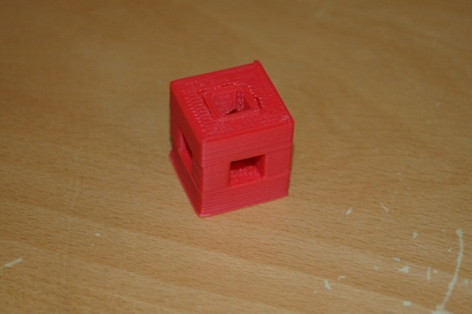

Go here: <http://www.thingiverse.com/download:15293> to download the STL file for the cube. We’ll be feeding this to Slic3r to print!

Before you can print the cube, you’ll need to adjust some settings in Slic3r. Slic3r is a special program that will take a solid model file (STL) and “slice” it into many thin layers so the Rostock MAX can print it.

Click on the **Slicer** tab in Repetier-Host and then click on the **Configure** button to the right.

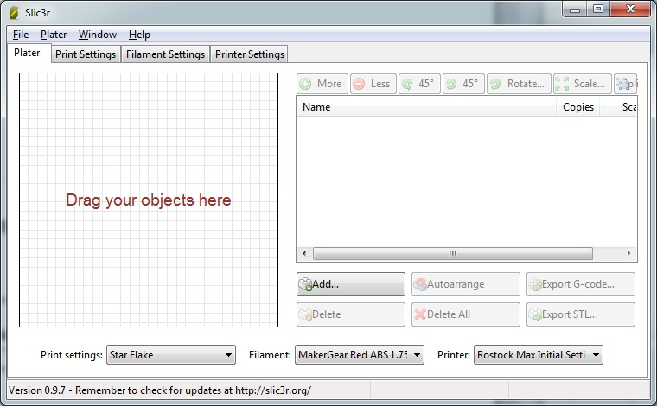

Figure - The Slic3r configuration screen.

You should see a window similar to Fig. 133 show up. The first tab, **Plater** isn’t going to be used for this tutorial, but I recommend you investigate it later.

Click on the **Print Settings** tab – this is where we’ll set up some important settings that pertain to this specific print.

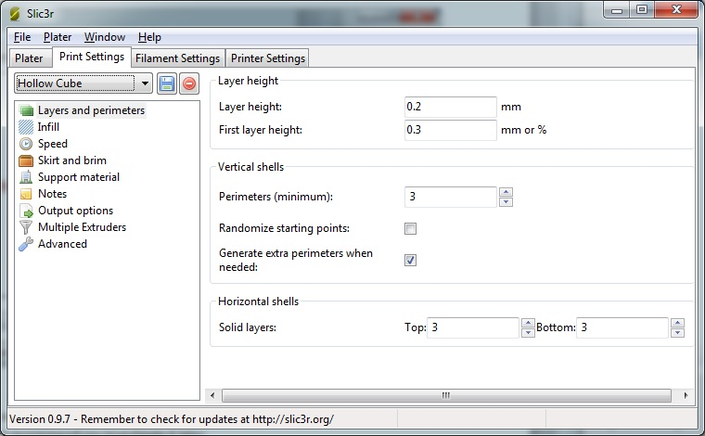

Figure - Layers and Perimeters

The first section, **Layers and perimeters** dictate how thick the print layers are and some other features.

**Layer height** is how thick each print layer will be. The smaller the thickness, the smoother your model will be. 0.2mm is a good first setting. Experiment with this and the other settings when printing other models. It’s the best way to learn how the various printing settings affect your print.

**First layer height** allows you to specify a starting layer that is thicker or thinner than the rest of the print. Please click in the input box and allow the Hint to be displayed – it will give you more information on this setting. All the other fields have this feature as well. Use it! The information is very good to have. For printing the calibration cube, set First layer height to 0.3.

**Perimeters (minimum),** specifies the minimum number of outlines on an object for every layer. For this first print, make sure it’s set to 3.

**Randomize Starting Points** if checked will make the print head move to a random location on each layer in order to prevent odd plastic buildup on one specific spot. For the calibration cube, leave this unchecked. This is another parameter that you’ll want to experiment with.

**Generate extra perimeters when needed** will add additional perimeter prints to each layer if they’re required. Leave this checked.

**Solid Layers** determines the number of solid or 100% fill layers that should be done on the top and the bottom of the print. For the calibration cube, set this value to 5. Higher values may give better print results on the top.

Click the floppy disk icon next to the drop-down and name the print settings “Calibration Cube” and then click on **Infill**.

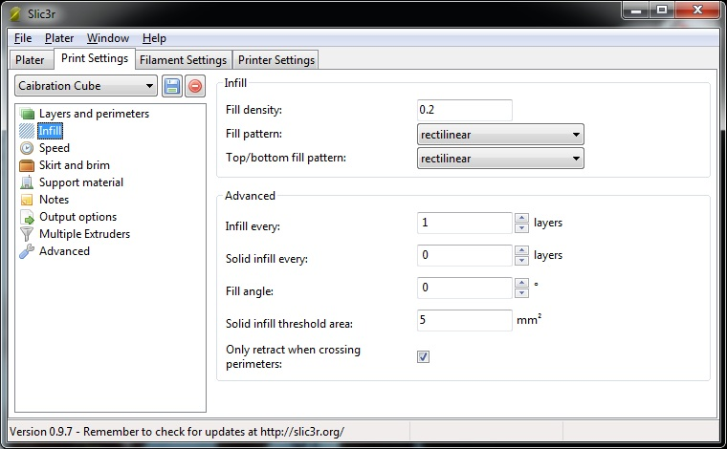

Figure - Infill

The Infill configuration page controls how the interior, solid areas of your model are filled up with plastic.

**Fill density** controls how much plastic is used to fill the “solid” areas of your model. This is a percentage value, so 0.2 shown above will be a 20% infill.

**Fill pattern** determines HOW the fill is added to the solid areas of your model. It provides for a number of different fill patterns, but for this first print make sure it’s set to **rectilinear**.

**Top/Bottom fill pattern** is essentially the same as **Fill pattern**, but the fill density is 100%. For this first print, make sure it’s set to **rectilinear**.

**Infill every** allows you to change how the infill works if you don’t want it to infill plastic on the solid areas for every layer. For the test cube, set this to 1.

**Solid infill every** allows you to force a 100% infill every so many layers. For the test cube, set this to 0.

**Solid infill threshold area** will force a 100% infill for sections that have a size less than or equal to the size specified. Note that the value is expressed in square millimeters. For our test cube, set this to 5.

**Only retract when crossing perimeters** means that the filament will only be retracted from the print head when you’re crossing perimeters of the part and you don’t want to risk any “extra” plastic accumulating outside the print volume. The infill areas really don’t matter and not retracting while crossing these areas will improve your print speed. For the test print, check this option.

Click the save icon (don’t change the name!) and let’s move on to Speed!

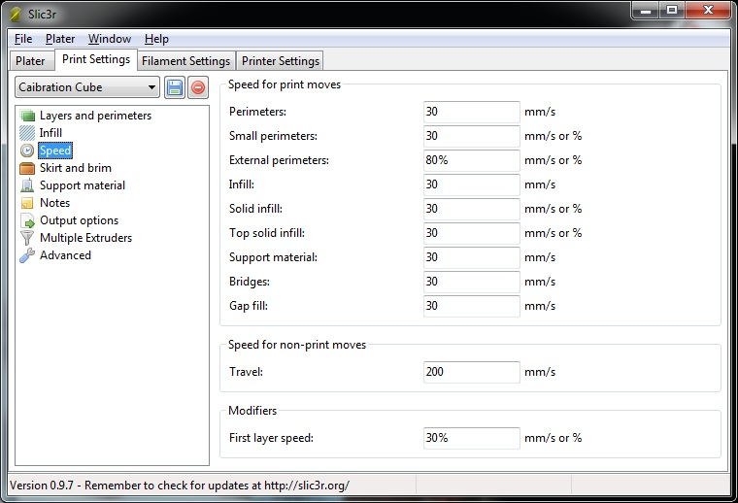

Figure - Speed

Each option above controls the speed in which the print head will move during the various stages of the print process. For your first print, make sure your settings match all those above. If you’re curious about what each one effects, hover your mouse pointer over the field you’re interested in. A helpful hint will be displayed with a short description of the field.

When you’re done, click the save button and let’s move on to the next section, Skirt and Brim.

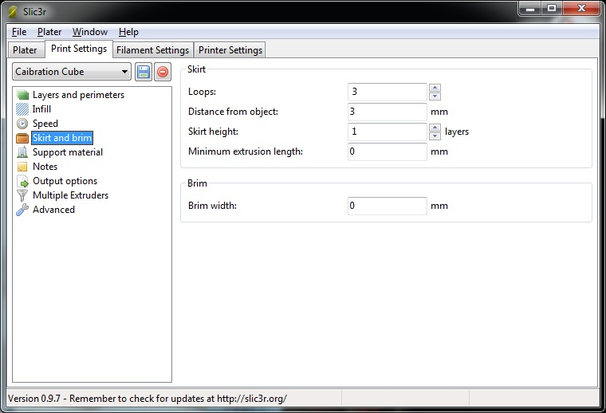

Figure - Skirt and Brim

The Skirt page has some very useful options on it that are useful for starting the printing process.

**Loops** does exactly that. Before your part starts to print, the printer will print a number of loops around where your part will print. This is very handy when you’d like to make sure that the hot-end is primed with enough plastic to begin the printing process. For the calibration cube, set this to 3.

**Distance from object** dictates how far away from where your part will be that the loop will print. Set this to 3mm for the cube print.

**Skirt height** will tell the looping routine in Slic3r how high to build a “skirt” around your part. This is especially useful if you want to use the looping feature to build a “draft dam” around your part to prevent air drafts from causing adhesion or other problems. Specify a high number here (20?) to build a skirt around your part. For now, set this to 0. This is really only a useful feature if you’ve got issues with cold air movement or you’re using a Cartesian printer than moves the build platform around quickly.

**Brim width** tells Slic3r to print what essentially amounts to a hat brim around your part for the distance specified. This can be helpful for prints that have problems with curling edges. Let’s leave this value set to zero – we’re more interested in getting a good overall print than worrying about curling issues right now.

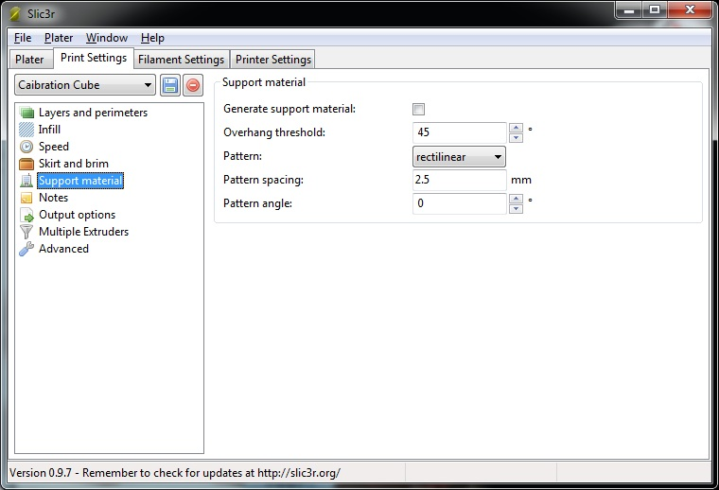

Figure - Support Material

The **Support Material** page covers options that are specific to parts that have large overhangs that could make printing problematic. These settings would craft little support structures as part of the printing process that you would cut away after printing finishes. Their purpose is to support extruded plastic that sticks out in “open” air at angles greater than 45 degrees and wouldn’t stand up well during printing. For our calibration cube, there’s nothing to set here, so leave “Generate support material” unchecked.

The **Notes** page is very straightforward. If you have any comments you’d like to include with the G-Code that Slic3r generates, put it here!

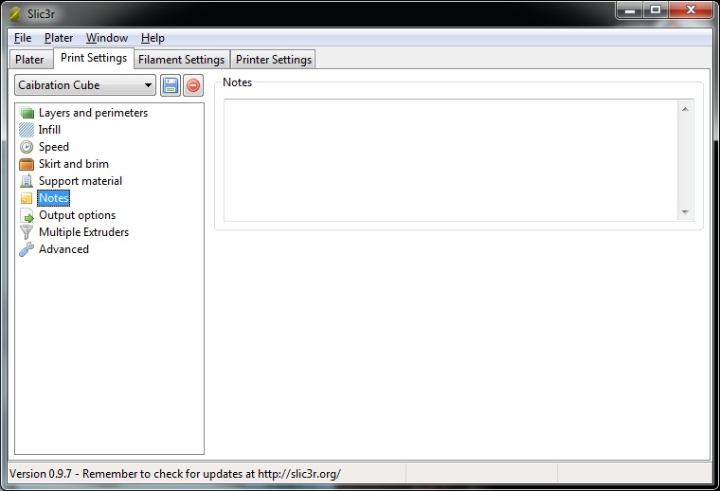

Figure – Notes

The **Output Options** page covers three main items that handle some details on how the G-Code is generated for your part.

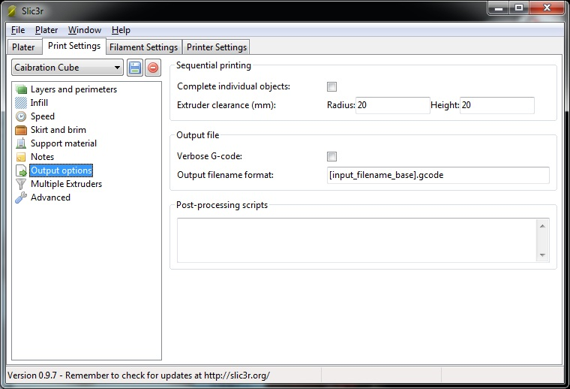

Figure - Output Options

**Complete individual objects** will tell Slic3r that if you’re printing multiple parts during one job that you want each part to print before Slic3r begins printing the next part. For the calibration cube we’ll leave this unchecked.

**Extruder clearance (mm)** tells Slic3r the amount of free space it needs to leave around each of the objects in order to avoid striking a previously printed object with the extruder.

**Verbose G-Code** indicates that you want Slic3r to put descriptive text on each line in the G-Code file. This can be a good educational tool to see what each G-Code statement does, but will create pretty large files – if you’re printing from an SD card, you may want to leave this unchecked. For your first print, you can check this or not. It’s entirely up to you. When it’s time to print, I’ll show you where you can view the code that Slic3r generated and you can see (or not!) the comments it put in.

**Output filename format** allows you to change how the filename is created for your print job. For now, just leave it at the default shown.

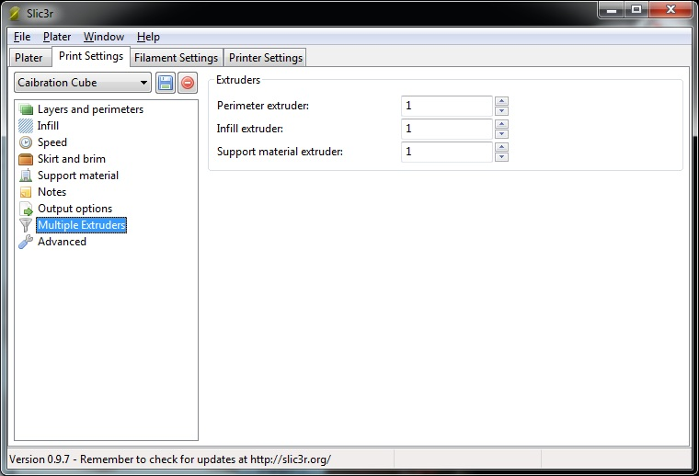

Figure - Multiple Extruders

The **Multiple Extruders** page allows you to specify a specific extruder for each of the tasks listed. For now, leave them all set to 1. Note that unless your Rostock MAX has more than one extruder mounted on the carriage, you’ll never need to revisit this configuration page.

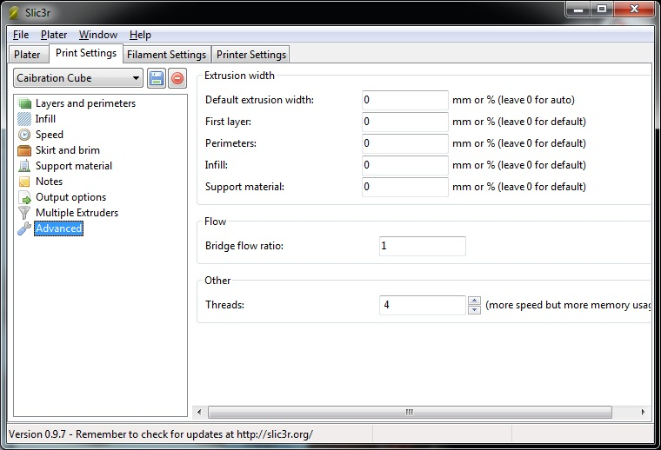

Figure - Advanced Options.

The **Advanced** page only has one setting we may need to adjust at this time. The **Threads** field tells Slic3r how many simultaneous tasks to undertake during the processing of your model. I would recommend setting this number to the number of CPU cores that your computer has. If you’re not sure what that count is, you can safely leave it set to the default of 2.

Click on the Save icon one more time to ensure that your changes have been saved and then click on the **Filament Settings** tab.

The **Filament Settings**  tab is for setting options that are relevant to the filament that you’re going to use on your test print.

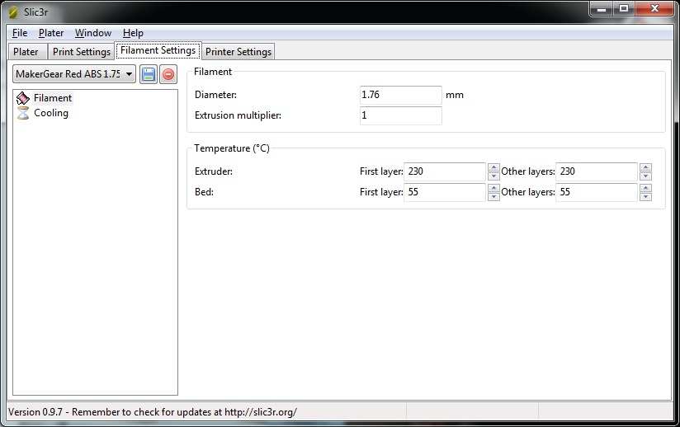

Figure – Filament

For the **Diameter** setting, you’ll want to use your digital calipers to take a few test measurements along some length of filament to get an idea of its actual diameter. Put an average of the measurements you took into the **Diameter** field.

**Extrusion Multiplier** proportionally changes the flow rate of the extruder. For your test print, make sure this is set to 1 as shown.

The temperature settings shown in Fig. 143 are good for your first test print, assuming you’re using ABS plastic. If you’re using PLA or another material, you should consult your filament vendor for appropriate extruder and heated bed settings.

Click the save icon at this point and name the configuration something that makes sense to you. I use the vendor name, the color, type and filament diameter. You really want a configuration file for every color, vendor and type of filament you print as not all filament is created the same, even from the same vendor.

The last filament page is **Cooling**. This is primarily used by people extruding PLA. Make sure Enable Cooling is unchecked, save your changes one more time and we’ll move on to **Printer Settings**.

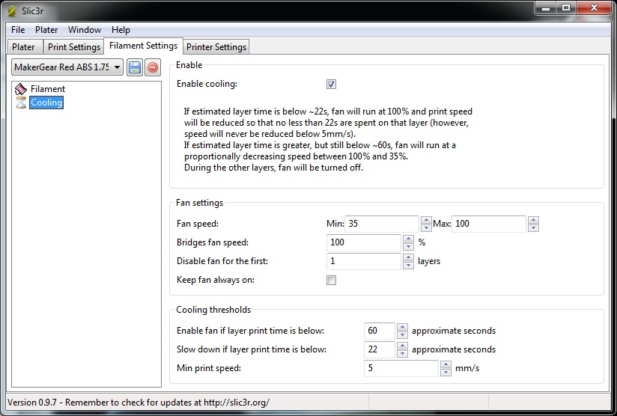

Figure - Cooling.

On the **Printer Settings** tab in the **General** page you’ll see how you specify the physical attributes of your Rostock MAX 3D printer. Make sure your Slic3r settings match those in Fig. 145 and then click the save icon. Name it “Rostock MAX” and then click on the **Custom G-Code** page.

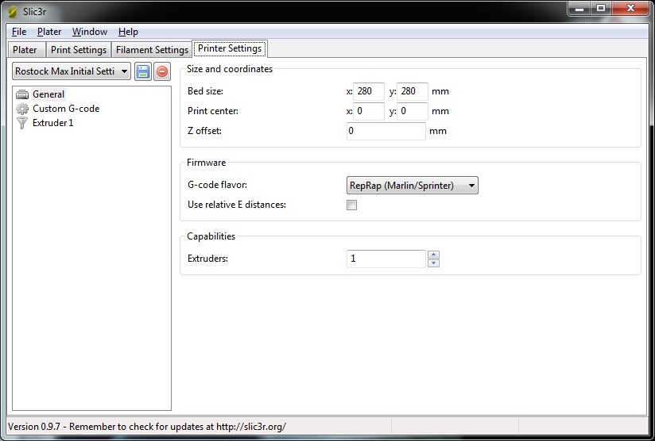

Figure - General printer settings.

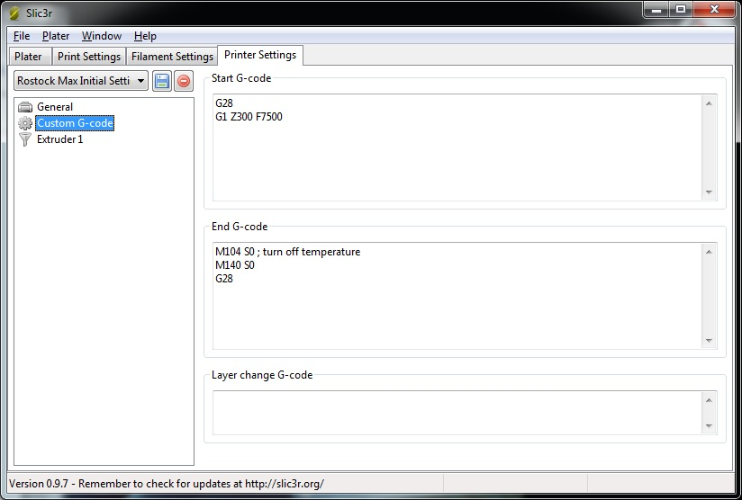

Figure - Custom G-Code

The **Custom G-Code** page allows you to tell your Rostock MAX to do some specific chores before and after a print job is run.

**Start G-Code** is run before the print job is run. In this case, we send **G28** which re-homes the Rostock MAX, followed by **G1 Z300 F7500** which rapidly moves the carriage to 300mm above the print surface.

**End G-Code** is executed right after the print job is finished. **M104 S0** turns off the heat to the extruder and **M140 S0** turns off the heat to the heated bed. **G28** re-homes the machine.

**Layer Change G-Code** would insert any special code you need between each layer that’s printed.

For your first test print, make sure your Slic3R configuration matches what’s shown above in Fig. 146. Click save and let’s move on to the **Extruder 1** page.

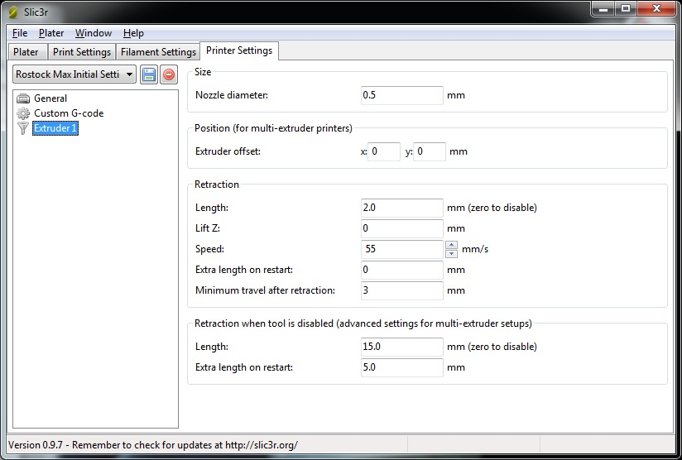

Figure - Extruder Settings

**Size** describes the diameter of the hole in your extruder nozzle. For a typical Rostock MAX, this should be 0.5mm. This helps Slic3r know how much plastic is extruded for a given extrusion speed.

**Extruder Offset** is only used if you’ve got multiple extruder nozzles. For now, leave both **X** and **Y** set to 0.

Retraction **Length** tells Slic3r how much filament should be “backed out” of the hot end when making rapid moves. This helps ensure that no plastic is accidentally extruded while the hot end is moving to a new position to begin printing again.

**Lift Z** will tell the machine to rapidly move the **Z** axis up this amount during retractions. For the calibration cube, leave this set to 0.

**Speed** will tell Slic3r how fast the plastic should be fed to the hot end. For this and most other prints, you’ll want to set it to 55.

**Extra length on restart** will extrude an extra amount of filament once a rapid move & retraction has occurred. This is seldom used. Set it to 0.

**Minimum travel after retraction** will tell Slic3r that you have to move at least as far as specified here for a retraction to take place during a rapid move. Set this to 3 for the calibration (and most other) cube prints.

You can leave the **Retraction when tool is disabled** advanced settings at their defaults as they really only pertain to multiple-extruder jobs.

Now make sure you click save and then close the Slic3r configuration window.

In order to give Slic3r something to work with, we need to load a model into Repetier-Host. Click the **Load** button and navigate to where you saved the hollow_cube.stl file. When you open the file, you should see a rendering of the cube sitting in the center of your build volume as shown below.

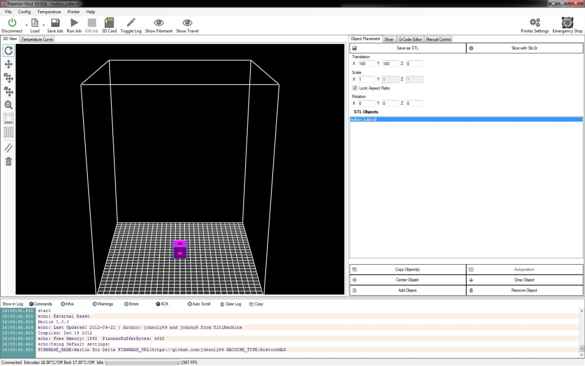

Figure - Hollow Cube loaded!

Now it’s time to tell Slic3r to do its thing. Click on the **Slicer** tab and then click the **Slice with Slic3r** button. After a few seconds, you should have a display that looks very much like this:

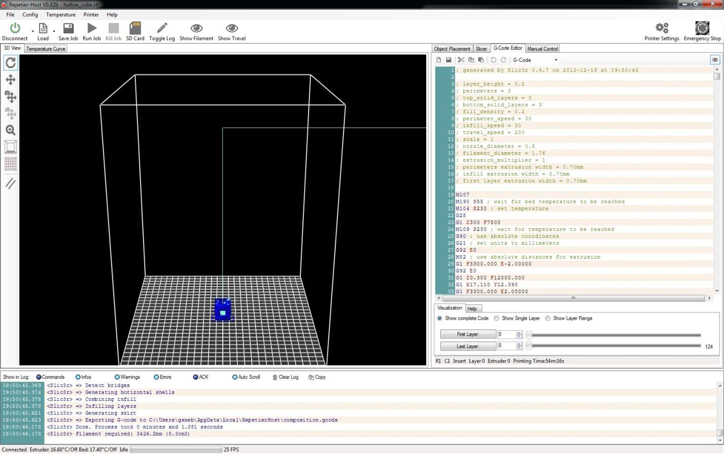

Figure - Sliced and ready to go!

The cyan colored line you see is the path that the extruder head will take as it moves and the dark blue represents the extruded plastic. You can click in that window and using your mouse, pan, zoom and rotate the model. In fact, why don’t you zoom in on the calibration cube so you can see what it will look like:

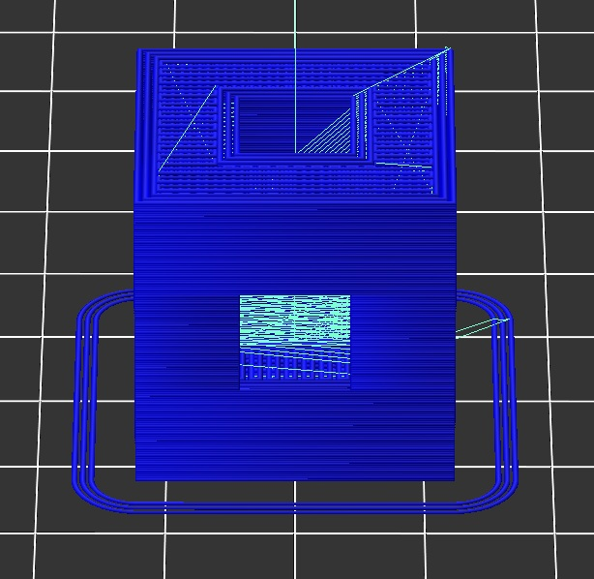

Figure - Visible tool path.

The rendering in Fig. 150 is a pretty accurate rendition of what will happen on your print bed. Notice the three rings around the part? When you set **Loops** to 3, it caused that to be generated as part of the tool path. (“tool path” is a term used to describe the path that the tool takes during the entire printing process)

Back when I was walking you through the Slic3r configuration, I mentioned we’d be viewing the G-Code that Slic3r generates. Fig. 151 below shows the code.

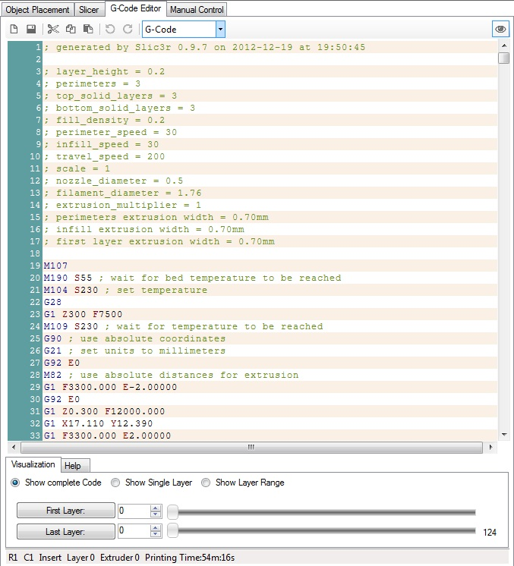

Figure - G-Code for the calibration cube.

All that text is what controls the Rostock MAX through the RAMBo. Repetier-Host sends each line of that file to the RAMBo board and the software on the board interprets each line in order to tell the Rostock MAX to move to a specific place, extrude plastic, etc. Lines that start with “;” are comments. They’re ignored by the G-Code processor on the RAMBo board and you’ll notice that the start of the file contains all the settings that you set up in Slic3r. This is a great way to track prior configurations.

If you want to know what a specific program code does, you can click on the **Help** tab under the editor and each time you click on a line of code, Repetier-Host will display a little bit about what it does if it knows about it. There are very few codes that Repetier-Host doesn’t know about.

I highly recommend learning more about how G-Code works – that knowledge will help you get the most out of your Rostock MAX in the long run.

Now before can print the model you just sliced, we need to load filament into the printer! If you haven’t already, mount the spool of ABS on the spool holder and then begin heating the extruder by clicking on the **Heat Extruder** button. Make sure the temperature is set to 240 (for ABS – for PLA use 190).

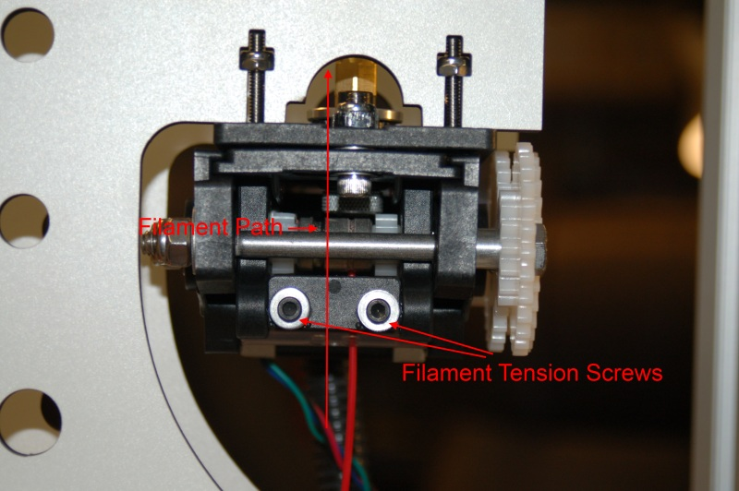

Figure - Loading the filament into the extruder drive.

The simplest and most trouble-free method of loading filament into the extruder drive is to loosen the two tension screws shown in Fig. 152. You want them loose enough that you can pass the filament between the hobbed drive rollers pretty easily. Thread the filament into the Bowden tube entrance until you see a couple of inches of filament showing in the Bowden tube. I came to this procedure by trial and error, mostly error. In trying to get the extruder to do the loading for me, I found that it would most often not hit the entry to the Bowden tube squarely and would start shoving filament through the space between the drive rollers and the Bowden tube entry. Makes a hell of a mess!

Once you have the filament loaded, tighten down the tension screws such that they’re compressing the O-ring spacers a small amount. This will give you a good amount of tension to start with. We’ll adjust that if needed in a sec.

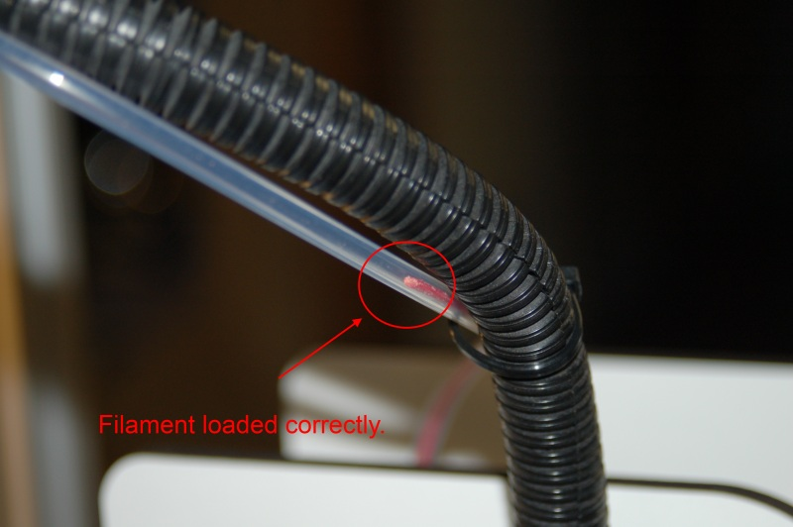

Figure - Filament loaded correctly in the Bowden tube.

Now that you’ve got the filament properly loaded, I want you to make sure the machine is in its home position by entering **G28** in the G-Code window, followed by **G1 Z5 F1200**. This will help the filament load into the hot end by making the Bowden tube as parallel as possible to the hot end. This will help prevent loading jams.

Once the hot end is in position, I want you to set the extruder temperature to 240 (for ABS, 190 for PLA) and click on the **Heat Extruder** button. The next step requires using the extruder drive, and safety interlocks prevent it from functioning if the hot end is not at operating temperature.

After the hot end is at temperature, you’re going to use the manual extruder controls to feed filament into the hot end.

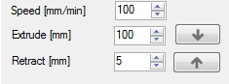

Figure - Controlling the extruder drive manually.

Set the extruder controls as shown above. The down pointing arrow feeds filament into the hot end and the up arrow retracts it. Go ahead and click on the up arrow. Continue to click the button (only click it once – wait for the extruder to stop before you click it again!) until the extrusion is about an inch from the hot end. While the filament is loading, I want you to pinch the filament as it enters the extruder drive. If you have the tension set correctly you shouldn’t be able to stop the filament by pinching it with two fingers. If you CAN stop it, tighten each tension screw about a half-turn until you’re unable to stop the filament. Please make sure that you tighten each screw evenly!

Now that you’ve got the drive tension set properly, click the down arrow again and get the filament to enter the hot end. It may take a click or two, but you should see filament coming out of the nozzle shortly after you see the end of the filament enter the top of the hot end. Once the filament is extruding, I want you to enter **G1 Z300 F1200** to bring the platform up close to the top and then click then down button to extrude at least another 300mm through the hot end. When the extruder motor stops for the final time, go ahead and turn off the heat to the hot end. (..and clean up the mess of thin plastic that’s now all over the build platform!)

I would recommend that before each print, it’s a good idea to extrude about 20-25mm of filament before you begin. That would ensure that the extruder is primed and you don’t have any jams.

Ok, I give up. I can’t keep you waiting any longer. Reach up with your mouse cursor and whack the **Run Job** button!

When you start the job, Repetier-Host will start sending the G-Code in the editor to the RAMBo over the USB cable. The first thing it will do is begin to heat the bed. When the bed has reached its operating temperature, it will then begin heating the hot-end. Once the hot end has come up to temperature, the Rostock MAX will begin printing the calibration cube you just sliced.

Before the printer begins, I want you to move the **Feed rate** slider that’s in the **Speed Multiply** box back to about 50.

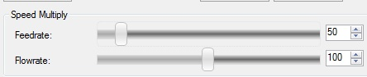

The reason for this is to help make sure that the print is going to adhere to the bed properly and to ensure that the flow rate will be sufficient for the printing speed. If you go too fast, you can easily over-run the ability of the hot end to melt the plastic. When that happens, the hot end will jam and the extruder will begin shoving plastic out the side, between the face of the Bowden tube and the extrusion drive rollers. It’s not a pretty sight and I’ve done it more times than I care to think about while learning how to use a 3D printer.

Now that being said, there’s no reason you can’t bump the speed up just to see how well it does. The worst that can happen at this point is you jam the extruder. You’ll do that often enough so you might as well figure out how to clear it now. ☺

I’ll shut up now so you can watch your Rostock MAX in peace. It’s absolutely the most fascinating thing you’ll watch in a long time.

# Fail Happens. (To *everyone!*)

You will find over time that 3D printing can be very rewarding and simultaneously the most frustrating thing you’ve ever done. You’ll quickly learn the new natural law that has come into effect in the last few years. 3D Printers Are Total Jerks. It’s just the nature of the beast – when you’re on the bleeding edge of technology, you ARE going to get paper-cuts as part of your learning curve.

Let’s take a look at some of the mistakes that I made while writing this manual and learning about 3D printing as I did it.

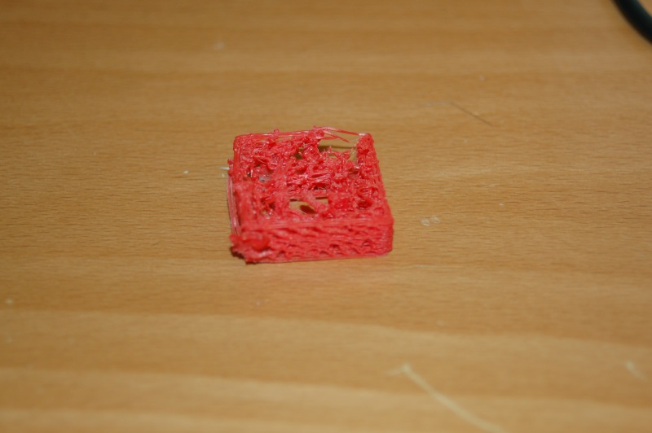

Figure - Too fast, not enough plastic.

Above is my first “official” print. This is the calibration cube that you’re either already printing, or will soon print from my example above.

There are a couple of things going on here – first of all you’ll notice how ratty it looks. This is a very obvious symptom of inadequate material flow as a result of either too slow an extrusion rate, too fast a printing speed or insufficient hot end temperature. Sometimes it’s hard to learn how to go slow when all you really want to do is firewall the throttles and scream like a little kid.

I stopped the print in Fig. 155 and started over.

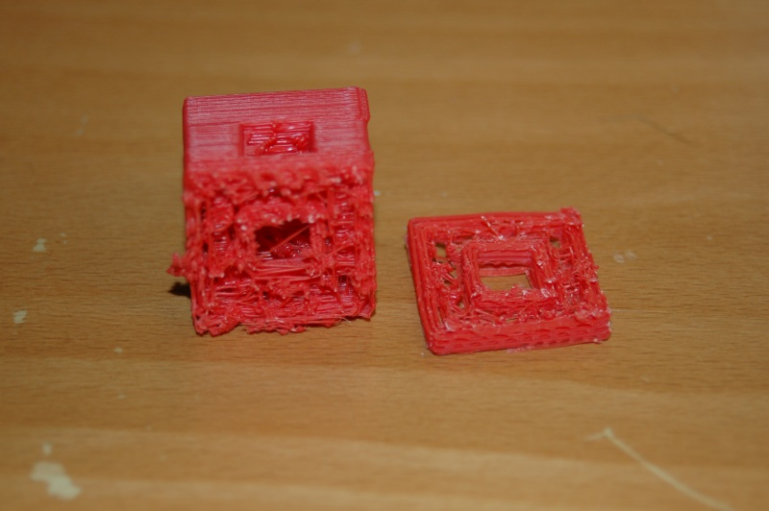

Figure - Too fast, then slowed it down!

This time I started slowing it down using the **Feed rate** multiplier slider. The good print you see above the rotted portion was done at the 60% I recommended in the previous section.

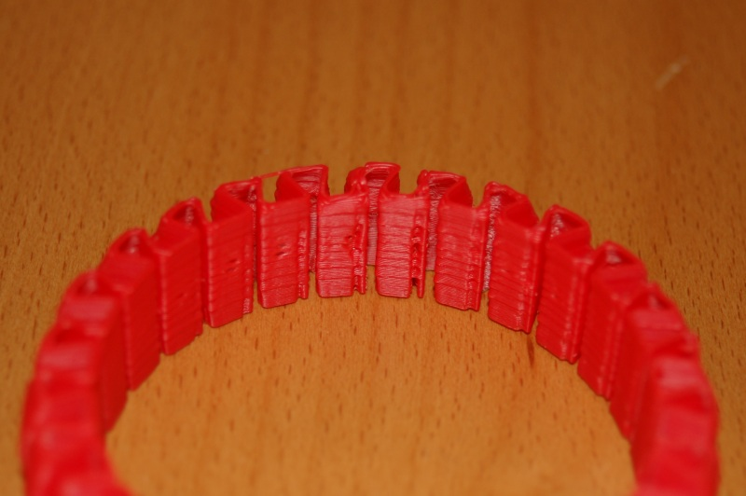

Figure - Stretchlet, too fast.

Now this is an interesting result – it’s the same flow issue but there’s a deeper reason for it than what you’d think. You see this is the *second* stretchlet I printed. The first one printed perfectly and with the **Feed rate** multiplier slid all the way over to 300%!

The knurled nut loosened on my hot end during another print I was doing and that resulted in a short that blew the MOSFET fuse on the RAMBo and may have damaged the thermistor. This damage may have done a number on the thermistor and caused it to over-report the temperature. This would result in the absolutely INSANE jamming problems. What was happening is that at normal feed settings, the extruder drive would pack the under-heated hot end and because it’s such a strong little monster, it would eventually start shoving filament out the side of the extruder! The only place the filament had to go was out the side through the space between the drive rollers and the face of the Bowden tube!

This stretchlet was an experiment to see if increasing the hot end temperature would resolve the issue. The holes and odd spots appeared at 300%, but backing it down to 200% resulted in a good result. In the coming days I’m going to do some further checking to see if I’m right.

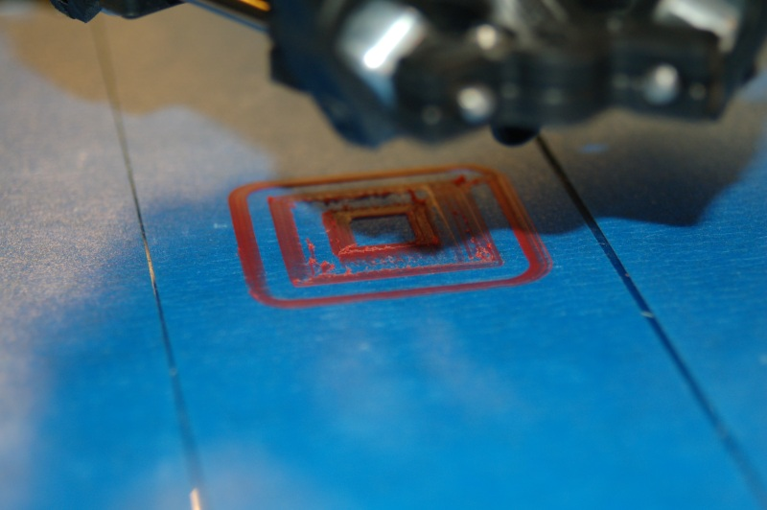

Figure - Starting the print process.

In the photo above you’ll see the starting of the print process. Remember those loops you configured in Slic3r? That’s the rounded ring around the inner print. It’s very useful at getting the plastic flowing. The inner layer looks a little ratty, but it does improve over time as more plastic is deposited. The hot-end will also “smoosh” the plastic into a flat layer.

In Fig. 159 below, you’ll see some common issues that you’ll run into.

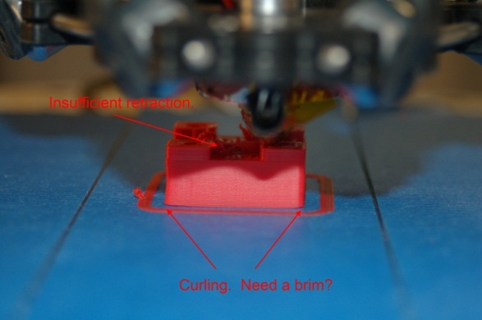

Figure - Retraction & Brims

You’ll notice that there are little “strings” of plastic in the spaces between the four corner posts. This happens because while we ARE using retraction, the 2.0mm setting isn’t sufficient. As the hot end crosses the open space it continues to extrude a small amount of plastic because the “head pressure” in the nozzle hasn’t been reduced enough. That is what retraction is all about – getting that pressure down during rapid moves in order to avoid un-intentional extrusion from messing up the print. Increasing the retraction setting to somewhere between 5 and 10mm should greatly decrease the effect you see above.

The second thing that’s happening is part curl. This happens because different parts of the part cool at different rates. If you don’t have perfect adhesion to the print bed, you’ll get the effect seen above. There’s a number of different ways to combat curling. Using Painter’s Tape with a heated build platform is a good start, but more is obviously needed. There’s a lot you can do to combat curling and that’s really beyond the scope of this guide, but I would recommend playing around with the **Brim** setting in Slic3r to see how that effects curling. I would recommend that you search around using Google to learn more about curling. There’s a lot of great information out there, written up by some really smart people.

When your print completes, you should have something that looks like this:

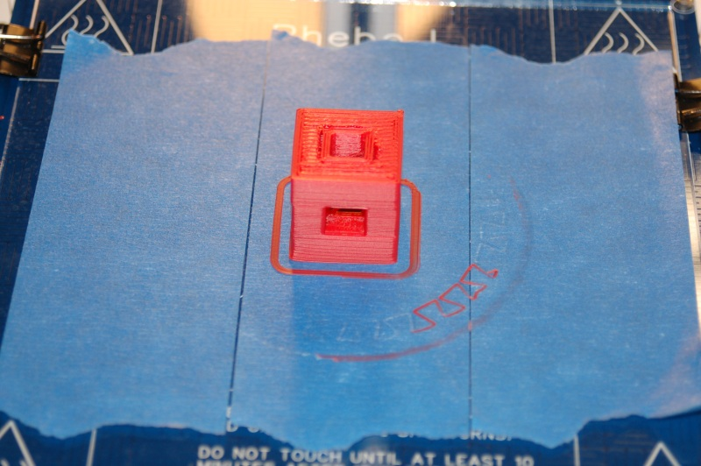

Figure - Successful print of the Calibration Cube!

The settings listed in the Slic3r configuration are the ones I used to print this cube. You should get similar results as I did here – if you didn’t, please check the Slic3r settings and try your print again. If you find the settings to be correct, I would recommend asking for assistance on the SeeMeCNC forums (<http://forum.seemecnc.com/index.php>) or on the IRC channel #reprap on the freenode network.

# Maintenance & Troubleshooting

Like any machine, your Rostock MAX 3D printer needs preventative maintenance to continue to function as good as the day you built it. Vibration and heating/cooling cycles can take their toll and you want to stay ahead of any issues before they begin to adversely affect your prints.

1. Check the condition of your drive belts to insure they’re not getting worn out or rubbing on any of the Rostock MAX structure. Check to make sure that a print too close to the bed hasn’t caused the drive gear to chew up the belt in one spot. This would be a good item to add to your startup checklist.
2. Check all bolted connections to ensure that vibration hasn’t begun to loosen them. This should be part of your startup checklist.
3. Check the Cheapskate bearings to ensure that they still have a good hold on the rails. If you leave your Rostock MAX idle for an extended period of time could cause “flat” spots to form on the Acetal bearing covers. You’ll know this has happened if you begin to hear “ticks” as the flat spot comes into contact with the rail. The good news is that the flat spot isn’t permanent as the Acetal will relax a bit with continued use and the flat spot will disappear.
4. Make sure that the fan in the power supply remains dust-free. Vacuum it out periodically to prevent the buildup of too much dust. Dust traps heat and isn’t any good for power supplies.
5. Keep the RAMBo free of dust. Clean it periodically with either canned air or a dry paintbrush. Do NOT use a vacuum cleaner on it! The tip of a vacuum cleaner accumulates static electricity and will kill the RAMBo dead as a post.
6. Keep the heated bed free of scratches and debris. If your bed gets too scratched up to be usable, you can either order a new one from SeeMeCNC or go to your local glass shop and order a 7” x 6.5” sheet of 1/8” glass. Compare the thickness of the glass and your original build surface. If the glass isn’t the same, you may need to re-adjust your Z axis height.

The problem with troubleshooting is sometimes trouble shoots back. ☺

Your Rostock MAX 3D printer is a pretty complex piece of machinery even though it looks pretty simple. As with any complex device sometimes things can go wrong in really weird ways. This won’t be a comprehensive troubleshooting guide, but will touch on a few of the problems I’ve run into with my printer. As others offer tips, they’ll be added to this section.

**Print layer issues**

When you first start a print, you should get a very even and consistent layer height. By properly adjusting the machine, you should get this automatically if you’ve got all three towers adjusted exactly the same. Unfortunately, that’s really difficult to do. The larger the object you print, the more obvious first layer thickness inconsistencies will be, especially when using loops.

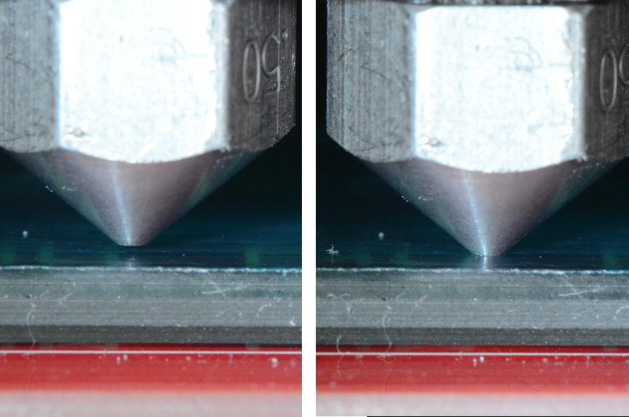

Figure - Correct Nozzle Height Example. (Image by LulzBot)

Above is an example of correct and incorrect nozzle height. The nozzle on the right is right at the surface of the print bed. This means that there’s no room for the plastic to go – the bed is effectively plugging the nozzle and will eventually cause the extruder drive to start shoving filament out the side of the drive rollers. The nozzle on the left is spaced about .3mm away from the print bed. This height gives plenty of space for plastic to flow and won’t cause a clogged nozzle.

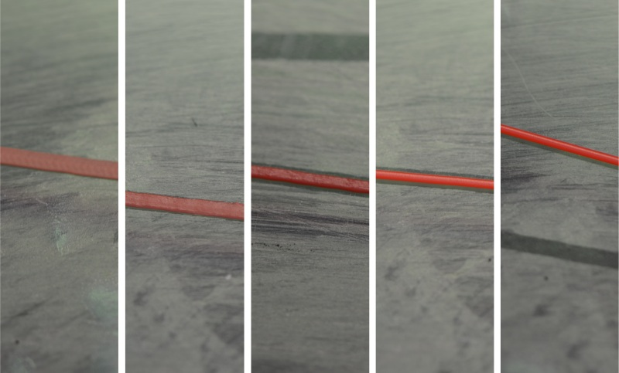

Figure - First layer examples. (Image by LulzBot)

In the figure above, you’ll see five different print examples. On the far left you see the result of the nozzle being too close to the print bed, while at the far right you see the result of the nozzle being too far away. The result you’re looking for is shown in the center. That’s what a good first layer should look like. If you set the Z height such that you can just begin to feel a sheet of note paper begin to drag between the nozzle and machine bed, you’re pretty close to the idea Z height when at zero.

**Machine won’t move!**

You’ve sent **G28** and the machine still won’t move using the jog arrows.

Take a look at the log output. You may be seeing an error go by that looks like this:

**Extruder switched off. MINTEMP triggered!**

What is most likely happening is that you haven’t yet plugged the hot-end thermistor in. The firmware is preventing the machine from moving because of this – it’s a safety measure of sorts. A cold thermistor will read ambient room temperature, but a failed one may not – it could read zero or some very high number. The firmware is will prevent the Rostock MAX from operating if the thermistor readings are below 3 degrees Celsius for the hot end and heated bed, or if the hot end temp is above 275 or the heated bed is above 140. (These are defaults and shouldn’t be messed with unless you know *exactly* what you’re doing)

**Belt Damage**

So you’re printing along and you start to notice stuff like this:

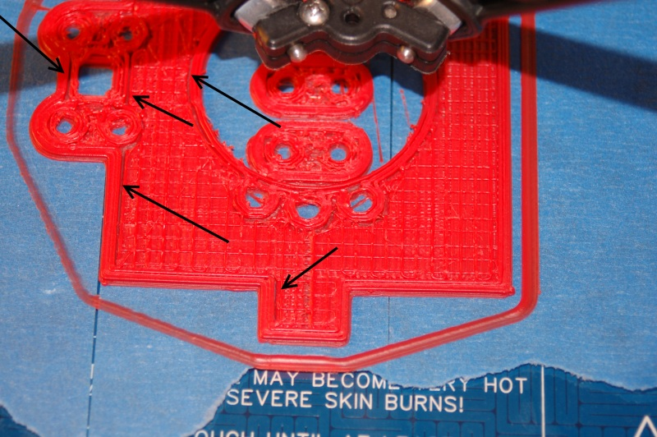

Figure - Indications of belt lash.

The arrows are pointing to a gap between the infill and the perimeter of the part. This was caused by a number of factors, eventually resulting in a sharp drive gear devouring all the teeth from a short section of the drive belt. Vigilant belt inspection and more care in setting the Z height would have helped to prevent this from happening.

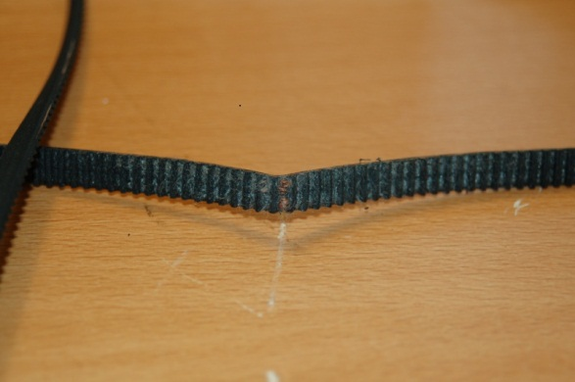

Figure - Belt Damage

As you can see, the teeth on the gear have nearly completely chewed through the belt.

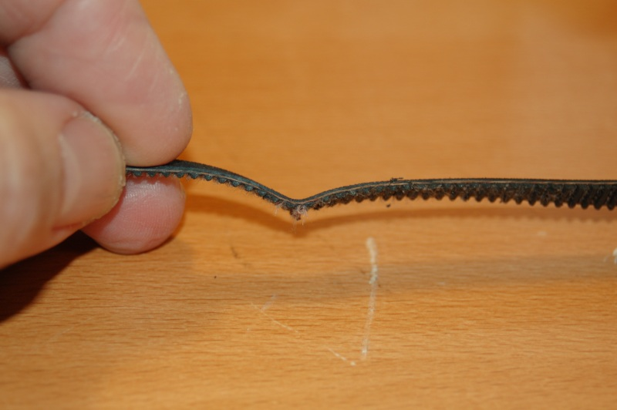

Figure - Belt Damage

The internal strings in the belt are exposed and the belt is essentially ‘used up’ at this point.

# Change Log

Version 1.9:

Sec. 2: Notified builder that heated bed would have to be removed to install wiring advised to check out Sec. 20 ahead of time.

Sec. 19.3: Added new technique for routing end stop wiring as contributed by [dbarrans](http://forum.seemecnc.com/memberlist.php?mode=viewprofile&u=437).

Version 1.10:

Added warning about calibrating with the printer heated up to operating temperature.

Version 1.11:

Noted an error with Figures 7 and 8 that show the T-Slot panel mated to the wrong side

of the Tri-Support.

Version 1.12:

Revised the door installation location in order to not block the LCD installation if a

second extruder is installed.

Version 1.13:

Changed the recommended ABS extrusion temp to 240 from 260. Mentioned 190 for

PLA.

Version 1.14:

Did a complete spell check to catch some outliers and corrected a terminology error

with regard to placing the thermistor in the hot end (was perpendicular, should have

been parallel)